Cascaded Budgeted Adaptive Reasoning Routing (C-BARR)
Architecture Specification, Dual-Signal Routing & Re-Anchoring Design, Technical Audit, and Reproducible Codebase
This research specification and reproducible codebase presents a unified, end-to-end 450-example experimental plan and software suite for Cascaded Budgeted Adaptive Reasoning Routing (C-BARR)¹, combining zero-cost lexical constraint routing and post-thinking constraint re-anchoring (Gate 1) with fast-pass token entropy + Thinking Inertia⁹⁷ probing and tight budgeted prefix termination (Gate 2)¹. First, it establishes the theoretical, architectural, and empirical foundations of the framework¹, situating C-BARR within 2025–2026 test-time compute scaling, early-exit, and instruction-forgetting research⁵ while compiling exact architectural specifications across hybrid linear-attention models (Qwen/Qwen3.5-0.8B, 2B, 4B, 9B)⁴ and dense Grouped-Query Attention models (HuggingFaceTB/SmolLM3-3B)¹³. Second, it identifies and resolves twelve implementation defects and omissions across baseline and naive post-tag reminder designs¹—including a fast-probe prefix bug ("#### ") that corrupts non-escalated IFEval outputs, a lexical router gap that misses or misclassifies 13 of IFEval's 25 canonical constraint etemplates¹⁵, unseeded langdetect nondeterminism in upstream IFEval verification¹⁷, an off-by-ten diagnostic split size (491 vs. 501) with complete 150-item eval_450 overlap¹, verifier corruption when an unstripped post-</think> reminder precedes JSON or quotation-wrapped outputs¹⁵, outdated package bounds (transformers>=4.51, vllm>=0.8) incompatible with qwen3_5 and smollm3¹³, and omitted linear-attention CUDA kernels (flash-linear-attention, causal-conv1d) whose absence triggers PyTorch reference fallbacks reported at over 10x slower execution²¹.
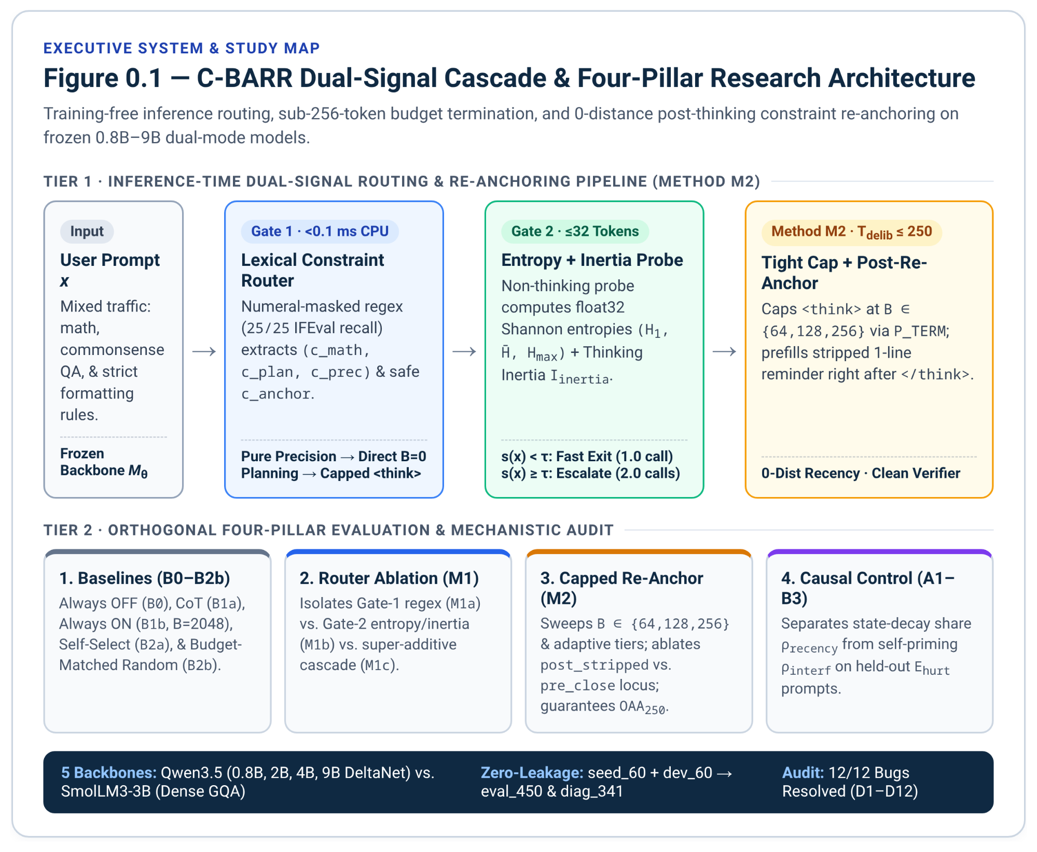

Core Methodological & Experimental Contributions
This specification implements the complete dual-signal C-BARR methodology, production codebase, and step-by-step execution playbook across five integrated components:
- Baselines B0–B2: Evaluates B0 (Always Non-Thinking), B1a/B1b (Prompted and Built-In Always Thinking), B2a (Self-Selective Prompting), and B2b (Budget-Matched Random Escalation Control)¹.
- Method M1 Dual-Signal Router: Ablates the zero-cost regex constraint router (M1a, Gate 1), the 32-token fast-pass entropy + Thinking Inertia detector (M1b, Gate 2), and their cascaded union (M1c)¹. The term Thinking Inertia follows Lei et al. (NeurIPS 2026)⁹⁷, who benchmark the behavior offline; C-BARR uses it online, as a runtime routing signal.
- Method M2 Tight Budgeted Prefix Termination + Post-Think Constraint Re-Anchoring: Caps <think> at $B∈\{64,128,256\}$ tokens via \nOkay, I think I have finished thinking.\n</think>\n¹ and prefills a channel-stripped 1-line constraint reminder right after </think> (with a direct pre_close ablation right before </think>).
- Causal Diagnostic Control: Compares Trace Stripping against Post-Think Constraint Re-Anchoring on held-out IFEval Hurt prompts to separate context-length recency decay from semantic self-priming interference¹.
- Seven-Phase Execution Playbook & Manuscript Blueprint: Provides a step-by-step GPU execution playbook with pass/fail verification gates, VRAM/runtime budgets, and an 8-page manuscript blueprint (UT Austin CS388 report first, then arXiv and a 2027 venue).
Empirical Caveats & Upstream Benchmark Hygiene
Official Qwen3.5-4B and Qwen3.5-9B model cards report language benchmarks only under default thinking mode without separate non-thinking baselines¹⁰, whereas smaller dual-mode evaluations show divergent aggregate IFEval trends depending on model scale and stochastic vs. greedy decoding⁷; local B0 vs. B1b runs under greedy decoding are therefore mandatory to establish matched baselines. In addition, upstream google/IFEval (541 prompts, 834 constraint instances) contains four documented prompt-argument discrepancies (keys 30, 337, 2078, 3311)²⁴, which the upgraded freezer flags for sensitivity auditing while retaining unmodified upstream verifiers for leaderboard comparability²⁵.

Multi-Tab Specification Guide
Tab | Section Title | Core Contents & Tables | Primary Role
🧭 Tab 1 | Part 1. Problem & Dual-Signal Design | Overthinking-constraint trade-off, 2025–2026 routing literature (Table 1.1), 4-pillar experimental design (Table 1.2) | Motivation & Literature Synthesis
🧠 Tab 2 | Part 2. Backbones & State-Decay | Qwen3.5 Gated DeltaNet vs. SmolLM3-3B GQA (Table 2.1), IFEval flip audit (Table 2.2), causal diagnostic controls (Table 2.3) | Architectural & Causal Theory
⚙️ Tab 3 | Part 3. Formal C-BARR Methodology | Pipeline diagram, Gate 1 regex router, Gate 2 fast entropy/inertia probe, Method M2 4-lane schedule (Table 3.1) | Mathematical Specification
📏 Tab 4 | Part 4. Evaluation & Metrics | Frozen eval_450 6-slice suite, token accounting, OAA_250, AUC_OAA, U_0.05, BSR(B), Oracle_UB, McNemar tests | Evaluation & Statistical Protocol
🔍 Tab 5 | Part 5. Technical Audit (D1–D12) | Systematic audit and resolution of 12 draft implementation defects across A.1–A.6 (Table 5.1) | Defect Audit & Verification
💻 Tab 6 | Part 6. Production Codebase & LaTeX | Repository layout (Table 6.1), CUDA setup, 5 complete Python modules, run_matrix.py, booktabs Tables 1–3 | Reproducible Software Suite
🚀 Tab 7 | Part 7. Execution & Paper Blueprint | Engineering & analytic pillars, 7-phase GPU playbook, VRAM/runtime budget (Table 7.1), 8-page manuscript blueprint (Table 7.2) | Execution & Manuscript Plan
📚 Tab 8 | Works Cited (References 1–103) | Complete numbered bibliography aligned 1:1 with inline citation superscripts across all tabs | Bibliography & Sources

Glossary & Abbreviations
Plain-language key to the codes, symbols and acronyms used across this doc. Press Ctrl+F (Cmd+F on a Mac) and type the term you are stuck on. Subscripts are written with an underscore here, so T_probe means T with a small "probe" under it. Sections 0 to 6 and 11 explain labels invented in this doc; the other sections explain standard machine-learning, engineering and publishing jargon. Compiled on 13 Nov 2026 from every tab and figure, so later edits to other tabs may not be reflected here.

0. Start here: how the labels are built
Most short codes are one letter (the kind of thing) plus a number (which one). Learn the letters below and most of the doc decodes itself.

Pattern | What it means | Examples
B + digit (+ letter) | Baseline: an existing strategy that C-BARR is compared against | B0, B1a, B1b, B2a, B2b
M + digit (+ letter) | Method: a C-BARR variant. M1x = routing only, M2 = the full system | M1a, M1b, M1c, M2, M2-64, M2-Pre
B alone, B = n, B(x), B ∈ {…} | Thinking budget: the most tokens allowed inside <think>. Not a baseline | B = 0, B = 2048, B ∈ {64, 128, 256}
"Control" + A1, A2, B1, B2a, B2b, B3 | Diagnostic controls: six ways of editing a failed thinking trace to find out why thinking hurts. A-controls delete or replace the trace; B-controls keep it and add a reminder or cut it short. Unrelated to the baselines | Control A1, Control B2a
M_θ | The frozen model itself (M with subscript theta = its weights). In figures it looks like "M0"; there is no method called M0 | Frozen Backbone M_θ
number + B | Model size in billions of parameters | Qwen3.5-4B, SmolLM3-3B, 0.8B–9B
D + number | Defect (bug) ID | D1–D12 in Tab 5; D13–D16 in the Detailed Master Plan
W + number | Workstream in the execution schedule | W1–W8
R + number | Risk in the risk register | R1–R6
E + number | Stretch extension | E1, E2
A.1–A.6 | Sections of the original draft's code appendix, audited in Tab 5 | A.4 = src/engine.py
T_… | A token count | T_probe, T_think, T_tot
H_… | An entropy (uncertainty) value | H_first, H_mean, H_max
ϕ_… (figures: c_…) | A yes/no flag raised by Gate 1 | ϕ_plan, ϕ_prec, ϕ_sym
ρ_…, R_… | A causal share and a recovery rate in the diagnostic study | ρ_recency, R_strip
τ | A threshold | τ*, τ_H,high
name + number | A data split and its size, or a metric and its limit | seed_60, eval_450, OAA_250
…_RE, …_IDS | In code: a text-matching pattern (regex), a set of IFEval rule IDs | PLANNING_RE, PRECISION_IDS

Same label, different meanings
These collisions cause most of the confusion. Each row says how to tell the meanings apart.

Label | What to know
B | Five uses: (1) prefix of baselines B0–B2b; (2) the thinking budget in tokens; (3) the total-token limit in BSR(B); (4) "billion parameters" in model names; (5) prefix of Controls B1–B3. Letter then digit with no "=" is a baseline, or a control if the word Control or E_hurt is nearby. With "=" or "∈" it is a token budget. Number then B (4B) is model size
B1, B2a, B2b | Baselines B1a, B1b, B2a, B2b (section 1) and diagnostic Controls B1, B2a, B2b (section 2) share names but are unrelated. Controls appear only in the causal study (Tab 2 §2.2, paper Table 3) and carry suffixes in code: B1_pre_anchor, B2a_post_anchor, B2b_post_raw
BSR(B) | Tab 4 defines it as Budget-Constrained Success Rate, where higher is better. The Future Improvement tab calls it "Budget Shifting Ratio" and uses it for reasoning that leaks into the answer, where lower is better. The two uses contradict each other; the leak measure is what the Detailed Master Plan (D16) calls spillover_rate
M0 | Not a method. It is M_θ, the frozen model, shown as "Frozen Backbone" in Figures 0.1 and 3.1
Gate | Gate 1 and Gate 2 are the two routing steps of the method (Tabs 1–3). Verification Gate 1–6 and "Pass Gate" are pass/fail checks in the execution plan (Tab 7, Detailed Master Plan)
Tier | Figure 0.1: Tier 1 = the pipeline, Tier 2 = the evaluation. Future Improvement tab: Tier 1–3 = upgrade levels. Venue tabs: Tier 1 = free journals, Tier 2 = conferences. "Tiered budget" = a cap chosen per prompt
Tab | Usually a tab of this doc, but in Figure 7.2 "Tab 1 / 2 / 3" means paper Tables 1–3. "Tab N" in prose follows the original order: 1–7 are the numbered tabs, 8 = Works Cited, 9 = CS388, 10 = Exposure and Novelty Audit. Tabs added later (Execution Note, Detailed Master Plan, this glossary) are not counted
Table 1 / 2 / 3 | Without a dot: the three result tables of the planned paper (templates in Tab 6 §6.8). With a dot (Table 1.1, 2.3, 5.1): a table inside this doc, numbered tab first
§ | §1–§8 in Tab 7 §7.4 and in the Detailed Master Plan are sections of the planned 8-page paper. "§3.2" style refers to heading 3.2 inside Tab 3
256 vs 250 | The largest thinking cap. Tabs 1–7 write 256 with an effective limit of min(256, 250 − T_probe). Patch D13 in the Detailed Master Plan sets it to 250. So {64, 128, 256} and {64, 128, 250} are the same schedule before and after the patch
512 vs 1024 | Maximum answer length in tokens: 512 in Tabs 3–7, raised to 1024 by patch D14
p | Escalation rate (calls = 1 + p); the p-value of a statistical test; p_esc(x), the escalation score; "1.00p" = pages in Figure 7.2
pp | Percentage points (Tabs 1–2) or pages (venue tabs, "up to 12 pp")
T | T_… is a token count; T = 0.6 is the sampling temperature
R1 | Risk R1 in the Detailed Master Plan, and also DeepSeek-R1, a reasoning model (Tab 1). R_strip, R_post, R_pre are recovery rates
Letter + number look-alikes | A100, A10G, H100 and L4 are GPU models; A4 is a paper size; A13B and A22B give a model's active parameters; L1 is an earlier method and L2 a kind of regularization; Q1 and Q2 are journal quartiles; B-PAC is an earlier method. None of these is a control, a baseline or a risk
seed | seed_60 is a 60-example data split; seed = 42 is the random seed; "3 seeds" means three repeated sampling runs
Small raised numbers | The small raised numbers right after a word (for example after OAA_250 or dev_60) are citation numbers, not exponents and not part of the term. In the Executive Overview and Tabs 1–7 they point to the Works Cited tab; the audit and venue tabs keep their own list at the bottom of the tab. Works Cited entries 1, 2 and 16 are this project's own internal specifications (marked not for export), so superscripts 1 and 16 are self-citations

1. Systems being compared (B = baselines, M = methods)
These are the rows of the paper's main results table (Table 1): five baselines, three routing-only methods, five M2 variants and an oracle. They are defined in Tab 1 §1.3 and Tab 3, with the exact logic in Tab 6 §6.5.

Code | Name | What it does
B0 | Always Non-Thinking | Thinking switched off for every prompt (B = 0). One model call. The "fast" reference point
B1a | Prompted Step-by-Step CoT | Thinking mode stays off, but a system prompt tells the model to think step by step and then write "Final Answer:"
B1b | Built-In Always Thinking | The model's own thinking mode is on for every prompt, up to B = 2048 tokens, never cut short. The "slow" reference point, and the system whose failures define E_hurt
B2a | Self-Selective Prompting | A prompt asks the model to decide for itself whether to reason first or answer directly
B2b | Budget-Matched Random Escalation | Sends a random fraction p of prompts to full thinking, with p set to M2's escalation rate on dev_60. Checks whether M2 wins by choosing well or only by spending the same compute
M1a | Regex Constraint Router (Gate 1 only) | If Gate 1 flags math or a planning rule, use full thinking (B1b); otherwise no thinking (B0)
M1b | Fast Entropy + Inertia Router (Gate 2 only) | Runs the 32-token probe. If the escalation score reaches τ*, use full thinking; otherwise keep the fast answer
M1c | Dual-Signal Cascade (Gate 1, then Gate 2) | Both gates in sequence, but escalated prompts still get uncapped B1b thinking and no reminder
M2 | Full C-BARR | M1c routing, plus thinking capped at a per-prompt B from {64, 128, 256}, a forced close with P_TERM, and a rule reminder right after </think>. The headline system
M2-64, M2-128, M2-256 | Fixed-cap sweeps | M2 with one fixed cap for every escalated prompt, to draw the accuracy-versus-compute curve. In code: M2_B64, M2_B128, M2_B256
M2-Pre | Pre-anchor ablation | Same as M2, but the reminder goes just before </think> instead of after. In code: M2_Pre
M2-512 | Contingency point | One extra run at B = 512, added only if the top cap proves too small on hard math (Risk R3)
Oracle_UB | Oracle upper bound | For each example, picks in hindsight the cheapest system that got it right (among B0, B1b and the M2 caps). Not achievable in practice; shows the remaining headroom

2. Diagnostic controls: why does thinking hurt?
This experiment runs only on E_hurt, the IFEval prompts that B0 gets right and B1b gets wrong. Each control changes B1b's failed attempt in one way and regenerates the answer; what recovers reveals the cause. See Tab 2 §2.2 (Table 2.3, Figure 2.3) and paper Table 3.

Control (code name) | What is changed | What it tells you
A1 (A1_strip) | Trace Stripping: delete the whole thinking trace, then answer | The ceiling on what can be recovered, since both suspected causes are removed. Its recovery rate is R_strip
B2a (B2a_post_anchor) | Keep the trace; add a one-line rule reminder right after </think>, hidden from the grader | Whether restating the rule next to the answer is enough. Rate R_post. Same mechanism as M2
B1 (B1_pre_anchor) | Keep the trace; put the reminder just before </think> | Whether the reminder's position (inside or after the thinking block) matters. Rate R_pre
B2b (B2b_post_raw) | Like B2a, but the reminder stays in the graded answer. Named B2_post_prefill in the original draft | How much a visible reminder breaks strict format checkers (bug D12)
A2 (A2_math_swap) | Replace the trace with unrelated GSM8K math of the same length | Keeps the distance but removes the task-specific text, which tests self-priming
B3 (B3_early_cut) | Cut the trace early, at its first "Wait"-style turn or at half its length, and close it with P_TERM; no reminder. In code: B3_early_cut_no_anchor | Roughly halves the distance while keeping the early text
The words used to describe the results:

Term | Meaning
E_hurt | The set of "hurt" prompts: Pass(B0) = 1 and Pass(B1b) = 0. Pass(system) = 1 when that system's answer satisfies every rule
Helped, Hurt, flip | Helped: wrong without thinking, right with it. Hurt: the reverse. Flip or churn: Helped + Hurt. Tie-Pass and Tie-Fail: same outcome both ways. Together these are the "4-regime" audit
OFF / ON | Thinking mode off / on (columns of Table 2.2)
Recency decay, state decay | First hypothesis: after hundreds of thinking tokens the formatting rule is far back in the context, so the model loses track of it
Self-priming interference | Second hypothesis: the style of the model's own thinking text (ordinary English with commas and capitals) carries over into the answer and overrides the rule
ρ_recency | Share of recoverable failures fixed by the reminder alone: R_post / R_strip. In code: rho_recency
ρ_interference | Share that no reminder fixes: max(0, R_strip − max(R_post, R_pre)) / R_strip. Also written ρ_interf and rho_interference; Figure 2.3 shows the simplified form 1 − ρ_recency
Locus | Where the reminder is placed (before or after </think>)
Constraint Attention, LOSE instances | From Li et al. (2025): how much of the model's attention lands on the rule's words; and their label for prompts where adding reasoning made the model fail, the same idea as Hurt

3. C-BARR pipeline vocabulary
The words used to describe how the method works, mostly from Tabs 1 and 3.

Term | Meaning
C-BARR | Cascaded Budgeted Adaptive Reasoning Routing, the method proposed in this doc. For each prompt it decides whether the model should think, caps how long, and restates formatting rules after thinking. The model itself is never trained
Thinking / non-thinking mode | Some open models can either answer directly or first write hidden reasoning between <think> and </think>. Such a model is "dual-mode". The switch is the enable_thinking setting, or the tags /think and /no_think on SmolLM3
Trace (t_think) | The text the model writes inside <think> … </think>
Overthinking, underthinking | Spending many thinking tokens where none are needed, or thinking making the answer worse; and the opposite, answering directly when reasoning was needed
Routing, escalation | Routing = choosing the mode for each prompt. Escalating = sending a prompt to thinking mode
Cascade | Gates applied in sequence: Gate 1 first, Gate 2 only if Gate 1 did not decide
Dual-signal | Uses two kinds of evidence: the prompt's wording (Gate 1) and the model's own uncertainty (Gate 2)
Gate 1 | A lexical (regex) screen of the prompt text. Runs on the CPU in under 0.1 ms with no model call. Outputs three flags and the anchor clause
Gate 2 | A fast probe: the model starts answering without thinking for up to 32 tokens. The uncertainty of those tokens plus the Thinking Inertia flag decide whether to escalate
Thinking Inertia (I_inertia) | The model starts reasoning step by step even though thinking is switched off. Used here as a sign that the prompt needs thinking; the flag also fires when a math or multiple-choice probe runs past 16 tokens without finishing. The term comes from Lei et al. (NeurIPS 2026; Works Cited entry 97)
Lane 1–4 | The four routes in M2. Lane 1 Pure Precision Bypass: no thinking. Lane 2 Direct Planning Escalation: capped thinking, skipping Gate 2. Lane 3 Confident Fast Exit: keep the probe's answer. Lane 4 Uncertain / High-Inertia Escalation: discard the probe and think under a cap (2 model calls)
Budget, cap (B) | The most tokens allowed inside <think>. "Tight" = 64, 128 or 256, against 2048 for B1b. "Tiered" or "adaptive" = chosen per prompt; "fixed" = the same for all
MC, MCQA, Mod. | Multiple-choice (question answering), which gets the 64 cap; "moderate", the default 128 cap
P_TERM | The fixed sentence spliced in when the cap is hit, to force thinking to end: "Okay, I think I have finished thinking." followed by </think>. Also called budget forcing or prefix termination. The \n written around it in the doc is the code for a line break. Borrowed from NoThinking (Ma et al., 2025)
Prefill, splice | Writing the start of the model's output for it, so that it continues from there
Answer prefix, #### | Text the Gate 2 probe is started with so that the answer comes first: "Answer:" for multiple-choice prompts, #### for pure math prompts (the marker GSM8K puts in front of a final number), and nothing otherwise. Adding #### to every non-multiple-choice prompt was bug D1
Anchor clause (c_anchor) | Gate 1's short summary (at most 30 words) of the formatting rules found in the prompt. In code: anchor_clause
Re-anchoring, reminder | Inserting "[Reminder: strictly follow: …]" with the anchor clause at the end of thinking, so the rules are fresh when the answer starts
anchor_locus | Where the reminder goes. post_stripped: right after </think> and removed before grading (the M2 default). pre_close: just before </think> (M2-Pre). post_raw: after </think> and left in the answer (bug D12, kept only as Control B2b)
Stripped, channel-stripped | Removed from the text that gets graded, although its tokens are still counted as cost
Zero token distance, 0-dist | The reminder sits immediately before the first answer token
Planning rules | IFEval rules that need global counting or layout, such as a number of words, paragraphs or sections. Thinking tends to help. 10 of the 25 rule types (PLANNING_IDS)
Precision rules | IFEval rules about exact surface form. Thinking tends to hurt. 15 of the 25 rule types (PRECISION_IDS), split into the next two rows
Inhibition rules | The 5 "never do X anywhere" rules: no commas, forbidden words, all lowercase, all capitals, answer language. A single slip fails
Structural rules | The 10 wrapper and boundary rules: JSON, title, quotation marks, postscript, placeholders, end phrase, repeat the prompt, and so on
Conflict prompts | Prompts that carry both a Planning rule and a Precision rule
Neutral types | Kumar's third category: 11 rule types with no consistent effect. C-BARR folds them into the two classes above
Constraint, template, instruction type | One of IFEval's 25 kinds of checkable formatting rule
Rule IDs such as json_format, repeat_prompt, no_comma | Names of IFEval's individual rule types, written group:name (for example punctuation:no_comma). The less obvious ones: repeat_prompt = repeat the request word for word before answering; two_responses = give two different answers; constrained_response = answer with one of a few fixed phrases; end_checker = end with a given phrase; number_placeholders = include a set number of bracketed placeholders; postscript = add a P.S.; letter_frequency = use a letter a set number of times; capital_word_frequency = a limit on words written in all capitals
Verifier, checker, grader | The code that decides pass or fail. A "wrapper" verifier checks the outer shape of the answer, such as JSON or quotation marks
Frozen | Never modified: the model weights are not trained, and the data splits are not changed after creation
Zero-leakage, zero-overlap | Nothing from the test set (eval_450) is used to tune the method
Calibration | Fitting Gate 2's six numbers on seed_60 and its threshold on dev_60
Greedy decoding | Always picking the most likely next token (do_sample=False), so results are repeatable. The opposite is sampled or stochastic decoding, set by temperature, top_p and presence_penalty
Calls | Separate generation runs per prompt: 1.0, or 2.0 when the probe is discarded (Lane 4). The average is 1 + p
Loop, exhaustion | Loop: the model gets stuck repeating the same few words. Exhaustion: it uses all 2048 thinking tokens without closing </think>, which leaves an empty answer
Spillover | After a forced cut, reasoning text leaks into the visible answer
Stage 1, Stage 2 | In the engine: the capped thinking pass, then the answer pass that starts after the reminder is spliced in. Stages I–III in the Detailed Master Plan are something else (groups of workstreams), and so are DART's Stage 1 and 2 in the audit tab (that method's own steps)
Pillar 1–4 | The four parts of the study: 1 baselines, 2 method M1 (routing ablation), 3 method M2 (cap and re-anchor), 4 causal diagnostic control
Ablation | Removing or changing one component to measure what it contributes

4. Symbols and variables
Symbols from the formulas in Tabs 2–4. The middle column lists other spellings used in figures and code for the same thing.

Symbol | Also written | Meaning
x |  | The input prompt
M_θ | looks like "M0" | The frozen dual-mode model (the "backbone"); θ = its weights
a_final |  | The final answer text that is graded: everything after </think>, minus any stripped reminder
t_think |  | The thinking trace. Its length in tokens is written with bars around it, or as L in Figure 2.1
B, B(x) | budget_b | Thinking budget: the most tokens allowed inside <think>, possibly depending on the prompt x
B_eff |  | Effective top cap: min(256, 250 − T_probe), so that probe plus thinking never exceed 250
T_probe |  | Tokens generated by the Gate 2 probe (at most 32)
T_think |  | Tokens generated inside <think>
T_delib |  | Deliberative tokens = T_probe + T_think. This is what OAA_250 limits to 250
T_wasted |  | Tokens generated after </think> in the first pass and then thrown away when the reminder is spliced in (D8)
T_inj |  | Tokens of the injected reminder
T_final |  | Tokens of the final answer
T_tot | T_total | Total tokens = probe + think + wasted + injected + final. The full cost. With a bar on top, its average
t_max |  | Upper end of the range used by AUC_OAA (2048)
N |  | Number of examples (450 for eval_450)
z_i | y in Figure 4.2 | 1 if example i is answered correctly, otherwise 0
I[…] | 1(…) | Indicator: 1 if the condition inside holds, otherwise 0
ϕ_sym | c_math, phi_sym | Gate 1 flag: the prompt looks like pure arithmetic or symbolic math
ϕ_plan | c_plan | Gate 1 flag: a Planning rule was found
ϕ_prec | c_prec | Gate 1 flag: a Precision rule was found
c_anchor(x) | anchor_clause | The extracted rule summary; ∅ means none was found
H_j |  | Entropy of the model's next-token probabilities at probe step j. High = unsure
H_first | H_1 | Entropy of the first probe token ("initial commitment")
H_mean | H with a bar | Average entropy over the probe
H_max |  | Highest entropy in the probe
p_esc(x) | s(x) | Escalation score between 0 and 1, computed from the three entropies, I_inertia and ϕ_sym
σ |  | The sigmoid (logistic) function that squeezes a number into the 0-to-1 range
w_0 … w_5 | coef, intercept | Weights of that score, fitted on seed_60; w_0 is the intercept. Numbering differs slightly between tabs (w_0..w_4, or w_1..w_5 plus b)
τ* | τ, tau_prob | Escalation threshold: escalate when p_esc(x) ≥ τ*. Chosen on dev_60 from 29 values between 0.15 and 0.85 to maximise U_0.05
τ_H,high | τ_H, tau_h_high | Entropy level above which an escalated prompt gets the largest cap. Set to the median H_max of the seed_60 items that thinking helped
p | target_esc_prob | Fraction of prompts that are escalated
V, p_j(v), z_j |  | In the entropy formula: the vocabulary, the probability of token v at step j, and the raw scores (logits). fp32 = computed in 32-bit numbers
R_strip, R_post, R_pre | R(A1), R(B2a), R(B1) | Recovery rates on E_hurt under Controls A1, B2a and B1
ε |  | A tiny constant that avoids division by zero
S_t | S_prompt, S_end, S_post | The fixed-size (128 × 128) memory matrix of a Gated DeltaNet layer at token t. The subscript names the moment it is taken
α_t |  | Decay gate between 0 and 1: how much old memory is kept at step t. Multiplied over many steps (∏ α), old content fades
β_t, k_t, v_t, q_t, o_t |  | Write strength, key, value, query and output of the layer at step t
γ_t,i |  | Total decay applied between tokens i and t
L_prompt | t_0 in Figure 2.1 | Position where the prompt ends
λ | α in the Future Improvement tab | Blend weight for state interpolation (Extension E1): 0.25 or 0.50
K |  | In DART: number of sampled drafts (K = 2)
n = b + c |  | In the McNemar test: number of examples on which the two systems disagree, b one way and c the other

5. Metrics and statistics
How results are scored, from Tab 4. An up arrow next to a metric means higher is better; a down arrow means lower is better.

Term | Meaning
Accuracy | Share of examples answered correctly
MacroAcc | Average of the six slice accuracies, each slice counting equally (16.7%). The primary metric; it stops the 150-item CSQA slice from outweighing the 30-item IFE-Conf slice
MicroAcc | Plain accuracy over all 450 examples, so bigger slices count more
OAA | Overthinking-Adjusted Accuracy, from OptimalThinkingBench: a correct answer only counts if it used at most t deliberative tokens. Written OAA_t
OAA_250 | OAA with t = 250: correct and T_delib ≤ 250. M2 is built so every run stays within 250, which makes its OAA_250 equal to its MicroAcc
AUC_OAA | Area under the OAA curve for t from 0 to 2048. Each correct answer earns 1 − T_delib / 2048, so being right with little thinking scores highest
U_0.05 | Net utility: correctness minus a cost of 0.05 per 250 total tokens. Used to choose τ*
BSR(B) | Budget-Constrained Success Rate: share of examples that are correct and used at most B total tokens (T_tot), for B from 64 to 2048. See the warning in section 0 about its other use
SLA ceiling | The total-token limit B in BSR, named by analogy with a service-level agreement
loop_rate, exhaust_rate | Share of runs with a repetition loop, and with thinking that never closed. Shown as Loop% and Exh.%
spillover_rate | Share of force-cut runs whose answer starts with leaked reasoning ("Wait", "Step 1"). Added by patch D16
Net Δ | Helped minus Hurt, in percentage points
Prompt Strict | IFEval's strict prompt-level accuracy: a prompt passes only if all of its rules are satisfied
Token Sav.% | Token savings of M2, a column of paper Table 2
Mean T_tot / Calls | Average total tokens and average number of model calls per prompt
pp | Percentage points: the difference between two percentages
Pareto frontier | The systems that no other system beats on both accuracy and cost
McNemar test | Significance test for two systems scored on the same examples. It looks only at the examples on which they disagree. "Exact" is the exact binomial version; "mid-p" (Lancaster) is a slightly less conservative variant
p-value | How likely a difference this large would be if the two systems were really equally good. Below 0.05 is the usual mark of significance (the dagger in Table 1)
Holm-Bonferroni | A correction that tightens p-values when several comparisons are made. In code: p_holm
Paired bootstrap 95% CI | Confidence interval obtained by resampling the examples 10,000 times
Wilson CI | Confidence interval for a proportion that behaves well on small samples (Risk R2)
L2-regularized logistic regression | The small statistical model behind Gate 2's score. "Balanced" means the two classes are reweighted to count equally
ETR, QRel., EIR | Metrics from Lei et al.: Empty-Thinking Rate, Question–Pre-answer Relevance, Explicit Inference Rate. They measure Thinking Inertia offline and are not used by C-BARR
reliable@k | IFEval++ metric: how reliably a model follows a rule across k paraphrased versions of the same prompt

6. Data splits and slices
Which examples are used for what, from Tab 4 §4.1 and the Detailed Master Plan §2. All splits are frozen with random seed 42; the calibration, test and strict-diagnostic splits share no example.

Name | Meaning
seed_60 | 60 examples used only to fit Gate 2's weights and the top-cap threshold τ_H,high
dev_60 | 60 examples used only to choose the threshold τ* and B2b's rate p
eval_450 | The frozen 450-example test suite on which every headline number is measured: 150 GSM8K + 150 CSQA + 150 IFEval, in the six slices below
GSM-E | 75 GSM8K test problems whose reference solution has at most 2 steps. Also written GSM-Easy or GSM8K-Easy. In code: gsm8k_easy
GSM-H | 75 GSM8K test problems with at least 4 steps. Also written GSM-Hard or GSM8K-Hard. In code: gsm8k_hard
CSQA | 150 CommonsenseQA validation questions
IFE-Plan | 60 IFEval prompts with only Planning rules. Also written IFE-Planning or IFEval-Planning. In code: ifeval_planning
IFE-Prec | 60 IFEval prompts with only Precision rules. Also written IFE-Precision or IFEval-Precision. In code: ifeval_precision
IFE-Conf | 30 IFEval prompts with both kinds. Also written IFE-Conflict. In code: ifeval_conflict
Slice | One of those six subgroups
GSM-tr, CSQA-tr, CSQA-val | Items taken from the train (tr) or validation (val) part of the source dataset
ifeval_diag_491 | The 491 IFEval prompts not used for calibration (541 − 50). A pool for finding E_hurt that overlaps eval_450. Short form: diag_491
ifeval_diag_341_strict | The 341 IFEval prompts used in neither calibration nor eval_450: the clean pool for the diagnostic study, selected with --strict-diag. Short form: diag_341
ifeval_diag_501 | A wrong file name in the original draft (D4); the count should have been 491
smoke_12 | 12 examples, 2 per slice, for a quick end-to-end test before long runs
Issue #3103 keys | Four IFEval prompts (keys 30, 337, 2078, 3311) known to be faulty in the source dataset. They are flagged and results are rechecked without them ("clean-446")
UID | Unique ID of an example. "UID-disjoint" splits share no example
manifest_sha256.json | File of checksums proving that the split files were not altered

7. Benchmarks and datasets
Only the first three are run in this study; the others appear because the doc quotes results from model cards and other papers.

Name | Meaning
IFEval | Instruction-Following Evaluation (Google; Zhou et al., 2023). 541 prompts carrying 25 kinds of automatically checkable formatting rule, such as "at least 300 words", "no commas" or "answer in JSON". Here it tests whether thinking breaks rule-following. google/IFEval is its dataset ID on Hugging Face
GSM8K | Grade School Math 8K: about 8,800 short arithmetic word problems (7,473 train, 1,319 test). Here it is the multi-step reasoning test
CSQA, CommonsenseQA | Five-option multiple-choice questions on everyday common sense. Here it is the "should be answered fast" test
AIME | American Invitational Mathematics Examination: hard competition math. AIME24, AIME2024 and AIME 2025 are the problems of that year
AMC23 | American Mathematics Competitions, 2023 problems
MATH, MATH500 | A competition-math dataset and its commonly used 500-problem subset (also written MATH-500)
GPQA | Graduate-Level Google-Proof Q&A: expert-written science questions. Diamond is its most carefully checked subset
SuperGPQA | Graduate-level questions across many disciplines
MMLU | Massive Multitask Language Understanding: a multiple-choice knowledge test over many subjects. MMLU-Pro is a harder version; Global MMLU is multilingual
LiveCodeBench | A regularly refreshed coding benchmark (v4 is one release)
HumanEval, MBPP | Python coding benchmarks. MBPP = Mostly Basic Python Problems
GSM-Plus | GSM8K with altered variants of each problem, to test robustness
MixEval | A benchmark mixing real user queries with items from existing benchmarks. Hard is its difficult subset
BFCL | Berkeley Function-Calling Leaderboard: tests whether a model calls tools and functions correctly
ComplexBench | 1,150 prompts that combine several instructions
OptimalThinkingBench | A benchmark for over- and under-thinking, and the origin of the OAA metric
S-NIAH | Single needle-in-a-haystack tasks: retrieve one fact buried in long filler text. Used by Yang et al. to test DeltaNet memory
BoolQ, StrategyQA | Yes/no question sets
BBH, ZebraLogic, OlympiadBench | BIG-Bench Hard reasoning tasks; logic-grid puzzles; olympiad-level problems
Arena-Hard, Magpie | Open-ended prompt sets used by the PAC-reasoning papers
MathIF, ReasonIF, IFEval++ | Newer instruction-following benchmarks cited in the novelty audit: formatting rules on math problems, rules about the reasoning trace itself, and reliability across paraphrases
ifeval-mini-120 | A separate public 120-prompt subset of IFEval. Not used here

8. Models, architecture and ML terms
Background vocabulary for Tabs 1 and 2 and the Future Improvement tab.

Term | Meaning
Qwen3.5 | Alibaba's open-weight (freely downloadable) model family used here, in sizes 0.8B, 2B, 4B and 9B. Three of every four layers are Gated DeltaNet. Qwen3.5-4B is the primary model
SmolLM3-3B | Hugging Face's 3-billion-parameter model (HuggingFaceTB/SmolLM3-3B). It uses classic dense attention and serves as the "control" architecture
Backbone, checkpoint | The underlying pre-trained model; one specific released set of weights
Model card | The documentation page published with a model; the source of the "official" benchmark numbers quoted in Tab 1
Hybrid vs dense | Hybrid: a mix of DeltaNet and full-attention layers (Qwen3.5). Dense: every layer is full attention (SmolLM3)
Qwen3, Hunyuan | Model families from Alibaba and Tencent, used in Kumar's 2026 study of thinking on IFEval. In names such as Hunyuan-A13B or Qwen3-235B-A22B, "A" gives the active parameters of a mixture-of-experts model
DeepSeek-R1, DS-1.5B, DS-7B, QwQ | Reasoning models used in earlier work. DS-1.5B and DS-7B are DeepSeek-R1 distilled into Qwen models of that size
LLM, LRM | Large Language Model; Large Reasoning Model, meaning an LLM with a built-in thinking phase
VLM, ViT, MTP | Vision-Language Model; Vision Transformer (the image encoder); Multi-Token Prediction, an add-on that predicts several tokens ahead to speed up generation. The ViT and the MTP heads of the full Qwen3.5 release are dropped here because only plain text generation is used
CausalLM | Hugging Face's name for a plain next-token text model, as in Qwen3_5ForCausalLM and AutoModelForCausalLM
Token | The unit of text a model reads and writes, roughly three quarters of a word
Context window | The most tokens a model can read at once
Attention (softmax, full, dense) | The standard Transformer mechanism: each new token looks back at every earlier token exactly
Linear attention, Gated DeltaNet | A cheaper kind of layer that keeps a fixed-size summary (S_t) of everything so far instead of every token, so old information gradually fades. From Yang et al., ICLR 2025
Gated Attn | The full-attention layers in Qwen3.5 (one in four)
GQA | Grouped-Query Attention: several query heads share one key/value head (for example 16 Q / 4 KV) to save memory
Q, K, V, QK, KV cache | The query, key and value vectors of attention; "16 V / 16 QK" counts value heads and query-key heads. The KV cache stores the keys and values of all past tokens, an exact "uncompressed" memory
Head | One of several parallel attention units inside a layer
RoPE, NoPE, YaRN | Rotary Position Embedding, which tells the model the order of tokens; a layer with no positional encoding; a method that stretches RoPE to longer contexts. θ = 5e6 is the RoPE base (rope_theta)
FFN | Feed-forward network inside each layer. "Hidden / FFN Dim" gives the layer widths
EOS | End-of-sequence token that stops generation (im_end, endoftext, end_of_text)
Logits, softmax, entropy | Raw scores for each possible next token; the function that turns them into probabilities; a measure of how spread out those probabilities are
Fast-weight matrix, delta rule, Householder projection | Mathematical parts of the DeltaNet update formula in Tab 2 §2.1
Mechanistic | Explaining a behaviour by what happens inside the model, not only by its outputs
Activation patching | An interpretability technique: swap internal activations between two runs to see which layers cause a behaviour
CoT | Chain of Thought: step-by-step reasoning written out before the answer
Test-time compute | Computation spent while answering (longer thinking), as opposed to during training
Training-free, inference-time | Works on the model as shipped; nothing is fine-tuned
Zero-shot | No worked examples in the prompt
System prompt, chat template | The instruction block placed before the user's message; the recipe (a Jinja file) that turns messages into model input
Temperature, top_p, presence_penalty | Settings for sampled decoding: amount of randomness, cut-off on unlikely tokens, penalty for repeating tokens
SFT | Supervised Fine-Tuning
RL, GRPO, RLVR | Reinforcement Learning; Group Relative Policy Optimization, an RL algorithm; RL with Verifiable Rewards
DPO | Direct Preference Optimization: fine-tuning from pairs of preferred and rejected outputs
LoRA | Low-Rank Adaptation: cheap fine-tuning that trains small add-on matrices
MLP, linear probe | Multi-Layer Perceptron, a small neural network; a tiny classifier trained on a model's internal activations
Distillation | Training a model to imitate another system's outputs
Think ≥ NoThink (monotonicity) | The assumption that thinking never makes answers worse. It fails on IFEval Precision rules

9. Earlier methods named in the doc
Short descriptions as given in Tab 1 (Table 1.1) and the Exposure and Novelty Audit tab.

Name | What it is
s1, budget forcing | Muennighoff et al., EMNLP 2025. Stops thinking at a budget by appending the end-of-thinking marker, or prolongs it by appending "Wait"
NoThinking | Ma et al., 2025. Skips thinking by prefilling an already closed <think> block. Source of the P_TERM sentence
TALE-EP, TALE-PT | Han et al., ACL 2025 Findings. Token-budget-aware reasoning. EP estimates a budget and puts it in the prompt; PT builds it in by post-training
L1 (LCPO) | A model trained with RL to obey a length limit (Length Controlled Policy Optimization)
Thinkless, AdaptThink, SelfBudgeter, TRAAC, CCC | Other methods that train the model itself to decide when or how long to think
ThinkSwitcher | Liang et al., EMNLP 2025 Findings. Trains a small switch on the query embedding to choose fast or slow mode
DEER | Yang et al., ICLR 2026. Exits early inside the thinking trace when a trial answer looks confident. DEER-Ent is its entropy variant
EntroCut | Yan et al., ICASSP 2026. Cuts thinking when the entropy of a probe answer drops
Classifier-Selective Reasoning | Li et al., 2025. A separate fine-tuned 7B model decides whether to reason
ThinkJev | Ding et al., October 2026 preprint. Fast/slow routing for decisions with a closed set of options
DART | Lee et al., EMNLP 2026 Findings. Draft-Agreement Routing: sample two quick drafts and think only if they disagree
PAC, B-PAC, G-PAC Reasoning | A family of papers giving statistical ("probably approximately correct") guarantees for routing between non-thinking and thinking models
Conformal Thinking, GlimpRouter | Further 2026 routing papers cited in the audit
Thinking Inertia (Lei et al.) | The NeurIPS 2026 paper that named the phenomenon. It evaluates it but does not route on it
Save Thinking? (Zhu et al.) | EMNLP 2026 Findings. Studies when a prefilled "finished thinking" is obeyed. NT = No-thinking, ST = Still-thinking
Kumar (2026) | Preprint measuring how IFEval pass/fail flips when thinking is toggled. Origin of the Planning / Precision / Neutral grouping and the Helped and Hurt figures
Prompt Repetition, Query Transfer, Bridging Auxiliary Constraints | Methods that change the user prompt itself, for example by repeating it, instead of acting after </think>
Spotlight Your Instructions, InstaBoost | Methods that raise the model's attention on instruction tokens
VerIH, Thinking Leakage | Other cited work. VerIH trains models to handle conflicts between system and user instructions. Thinking Leakage is an October 2026 preprint about models trained with reinforcement learning; the doc cites it without describing it

10. Engineering and tooling
Terms from the codebase and execution tabs (Tabs 5–7).

Term | Meaning
GPU, VRAM | The graphics processor that runs the model; its memory, which limits model size
A100, H100, L4, A10G, RTX 4090 | NVIDIA GPU models. A100-40GB is the version with 40 GB of VRAM
CUDA, CUDA kernel | NVIDIA's GPU software platform; a compiled GPU routine. Without the right kernels Qwen3.5 falls back to a much slower code path, the "PyTorch fallback"
FLA | flash-linear-attention, the library that provides the fast Gated DeltaNet kernels. Imported as fla
causal-conv1d | A companion GPU kernel package required by Qwen3.5
PyTorch, transformers, vLLM | The deep-learning framework; Hugging Face's model library; an optional fast serving engine
HF | Hugging Face, the hub that hosts the models and datasets
BF16, fp32 | bfloat16 and float32: 16-bit and 32-bit number formats. BF16 halves memory; entropies are computed in fp32 for precision
NLTK, punkt_tab | Natural Language Toolkit and its sentence-splitting data, needed by the IFEval checkers
langdetect, DetectorFactory.seed | A language-detection library. Fixing its seed makes the "answer in language X" check repeatable (D3)
instruction_following_eval | Google Research's official IFEval checking code
JSON, JSONL | A structured text format written with braces and quotes; a text file with one JSON record per line
SHA-256 | A checksum algorithm
RNG | Random number generator
CLI | Command-line interface
LOC | Lines of code
Regex | Regular expression: a text-matching pattern
LaTeX, booktabs, .tex, .bib | The typesetting system for papers; its table style; source and bibliography files
Smoke test | A tiny run to catch obvious breakage before the expensive run
Cache, resume | Results are saved per example, so an interrupted job continues where it stopped
Wall-clock | Real elapsed time
Names from the code that the prose of Tabs 5 and 7 and the Detailed Master Plan uses without explanation:

Name | Meaning
freeze_datasets.py, graders.py, engine.py, routers.py, metrics.py, run_matrix.py | The six code files, in order: build the data splits; grade answers; run the gates, capped thinking and controls; calibrate Gate 2 and assemble the compared systems; compute metrics and statistics; run everything and write the result files
CBARRDualModeEngine | The class in engine.py that runs the model in both modes. Figure 6.1 still shows the old name, DualModeEngine
CBARRCalibrator | The class in routers.py that fits Gate 2
complete_fast_probe | Continues an unfinished probe into a full answer, so answers are not cut off at 32 tokens
run_capped_think_and_anchor | Runs thinking under a cap and adds the reminder
cache_split_primitives | Runs and saves every basic generation for a split, so all systems can be assembled later without rerunning the model
max_new_tokens, max_ans_tokens | Upper limits on generated tokens and on answer tokens
think_exhausted, truncated | Flags on a run: thinking used its whole budget without closing; the output hit a length limit
m2_b64, m2_b128, m2_b256, m2_b256_direct, m2_pre_… | Saved M2 runs at each cap. "direct" = reached through Lane 2 with no probe; "pre" = reminder before </think>
matrix_summary.json, tables_rows.tex | Output files: all results; ready-made rows for the paper's tables

11. Planning and project codes
Labels used in Tabs 5 and 7, the Detailed Master Plan and the venue tabs.

Code | Meaning
D1–D12 | The twelve defects found in the original draft code and fixed in Tab 6. Listed in Tab 5 (Table 5.1)
D13–D16 | Four further defects found later, with patches in the Detailed Master Plan: cap at 250, answer cap 1024, cache de-duplication, spillover logging
A.1–A.6 | Sections of the original draft's appendix: A.1 environment setup, A.2 freeze_datasets.py, A.3 graders.py, A.4 engine.py, A.5 metrics.py, A.6 LaTeX tables
Phase 1–7 | Steps of the execution playbook in Tab 7: setup, freeze the splits, smoke test, calibration, main run, diagnostics and scale sweep, statistics and writing
Verification Gate 1–6 | The pass/fail check that ends each of Phases 1–6. Not the routing gates
W1–W8 | Workstreams of the Detailed Master Plan, the updated form of the phases: W1 environment and patches, W2 split freeze, W3 smoke gate, W4 calibration, W5 primary matrix and E_hurt, W6 scale sweep, W7 optional stretch ablations, W8 statistics, audit and delivery. The diagram groups them into Stages I–III
R1–R6 | Risks with responses agreed in advance (Detailed Master Plan §6)
E1, E2 | Stretch extensions: E1 DeltaNet state interpolation, E2 hidden-state MLP probe
Track A, Track B | Delivery tracks: A = the UT Austin CS388 course deliverable, B = arXiv plus a 2027 conference
Pathway A, B, C | Publication routes in the venue tab: A = arXiv then TMLR, B = arXiv then CL or TACL, C = arXiv then a 2027 conference
Pre-flight | Fixes and checks to finish before any GPU run
Pre-registered | Decided and written down before seeing the test results
Refs #n | Entry n in the Works Cited tab
Scooped | Someone else publishing the same idea first
Double-blind, anonymization | Reviewers must not be able to identify the authors, so identifying details are removed
NLP Draft Note | A separate Google Doc linked from the Other links tab

12. Publishing and venues
Terms from the two venue tabs and the Exposure and Novelty Audit tab.

Term | Meaning
NeurIPS, ICML, ICLR | The three leading machine-learning conferences: Neural Information Processing Systems, International Conference on Machine Learning, International Conference on Learning Representations
ACL, EMNLP, NAACL, EACL, COLING | Leading language-processing conferences: Association for Computational Linguistics (annual meeting), Empirical Methods in Natural Language Processing, the North American and European chapters of the ACL, International Conference on Computational Linguistics
*CL | Any ACL-family conference
COLM | Conference on Language Modeling
AAAI, IJCAI, UAI, ICASSP | Other conferences: Association for the Advancement of Artificial Intelligence, International Joint Conference on Artificial Intelligence, Uncertainty in Artificial Intelligence, International Conference on Acoustics, Speech and Signal Processing
Findings | A companion track of ACL and EMNLP for sound papers not selected for the main conference
ARR | ACL Rolling Review: the shared submission and review system for ACL-family conferences
Workshop, non-archival | A small event attached to a conference. Non-archival means the paper may still be published elsewhere
TMLR | Transactions on Machine Learning Research (journal)
TACL | Transactions of the Association for Computational Linguistics (journal)
CL | Computational Linguistics, the MIT Press journal. Also part of the arXiv category cs.CL
JAIR, JMLR | Journal of Artificial Intelligence Research; Journal of Machine Learning Research
TASLP, PMLR | IEEE/ACM Transactions on Audio, Speech, and Language Processing; Proceedings of Machine Learning Research
J2C | Journal-to-Conference certification: lets a TMLR paper be presented at NeurIPS, ICML or ICLR
AE, EiC | Action Editor, who handles one submission; Editor-in-Chief
arXiv | The free preprint server. cs.CL, cs.LG and cs.AI are its categories Computation and Language, Machine Learning and Artificial Intelligence. In arXiv:2610.11765 the first four digits are year and month
Preprint | A paper posted publicly before peer review
OpenReview | The website hosting submissions and reviews for many venues
OA | Open Access. Diamond = free for authors and readers; Gold = the author pays; Green = a free self-archived copy
APC | Article Processing Charge, the publication fee
Desk reject | Rejected by the editor without full review
Camera-ready | The final version after acceptance
CFP | Call for Papers
D&I | Diversity and Inclusion (fee-waiver programmes)
AoE, HST, ET | Deadline time zones: Anywhere on Earth, Hawaii Standard Time, US Eastern Time
Scopus, WoS, SCIE, SSCI, DOAJ, DBLP | Journal indexes: Scopus; Web of Science with its Science and Social Sciences Citation Indexes; the Directory of Open Access Journals; the DBLP computer-science bibliography
JCR, JIF | Journal Citation Reports and its Journal Impact Factor
SJR | SCImago Journal Rank, the Scopus-based journal score
Q1, Q2 | Journal quartile: top 25% and next 25% of journals in a field
ISSN, ORCID | Journal ID number; researcher ID
LMIC | Low- and middle-income countries, a fee-waiver category
CC BY 4.0 | Creative Commons Attribution licence
CS388, UT Austin | The Natural Language Processing course at the University of Texas at Austin, the first delivery target (Track A)
TBA | To be announced

Short forms in tables and figures
tok = tokens. Esc. = escalation. Anc. = anchor (Post-Anc., Pre-Anc.). Exh. = exhaustion. Sav. = savings. Attn = attention. Conf, Plan, Prec = the conflict, planning and precision slices. Dim = dimension. Est. = estimated. Pos-Invar. = position-invariant. ckpt = checkpoint. eq = the answer-equivalence check in DART. 0-dist = zero token distance.

1. Problem Formulation, Literature Synthesis, and Dual-Signal Routing Design

1.1 The Overthinking-Constraint Trade-Off in Dual-Mode Reasoning Models
Open-weight language models increasingly expose inference-time reasoning toggles—such as enable_thinking in Qwen3 and Qwen3.5¹⁰ or /think and /no_think directives in HuggingFaceTB/SmolLM3-3B¹³—allowing one checkpoint to answer either directly or after generating an explicit <think>...</think> trace. Operating any single static mode across mixed user traffic, however, creates an acute bidirectional trade-off documented across recent evaluations⁶: disabling deliberation causes underthinking on multi-step mathematical and compositional tasks, whereas unconditionally enabling thinking induces overthinking—inflating latency by hundreds of tokens on trivial queries, triggering degenerate repetition loops on smaller models, and degrading strict adherence to surface-form formatting constraints⁴.
Official model-card benchmarks illustrate the sharpness of this domain split. On SmolLM3-3B, switching from non-thinking mode to extended thinking boosts zero-shot AIME 2025 accuracy by 27.4 percentage points (9.3% to 36.7%), LiveCodeBench v4 by 14.8 points (15.2% to 30.0%), GSM-Plus by 10.6 points (72.8% to 83.4%), Global MMLU by 10.6 points (53.5% to 64.1%), GPQA Diamond by 6.0 points (35.7% to 41.7%), and MixEval Hard by 3.9 points (26.9% to 30.8%), yet simultaneously reduces IFEval accuracy by 5.5 points (76.7% to 71.2%) and Berkeley Function-Calling Leaderboard (BFCL) accuracy by 3.5 points (92.3% to 88.8%)¹³. Similarly, on Qwen/Qwen3.5-0.8B, official evaluations show thinking mode raises MMLU-Pro (29.7% to 42.3%) and SuperGPQA (16.9% to 21.3%) while reducing IFEval by 8.1 points (52.1% to 44.0%)⁴ and exhibiting heightened vulnerability to non-terminating thinking loops⁴. Although stochastic sampling with presence penalties (presence_penalty = 1.5 to 2.0) allows some mid-sized checkpoints to post net positive IFEval gains on vendor model cards—such as Qwen3.5-2B rising from 61.2% to 78.6%¹¹—controlled greedy-decoding studies without sampling heuristics (Kumar, 2026, June 2026 arXiv preprint) find consistent net IFEval drops across all five Qwen3 sizes from 1.7B (-3.52 points) to 32B (-2.22 points)⁷. Moreover, on simple queries where thinking does not hurt raw accuracy (2+3=? or basic unit conversions)³⁰, OptimalThinkingBench evaluations across 33 models show that thinking models routinely spend 100 to over 700 tokens deliberating, heavily penalizing Overthinking-Adjusted Accuracy (OAA) without improving answer quality³⁰.
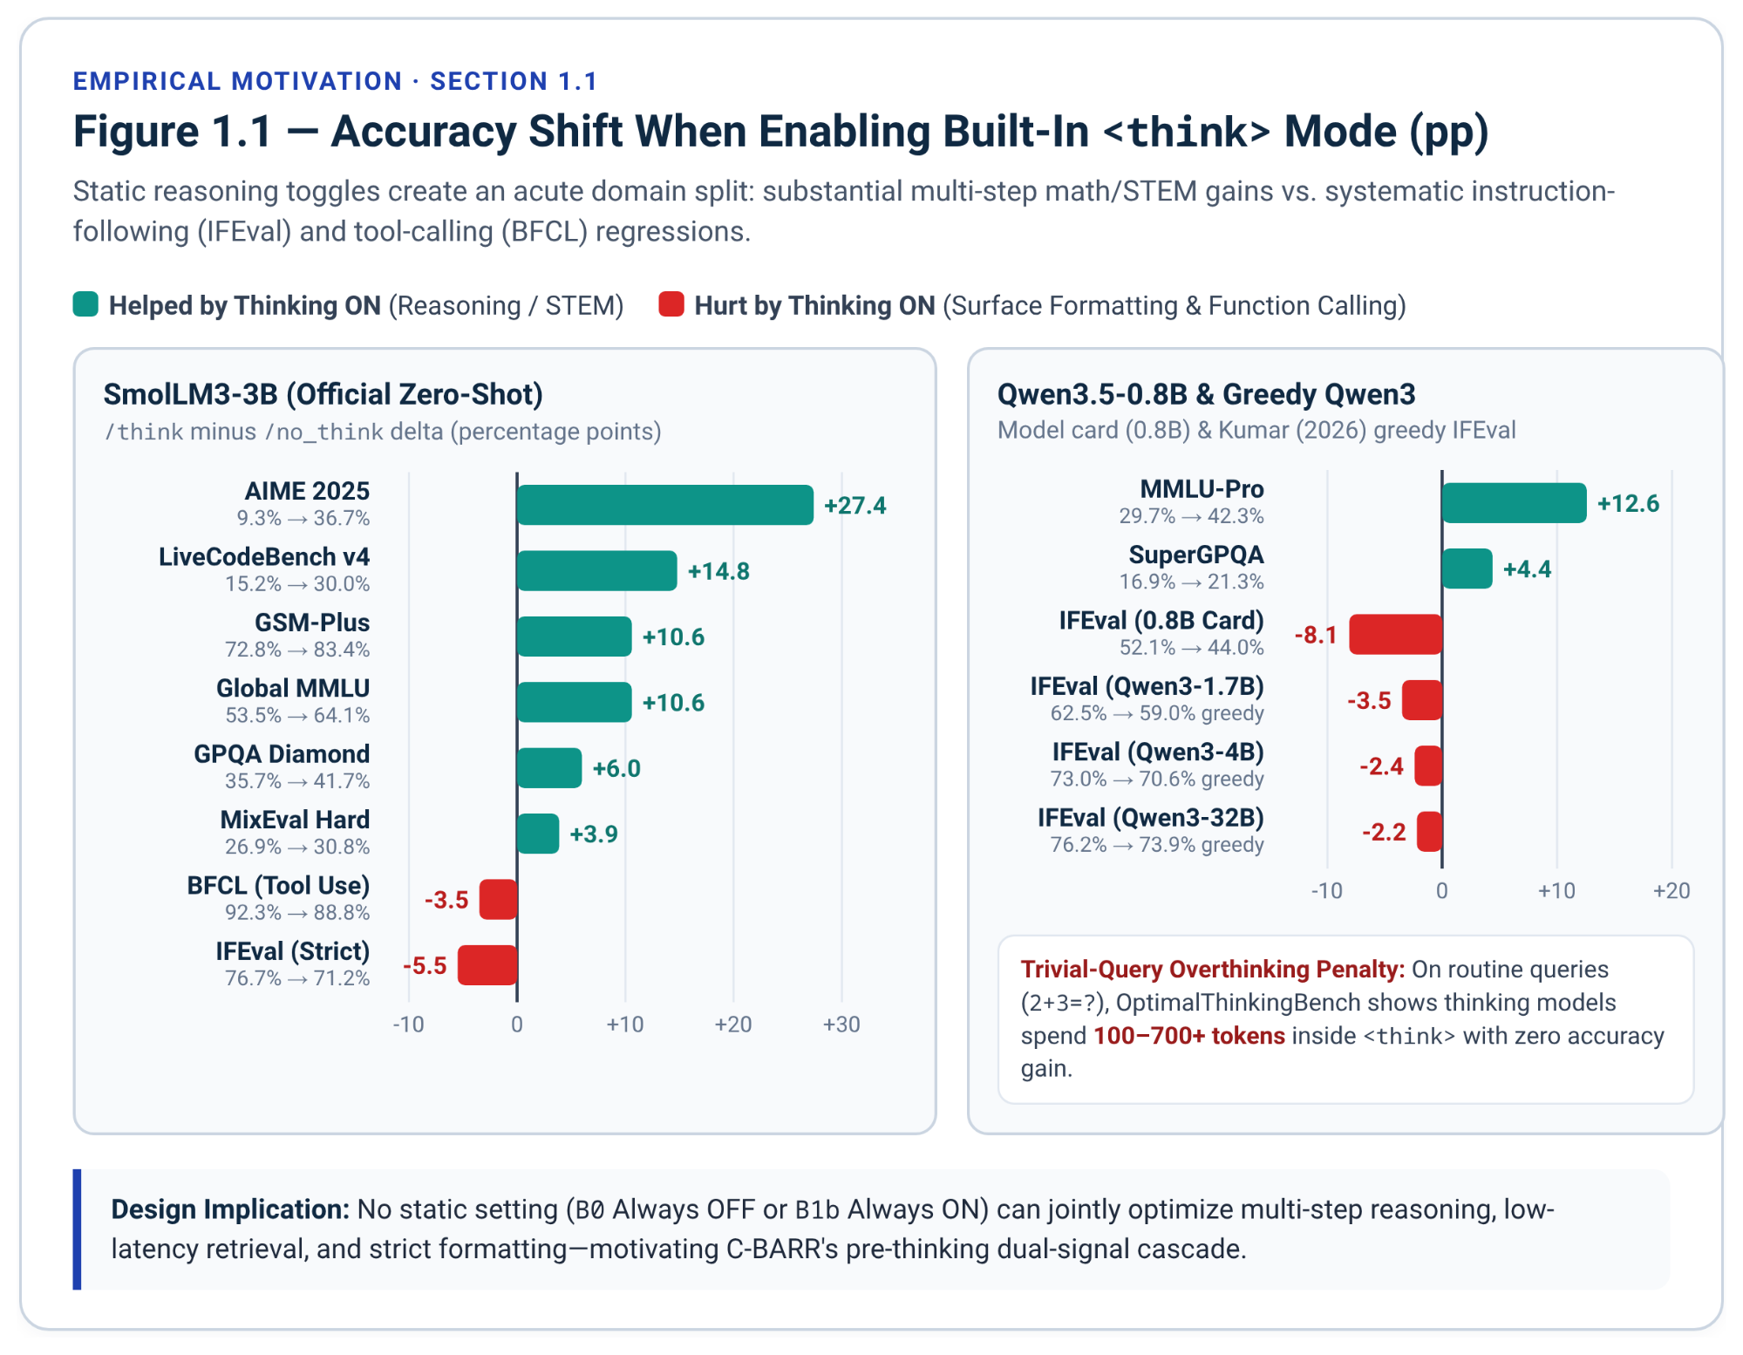

1.2 Positioning Within 2025-2026 Test-Time Compute and Routing Research
Existing efficient-reasoning methods fall into four primary families, none of which jointly resolves multi-step math (GSM8K), low-latency commonsense retrieval (CommonsenseQA), and fragile formatting adherence (IFEval) on a single frozen 0.8B–9B model without external LLM routers or post-training weight updates.
Method / Study | Paradigm | Weight Updates | Pre-Think Gate | Intra-Trace Budget Cap | Constraint Re-Anchor | Key Mechanism and Primary Limitation
s1 Budget Forcing (Muennighoff et al., EMNLP 2025)⁵ | Decoding intervention | None | No | Yes (delimiter splice) | No | Appends end-of-thinking delimiter at max budget or "Wait" to extrapolate (50.0% to 56.7% on AIME24); always enters <think> and risks repetitive loops³⁵.
NoThinking (Ma et al., 2025)²³ | Prefill bypass | None | Static bypass | Yes (P_TERM splice) | No | Prefills dummy <think> closure (7x–9x lower latency at low budgets)²³; sacrifices single-sample accuracy when multi-step reasoning is required²³.
TALE-EP / TALE-PT (Han et al., ACL 2025 Findings)³⁸ | Prompt budget / SFT-DPO | Optional (PT) | Extra LLM call (EP) | Soft prompt request | No | Zero-shot budget estimation cuts vanilla CoT tokens by ~67%³⁹, but requires an extra query (2.0 calls) and prompt caps fail to bind R1/QwQ-style LRMs⁴⁰.
L1 (LCPO)⁴², Thinkless⁴⁴, AdaptThink⁴⁶, SelfBudgeter⁴⁸, TRAAC⁴⁹, CCC⁵⁰ | Post-training RL / SFT | Required (RL/SFT) | Learned policy (Thinkless, AdaptThink) | Learned reward penalty | No | Achieves 28%–90% length reductions on math⁵², but requires per-model RL/GRPO pipelines and risks degrading general instruction adherence⁵⁴.
ThinkSwitcher (Liang et al., EMNLP 2025 Findings)⁵⁶ | Supervised embedding router | Router MLP trained | Yes (query embedding) | Soft prompt hint | No | Trains a switcher on multi-sample empirical pass rates (20%–30% compute savings on math)⁵⁷; requires labeled pass-rate corpora and lacks hard caps or IFEval protection.
DEER (Yang et al., ICLR 2026)⁹ & EntroCut (Yan et al., ICASSP 2026)⁸ | Intra-trace early exit | None | No | Dynamic confidence / entropy exit | No | Probes trial answers at "Wait" / "\n\n" transitions inside <think>, cutting 18.9% -- 47.6% of math tokens⁸; still pays hundreds of <think> tokens and never bypasses <think> upfront⁶⁰.
Classifier-Selective Reasoning (Li et al., 2025)⁶ | External 7B LLM router | Fine-tuned 7B classifier | Yes (external LLM) | No | No | Exposes CoT-induced IFEval/ComplexBench drops and trains a Qwen2.5-7B-Instruct classifier on 50% of benchmark data⁶; violates single-small-model memory and zero-leakage rules.
ThinkJev (Ding et al., Oct 2026 preprint)⁶² | Fast/slow calibrated routing | Frozen backbone | Yes (calibrated fast pass) | Budgeted slow pass | No | Routes Qwen3.5-4B/9B/27B between fast direct decisions and slow thinking under target error caps⁴, but requires closed-set typed option spaces rather than open generation.
DART (Lee et al., EMNLP 2026 Findings)⁹⁸ | Draft-agreement routing | None | Yes (2 sampled no-think drafts) | Budget set from draft entropy | No | Accepts the direct answer when two sampled no-think drafts agree under a task-specific equivalence check and otherwise maps draft entropy to a thinking budget (32%–73% fewer thinking tokens on math and code); needs stochastic drafts and an answer-equivalence function, which open-ended IFEval responses lack.
Save Thinking? (Zhu et al., EMNLP 2026 Findings)⁹⁹ | Mechanistic analysis + attention intervention | None | Static save-thinking prompt | No (suppresses thinking) | No | Explains when a save-thinking prompt is obeyed (No-thinking) or overridden (Still-thinking) on math benchmarks and forces No-thinking by intervening on attention; the intervention lowers accuracy, and there is no adaptive escalation, budget cap or constraint handling.
PAC Reasoning (Zeng et al., NeurIPS 2026)¹⁰⁰ & B-PAC (Yu et al., ICML 2026)¹⁰¹ | Calibrated routing with PAC guarantees | None (calibration set) | Yes (uncertainty score vs. threshold) | No | No | Sends a query to the non-thinking model when an uncertainty score clears a threshold that keeps the loss relative to the thinking model below a user-set tolerance (B-PAC: online and anytime-valid, up to 81% less thinking-model use); the thinking model is the reference, so IFEval-Precision prompts where thinking itself hurts fall outside the guarantee, and thinking length is uncapped.
Prompt Repetition (Leviathan et al., Dec 2025 preprint)¹⁰² | Prompt transformation | None | No | No | Input-side only (prompt repeated in the user turn) | Repeating the prompt in the user turn wins 47 of 70 benchmark-model tests with 0 losses when reasoning is off, but is near-neutral with reasoning on (5 wins, 1 loss, 22 ties); not evaluated on IFEval, and the repeated prompt still precedes the whole reasoning trace instead of sitting next to the answer.
Spotlight Your Instructions (Venkateswaran & Contractor, EACL 2026)¹⁰³ | Inference-time attention steering | None | No | No | Attention-level (boosts instruction tokens) | Adds a bias to pre-softmax attention logits across heads and layers until instruction tokens reach a target share of attention; evaluated on IFEval with Qwen2.5, Llama 3.1, Mistral and Granite models, but defined for softmax attention only, so it does not carry over directly to Qwen3.5's Gated DeltaNet layers (our inference; untested), and it does not control thinking length.
C-BARR (Dual-Signal Cascade)¹ | Cascaded regex + fast-entropy routing + post-think re-anchor | None (120-item scalar calibration) | Yes (Gate 1 <0.1 ms + Gate 2 <=32 tok) | Yes (tight cap B in {64, 128, 256} + P_TERM) | Yes (Post-</think> stripped + Pre-</think> splice) | Combines Gate-1 regex constraint routing + 1-line post-</think> constraint re-anchoring with Gate-2 fast-pass entropy/inertia probing + 64/128/256 early prefix termination on frozen 0.8B–9B models¹.
Training-free intra-trace truncation methods such as DEER⁶⁴ and EntroCut⁶⁵ are closest in spirit to C-BARR's uncertainty probing, yet intervene only after the model has already entered <think>. At reflective transition tokens ("Wait", "Alternatively", or "\n\n"), these methods append a trial-answer delimiter (</think>\n\nSo the final answer is) and halt reasoning when geometric-mean answer token confidence reaches 0.95 (DEER)⁶⁴ or mean probe-token entropy drops to 0.15–0.225 (EntroCut)⁸. While effective on long-horizon competition math—where EntroCut trims DeepSeek-R1-Distill-Qwen-1.5B from 15,591 to 8,295 tokens on AIME24 (29.2% vs. 28.8% accuracy) and 4,984 to 3,341 tokens on MATH500 (83.1% vs. 81.6%), and trims DS-7B from 4,097 to 3,046 tokens on MATH500 (92.1% vs. 91.1%) and 6,434 to 5,216 tokens on AMC23 (90.3% vs. 89.2%)⁶⁵—their residual token floor remains substantial. Even on simpler benchmarks, DEER-Ent on DS-7B compresses GSM8K from 1,484 to 876 tokens (89.6% to 90.8% accuracy), MATH from 3,858 to 2,261 tokens (87.4% to 89.2%), and GPQA from 10,247 to 5,037 tokens (23.7% to 29.6%)⁶⁴. Spending 876 tokens on GSM8K still exceeds a 250-token efficiency budget (OAA_250) by more than 3.5x. Moreover, a November 2026 empirical audit of early-stopping algorithms (Nguyen et al., arXiv:2611.00166) finds that intra-trace readiness is non-monotonic and performs poorly on hallucination and non-mathematical tasks⁶⁰. By probing uncertainty in non-thinking mode first (≤32 tokens) behind a <0.1 ms lexical gate, C-BARR answers routine arithmetic, commonsense (CSQA), and pure formatting (IFEval-Precision) prompts without opening <think> at all.
Five 2025–2026 neighbors each cover part of this design, but none combines open-ended constraint handling, a hard thinking cap under greedy decoding, and applicability to Qwen3.5's non-softmax Gated DeltaNet layers. DART⁹⁸ routes on the agreement of two sampled no-think drafts, which requires stochastic decoding and an answer-equivalence check that open-ended IFEval responses do not admit. Zhu et al.⁹⁹ show that forcing No-thinking through an attention intervention lowers accuracy; C-BARR instead escalates uncertain prompts to a capped <think> block rather than suppressing thinking outright. PAC Reasoning¹⁰⁰ and B-PAC¹⁰¹ bound the performance loss relative to the thinking model, a guarantee that does not cover IFEval-Precision prompts where thinking itself is the failure source, and neither caps thinking length. Prompt Repetition¹⁰² repeats the prompt in the user turn and is near-neutral once reasoning is enabled (5 wins, 1 loss, 22 ties); it was not evaluated on IFEval, whereas C-BARR restates the extracted rule after </think>, at zero token distance from the answer. Spotlight Your Instructions¹⁰³ raises attention on instruction tokens by biasing pre-softmax attention logits, an operation with no direct counterpart in the Gated DeltaNet layers that make up 75% of Qwen3.5's token mixers (our inference; not tested in that paper). The term Thinking Inertia itself comes from Lei et al.⁹⁷, who measure reasoning that persists under no-thinking controls as an offline evaluation target (ETR, QRel., EIR); C-BARR reads the same behavior online, as a 32-token escalation feature inside Gate 2.
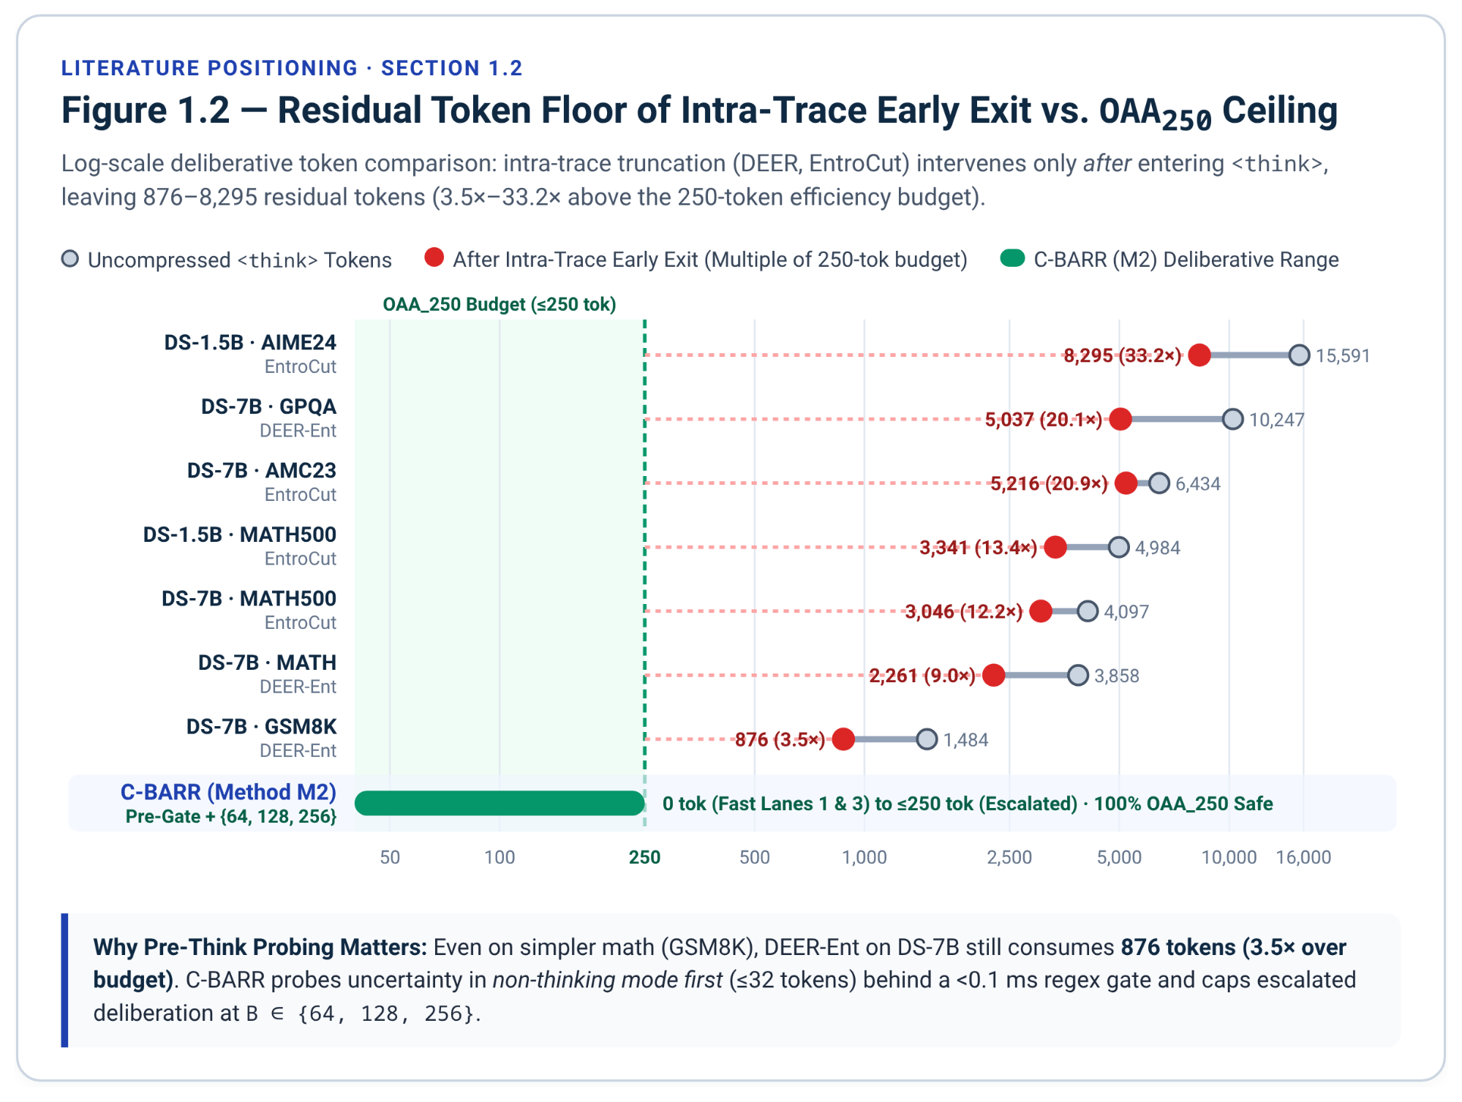

1.3 Complementary Synergy of Lexical Constraint Routing and Fast Entropy/Inertia Probing
Executed separately, lexical constraint-aware routing with rule reminders (Gate 1) and fast-pass token entropy + Thinking Inertia probing with tight prefix termination (Gate 2) each resolve only half of the dual-mode reasoning failure surface¹. Lexical constraint routing protects IFEval-Precision prompts from <think> formatting drift and routes explicit IFEval-Planning prompts to deliberation¹, yet cannot tell apart an easy 2-step GSM8K word problem or trivial CommonsenseQA item (which should exit fast) from a genuinely ambiguous multi-step problem that lacks explicit formatting keywords¹. Conversely, fast-pass entropy and inertia probing separates confident fast-pass answers from high-entropy or high-inertia queries and caps <think> length at $B∈\{64,128,256\}$ tokens using \nOkay, I think I have finished thinking.\n</think>\n¹, yet remains blind to negative formatting constraints—allowing a model that confidently begins generating a 300-word essay without planning to fail global word-count targets, or allowing an escalated multi-constraint prompt to suffer attention decay across <think>⁶.
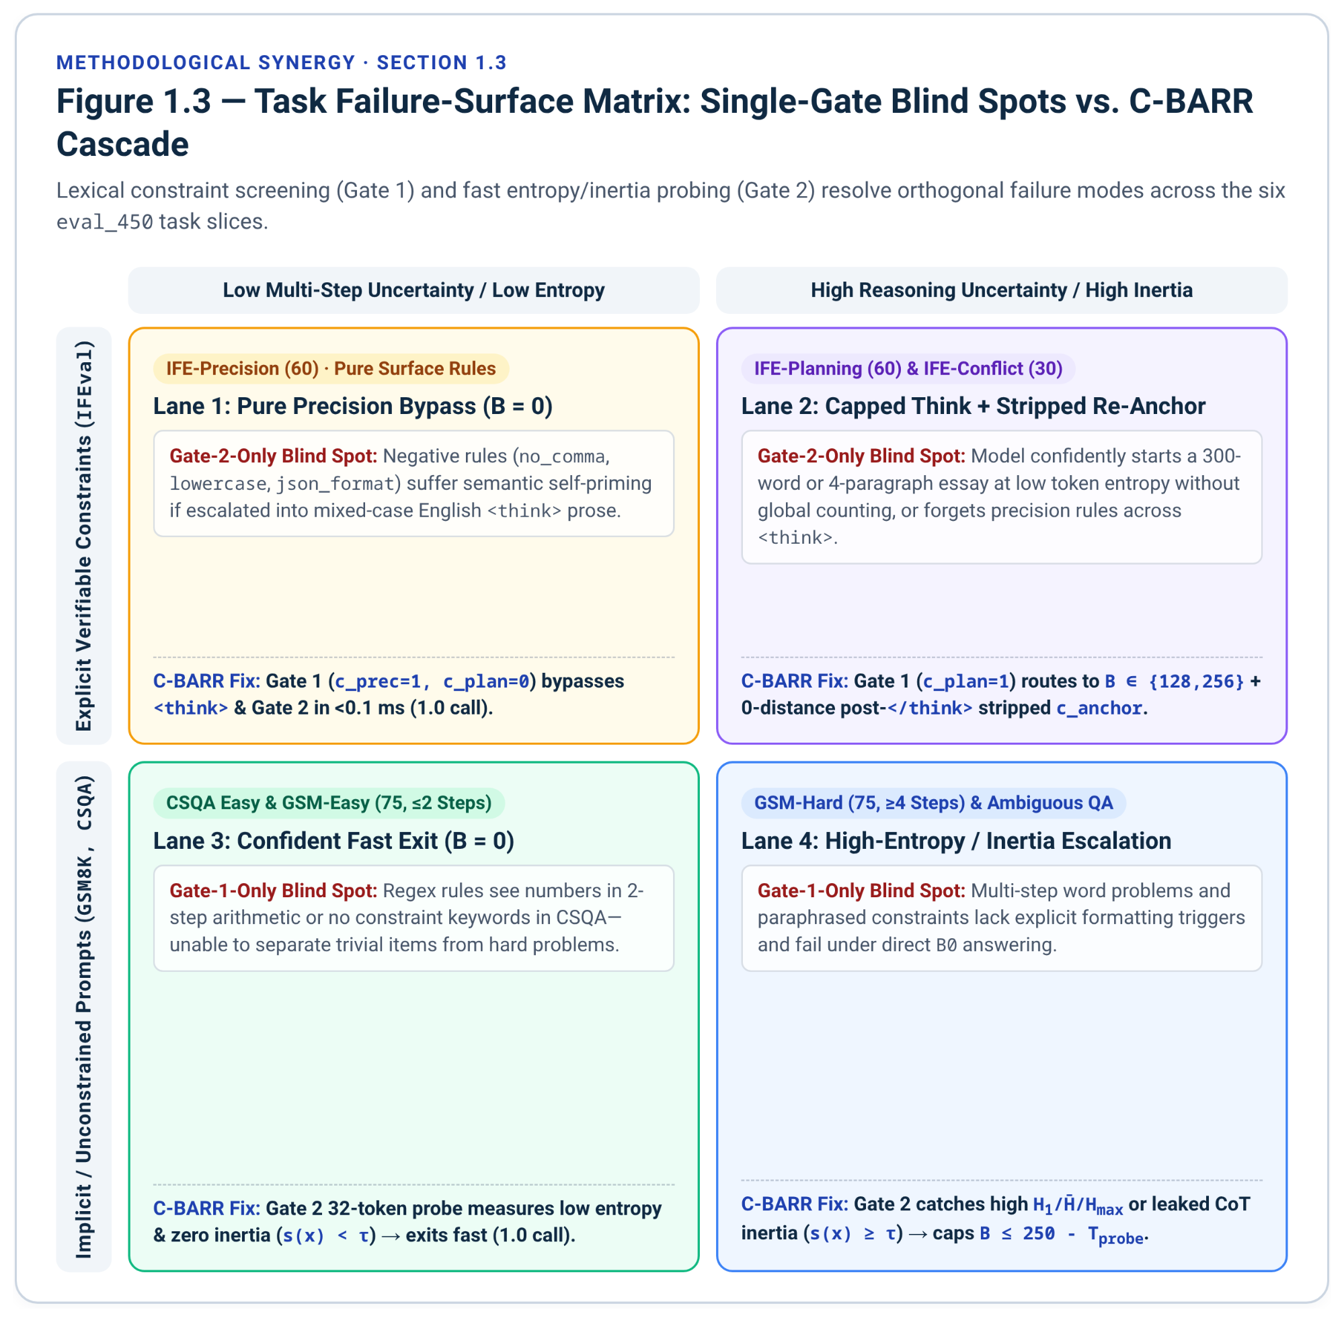
Combining both mechanisms on the frozen N = 450 evaluation suite (150 GSM8K split into 75 Easy + 75 Hard, 150 CommonsenseQA, and 150 IFEval split into 60 Planning + 60 Precision + 30 Planning+Precision Conflict) yields an orthogonal four-part experimental architecture¹:
Experimental Pillar | Source Mechanism | Concrete Specification on Frozen eval_450 (150 GSM8K + 150 CSQA + 150 IFEval) | Scientific Question Answered
Pillar 1. Baselines (B0-B2) | Static & Self-Selective Controls¹ | B0 (Always Non-Thinking, B=0), B1a (Prompted Step-by-Step CoT), B1b (Built-In Always Thinking, B=2048), B2a (Self-Selective Prompting)⁶, and B2b (Budget-Matched Random Escalation at rate p). | Do prompt-only self-selection (B2a) or random compute matching (B2b) match structured dual-signal routing?
Pillar 2. Method M1 (Dual-Signal Router) | Lexical Gate 1 (M1a) + Entropy/Inertia Gate 2 (M1b) -> Cascade (M1c)¹ | M1a routes purely via <0.1 ms numeral-masked regex (Math vs. Planning vs. Precision); M1b routes purely via 32-token non-thinking entropy + Thinking Inertia; M1c cascades Gate 1 into Gate 2. | How much gain comes from zero-cost task-structure lexical rules (M1a) vs. model-internal uncertainty/inertia probing (M1b), and is their cascade super-additive?
Pillar 3. Method M2 (Budgeted Termination + Post-Think Re-Anchor) | Tight Cap (B in {64, 128, 256} + P_TERM) + Post-</think> Reminder¹ | Caps <think> at B in {64, 128, 256} (both fixed-budget sweep and adaptive tiering), terminates via \nOkay, I think I have finished thinking.\n</think>\n, and prefills a channel-stripped 1-line constraint reminder right after </think> (ablated against pre-</think>). | Can sub-256-token capped thinking preserve GSM8K-Hard and IFEval-Planning gains while keeping total deliberative tokens inside OAA_250 (<=250 tokens) and curing IFEval constraint drift³⁰?
Pillar 4. Causal Diagnostic Control | Trace Stripping vs. Post-Think Re-Anchoring on E_hurt¹ | On held-out IFEval prompts where Pass(B0)=1 and Pass(B1b)=0, compares deleting <think> (A1) vs. keeping <think> intact and appending a 1-line rule reminder after </think> (B2a), alongside Pre-Think (B1) and Math-Swap (A2). | Do built-in thinking IFEval failures arise from context-length recency/state decay or semantic self-priming interference across Gated DeltaNet (Qwen3.5-4B) vs. Dense GQA (SmolLM3-3B)⁶?

2. Model Backbone Specifications and Mechanistic State-Decay Hypothesis

2.1 Architectural Contrast: Hybrid Gated DeltaNet vs. Dense NoPE/RoPE Attention
C-BARR pairs its routing and budget-control evaluation with a mechanistic architectural comparison between hybrid linear-attention state-space models (Qwen3.5 0.8B–9B) and dense full-softmax Transformers (SmolLM3-3B)¹. Auditing the upstream Hugging Face repository files (config.json, tokenizer_config.json, generation_config.json, and chat_template.jinja) establishes the exact structural and template differences across all five checkpoints⁴.
Specification | Qwen/Qwen3.5-0.8B | Qwen/Qwen3.5-2B | Qwen/Qwen3.5-4B (Primary) | Qwen/Qwen3.5-9B | HuggingFaceTB/SmolLM3-3B (Control)
HF Causal Class | Qwen3_5ForCausalLM⁶⁴ | Qwen3_5ForCausalLM⁷⁰ | Qwen3_5ForCausalLM⁷¹ | Qwen3_5ForCausalLM⁷³ | SmolLM3ForCausalLM¹⁴
Upstream Modality | VLM (ViT + MTP dropped in CausalLM)⁶⁴ | VLM (ViT + MTP dropped in CausalLM)¹² | VLM (ViT + MTP dropped in CausalLM)¹⁰ | VLM (ViT + MTP dropped in CausalLM)¹¹ | Text-only Decoder Transformer¹⁰
Total Layers | 24 | 24¹² | 32¹⁰ | 32¹¹ | 36
Token Mixer Layout | 6 x (3 DeltaNet + 1 Gated Attn) (18 linear, 6 full)⁴ | 6 x (3 DeltaNet + 1 Gated Attn) (18 linear, 6 full) | 8 x (3 DeltaNet + 1 Gated Attn) (24 linear, 8 full)¹⁰ | 8 x (3 DeltaNet + 1 Gated Attn) (24 linear, 8 full) | 36 Full Softmax GQA (3 RoPE : 1 NoPE)¹⁰
Hidden / FFN Dim | 1024 / 3584 | 2048 / 6144 | 2560 / 9216 | 4096 / 12288 | 2048 / 11008
Linear Heads (V / QK, Dim) | 16 V / 16 QK (dim=128) | 16 V / 16 QK (dim=128) | 32 V / 16 QK (dim=128)¹⁰ | 32 V / 16 QK (dim=128) | N/A (Full Softmax GQA)
Full-Attn Heads (Q / KV, Dim) | 8 Q / 2 KV (dim=256, RoPE=64) | 8 Q / 2 KV (dim=256, RoPE=64) | 16 Q / 4 KV (dim=256, RoPE=64) | 16 Q / 4 KV (dim=256, RoPE=64) | 16 Q / 4 KV (dim=128, no_rope_interval=4)
Vocab Size & EOS IDs | 248,320 (<|im_end|>, <|endoftext|>)⁴ | 248,320 (<|im_end|>, <|endoftext|>) | 248,320 (<|im_end|>, <|endoftext|>)⁷⁶ | 248,320 (<|im_end|>, <|endoftext|>) | 128,256 (<|end_of_text|>, <|im_end|>)¹⁴
Native Context Window | 262,144 | 262,144 | 262,144 (extensible to 1.01M) | 262,144 (extensible to 1.01M) | 65,536 (YaRN 131,072–262,144)¹³
Mode Control & Default | enable_thinking flag (default non-thinking per card; no /think soft switch) | enable_thinking flag (no /think soft switch) | enable_thinking flag (default True in Jinja template)¹⁰ | enable_thinking flag (default True)¹¹ | enable_thinking flag or /think, /no_think system tag (default True)¹³
In Qwen3.5, three out of every four layers (18/24 in 0.8B/2B and 24/32 in 4B/9B) replace quadratic softmax attention with Gated DeltaNet (Yang et al., ICLR 2025, arXiv:2412.06464)⁴. Rather than growing a per-token KV cache, each Gated DeltaNet head compresses history into a fixed-size fast-weight matrix $S_{t}∈R^{d_{v}×d_{k}}$ (128 × 128) updated by an online delta-rule regression step combined with a data-dependent scalar decay gate $α_{t}∈(0,1)$⁶⁸:
$S_{t}=S_{t-1}(α_{t}(I-β_{t}k_{t}k_{t}^{⊤}))+β_{t}v_{t}k_{t}^{⊤}$, $o_{t}=S_{t}q_{t}$

Unrolling this recurrence across a <think> trace of length $T_{think}$ between prompt end $L_{prompt}$ and final-answer start $t=L_{prompt}+T_{think}$ reveals how prompt-encoded associations attenuate over extended reasoning⁶⁸:
$S_{t}=S_{L_{prompt}}\left(\prod_{j=L_{prompt}+1}^{L_{prompt}+T_{think}}{}α_{j}(I-β_{j}k_{j}k_{j}^{⊤})\right)+\sum_{j=L_{prompt}+1}^{L_{prompt}+T_{think}}{}β_{j}v_{j}k_{j}^{⊤}\prod_{r=j+1}^{L_{prompt}+T_{think}}{}α_{r}(I-β_{r}k_{r}k_{r}^{⊤})$

(where $k_{j}k_{j}^{⊤}$ forms the generalized Householder projection at step $j$⁶⁸). As Yang et al. (2025) observe on S-NIAH benchmarks, multiplicative gating $γ_{t,i}=\prod_{j=i+1}^{t}{}α_{j}$ clears irrelevant context to prevent state superposition collisions, but progressively decays historical key-value associations as intervening token distance increases—leaving only the 25% interleaved Gated Attention layers with exact token-level recall⁶⁸. Conversely, SmolLM3-3B retains an uncompressed KV cache across all 36 Grouped-Query Attention layers (16 query heads, 4 KV heads), interleaving three RoPE layers (rope_theta = 5,000,000) with one position-invariant NoPE layer (no_rope_layer_interval = 4)¹⁰.
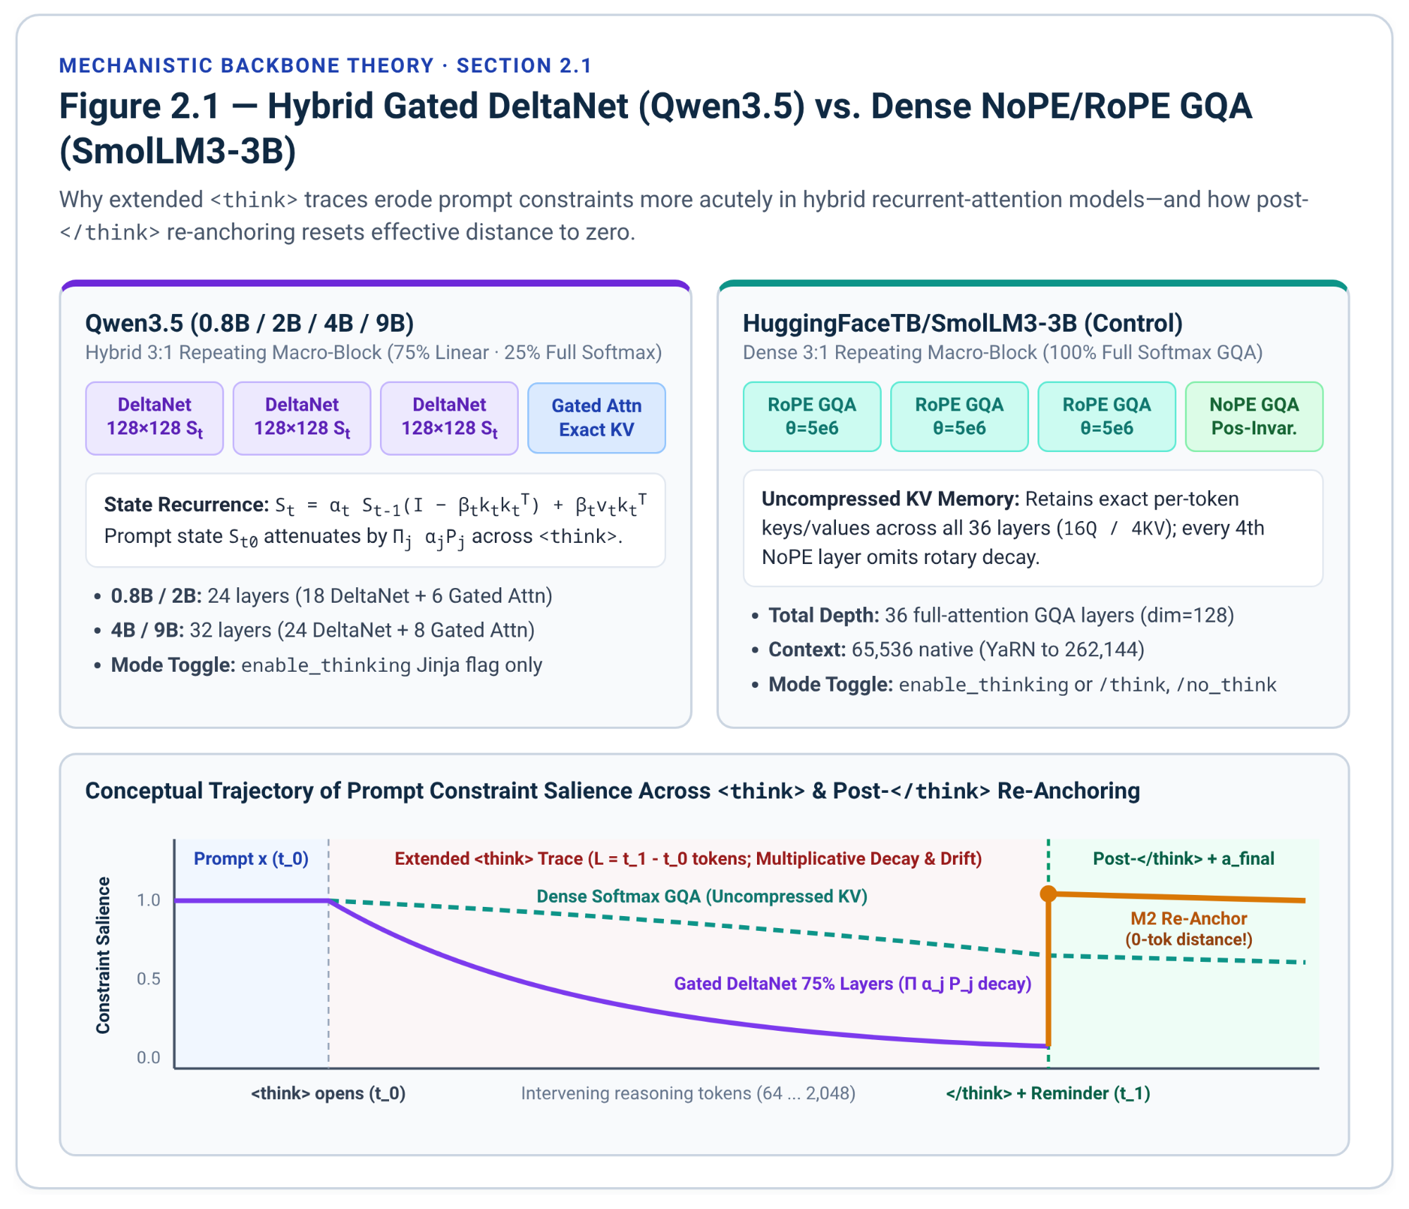

2.2 Constraint-Level Error Shifts and the Causal Decomposition Control
Aggregate benchmark deltas conceal substantial bidirectional instance churn when built-in thinking is toggled. In a controlled greedy-decoding study across Qwen3 (1.7B–32B) and Hunyuan (1.8B–A13B) on google/IFEval (541 prompts, 834 constraint instances across 25 verifiable types, scored after <think> stripping), Kumar (June 2026 preprint, arXiv:2606.09662) reports that 10.2% to 24.4% of prompts flip pass/fail between Thinking OFF and Thinking ON⁷.
Model & Evaluation Regime | Prompt Strict OFF (%) | Prompt Strict ON (%) | Net Delta (pp) | Total Flip (%) | Helped: OFF=0, ON=1 (%) | Hurt: OFF=1, ON=0 (%)
Qwen3-1.7B (Greedy, Kumar 2026)⁷ | 62.48 | 58.96 | -3.52 | 20.1 | 8.3 | 11.8
Qwen3-4B (Greedy, Kumar 2026)⁷⁵ | 73.01 | 70.61 | -2.40 | 13.5 | 5.5 | 7.9
Qwen3-8B (Greedy, Kumar 2026)⁷⁵ | 75.05 | 73.75 | -1.30 | 11.6 | 5.2 | 6.5
Qwen3-14B (Greedy, Kumar 2026)⁷⁵ | 76.52 | 75.97 | -0.55 | 10.2 | 4.8 | 5.4
Qwen3-32B (Greedy, Kumar 2026)⁷⁵ | 76.16 | 73.94 | -2.22 | 11.5 | 4.6 | 6.8
Hunyuan-1.8B (Greedy, Kumar 2026)⁷⁵ | 48.06 | 49.72 | +1.66 | 24.4 | 13.1 | 11.3
Hunyuan-4B (Greedy, Kumar 2026)⁷⁵ | 61.37 | 64.70 | +3.33 | 21.6 | 12.6 | 9.1
Hunyuan-7B (Greedy, Kumar 2026)⁷⁵ | 63.40 | 63.40 | 0.00 | 23.5 | 11.8 | 11.6
Hunyuan-A13B (Greedy, Kumar 2026)⁷⁵ | 70.98 | 72.46 | +1.48 | 18.9 | 10.4 | 8.5
Qwen3.5-0.8B (Model card sampled) | 52.1 | 44.0 | -8.1 | — | — | —
Qwen3.5-2B (Model card sampled) | 61.2 | 78.6 | +17.4 | — | — | —
Qwen3.5-4B / 9B (Model card sampled) | — | 89.8 / 91.5 | — | — | — | —
SmolLM3-3B (Model card zero-shot)¹⁰ | 76.7 | 71.2 | -5.5 | — | — | —
Crucially, even on Hunyuan-7B—where aggregate accuracy appears completely unchanged (63.40% OFF vs. 63.40% ON)—23.5% of all prompts flip outcome (11.8% Helped vs. 11.6% Hurt)⁷⁵. Kumar (2026) categorizes IFEval's 25 instruction types post-hoc into 5 consistently helped Planning types (global counting and structural coordination such as number_words, letter_frequency, and number_highlighted_sections), 9 consistently degraded Precision types (exact local form such as punctuation:no_comma and change_case:english_lowercase), and 11 Neutral types without uniform cross-scale direction (such as json_format)⁷⁵. For operational zero-leakage routing in C-BARR, freeze_datasets.py and engine.py map all 25 verifiable templates into an exhaustive two-class routing partition (10 PLANNING_IDS requiring global counting/structural planning and 15 PRECISION_IDS requiring strict surface-form or boundary compliance), further subdividing PRECISION_IDS into 5 Inhibition rules (global negative constraints where a single comma, forbidden word, capital letter, or wrong-language token fails verification) and 10 Structural rules (wrappers, titles, JSON, postscripts, placeholders, end-phrases, and verbatim repetition)¹.
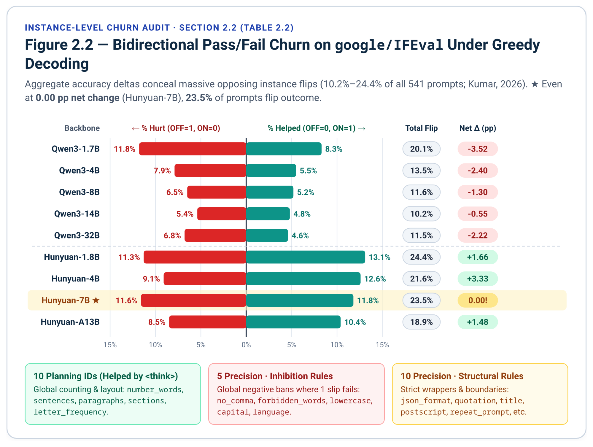
Two distinct causal mechanisms could drive Hurt flips during extended thinking. Under the Context-Length Recency / State-Decay Hypothesis, generating hundreds of <think> tokens attenuates attention to prompt constraint tokens—consistent with Li et al. (2025, arXiv:2505.11423), who measure significant early-to-middle-layer Constraint Attention drops on LOSE instances across 15 models on IFEval (541 prompts) and ComplexBench (1,150 compositional prompts)—an effect amplified by multiplicative Gated DeltaNet decay in Qwen3.5-4B⁸⁴. Under the Semantic Self-Priming Interference Hypothesis, deliberating inside <think> in standard mixed-case, comma-laden English prose primes output logits to continue using commas, capital letters, forbidden task words, or helpful English commentary after </think>—consistent with Kumar (2026)'s activation-patching results showing 32%–58% layer-restoration on Precision flips vs. 14%–40% on Planning flips⁸⁵.
To isolate the underlying failure mechanisms through controlled hypothesis testing, mechanistic error attribution, and ablation rigor¹, Section 6 evaluates held-out IFEval Hurt prompts $E_{hurt}=\{x:Pass(B0,x)=1∧Pass(B1b,x)=0\}$ across Qwen3.5-4B and SmolLM3-3B. The primary head-to-head contrast compares Trace Stripping (Control A1)—deleting the generated <think> tokens before decoding the final answer—against Post-Think Constraint Re-Anchoring (Control B2a)—retaining 100% of the failed <think> trace $t_{think}$ intact and appending a 1-line rule reminder [Reminder: strictly follow: {anchor_clause}]\n immediately after </think> (stripped from the scored buffer so wrapper verifiers are evaluated fairly)¹, supplemented by four auxiliary boundary and filler controls:
Diagnostic Condition | Trace Length | Modification Applied to Cached B1b Trace ($t_{think}$) | Causal Factor Isolated Across Inhibition vs. Structural Subsets
Control A1: Trace Stripping (A1_strip)¹ | 0 tokens | Deletes $t_{think}$ (<think>\n\n</think>\n\n) before decoding $a_{final}$¹. | Removes both context-length recency decay and <think> semantic interference; establishes total recoverable ceiling $R_{strip}$¹⁶.
Control B2a: Post-Think Stripped Re-Anchor (B2a_post_anchor)¹⁶ | $|t_{think}|+T_{inj}$ | Keeps <think> intact; appends [Reminder: strictly follow: {anchor_clause}]\n right after </think> (stripped from $a_{final}$)¹⁶ | Preserves <think> state in KV/DeltaNet; restores post-</think> constraint recency at 0 token distance¹⁶
Control B1: Pre-</think> Clause Re-Anchor (B1_pre_anchor)¹ | $|t_{think}|+T_{inj}$ | Keeps <think> intact; splices Constraint check: strictly follow: {anchor_clause}\n right before </think>¹ | Tests pre-</think> vs. post-</think> tag boundary locus for constraint re-anchoring¹
Control B2b: Post-</think> Unstripped Prefill (B2b_post_raw)¹ | $|t_{think}|+T_{inj}$ | Appends [Reminder: strictly follow: {anchor_clause}]\n after </think> and leaves reminder unstripped in $a_{final}$¹ | Quantifies strict wrapper verifier corruption (JSON, quotes, lowercase, repeat_prompt) when prefill is unstripped¹⁵
Control A2: Length-Matched Math Filler (A2_math_swap)¹ | $|t_{think}|$ tokens | Replaces <think> with length-matched unrelated GSM8K math tokens ($|t_{think}|$) before </think>¹ | Preserves context-length distance while removing task-specific semantic self-priming¹
Control B3: Early Cut Without Re-Anchor (B3_early_cut) | $≈0.5|t_{think}|$ | Truncates <think> at first reflection transition (or 50% length) via P_TERM\n</think>\n without re-anchoring | Halves context-length distance while retaining early <think> self-priming
Denoting strict prompt-level recovery rates on $E_{hurt}$ under Trace Stripping, Post-Think Stripped Re-Anchoring, and Pre-Think Re-Anchoring by $R_{strip}$, $R_{post}$, and $R_{pre}$ respectively, C-BARR decomposes instruction-following degradation into two interpretable shares¹⁶:
$ρ_{recency}=\frac{R_{post}}{\max_{}(ϵ,R_{strip})}$, $ρ_{interference}=\frac{\max_{}(0,R_{strip}-\max_{}(R_{post},R_{pre}))}{\max_{}(ϵ,R_{strip})}$

Because B2a_post_anchor leaves every token of the failed <think> trace untouched in the KV cache / recurrent state $S_{t}$ and only refreshes constraint recency after </think>, $ρ_{recency}$ measures the exact fraction of recoverable Hurt failures cured solely by restoring recency, while $ρ_{interference}$ isolates failures where semantic self-priming from <think> overrides even an adjacent 0-distance rule reminder6.
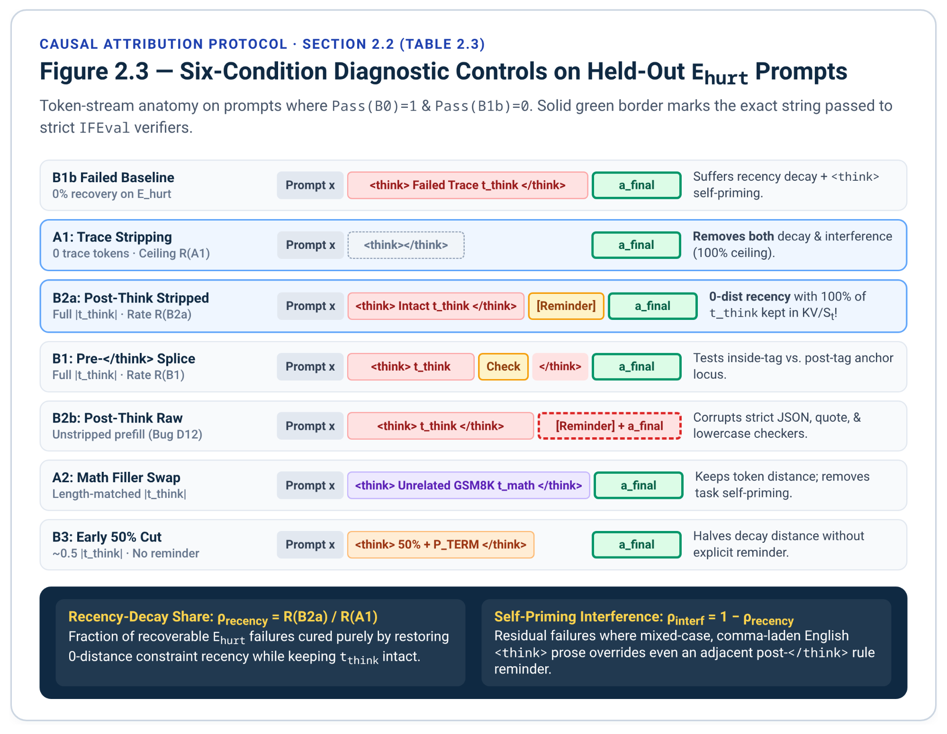

3. Formal C-BARR Methodology and Mathematical Specification
Given an input prompt $x$ and a frozen dual-mode backbone $M_{θ}$, Full C-BARR (M2) routes $x$ through the two-stage dual-signal pre-thinking cascade (Gate 1 zero-cost lexical screening followed by conditional Gate 2 32-token fast entropy + Thinking Inertia probing), enforcing a tight thinking budget $B(x)∈\{64,128,256\}$ via \nOkay, I think I have finished thinking.\n</think>\n and injecting a channel-stripped 1-line constraint reminder right after </think> (with a direct pre_close ablation before </think>) whenever deliberation is invoked¹.
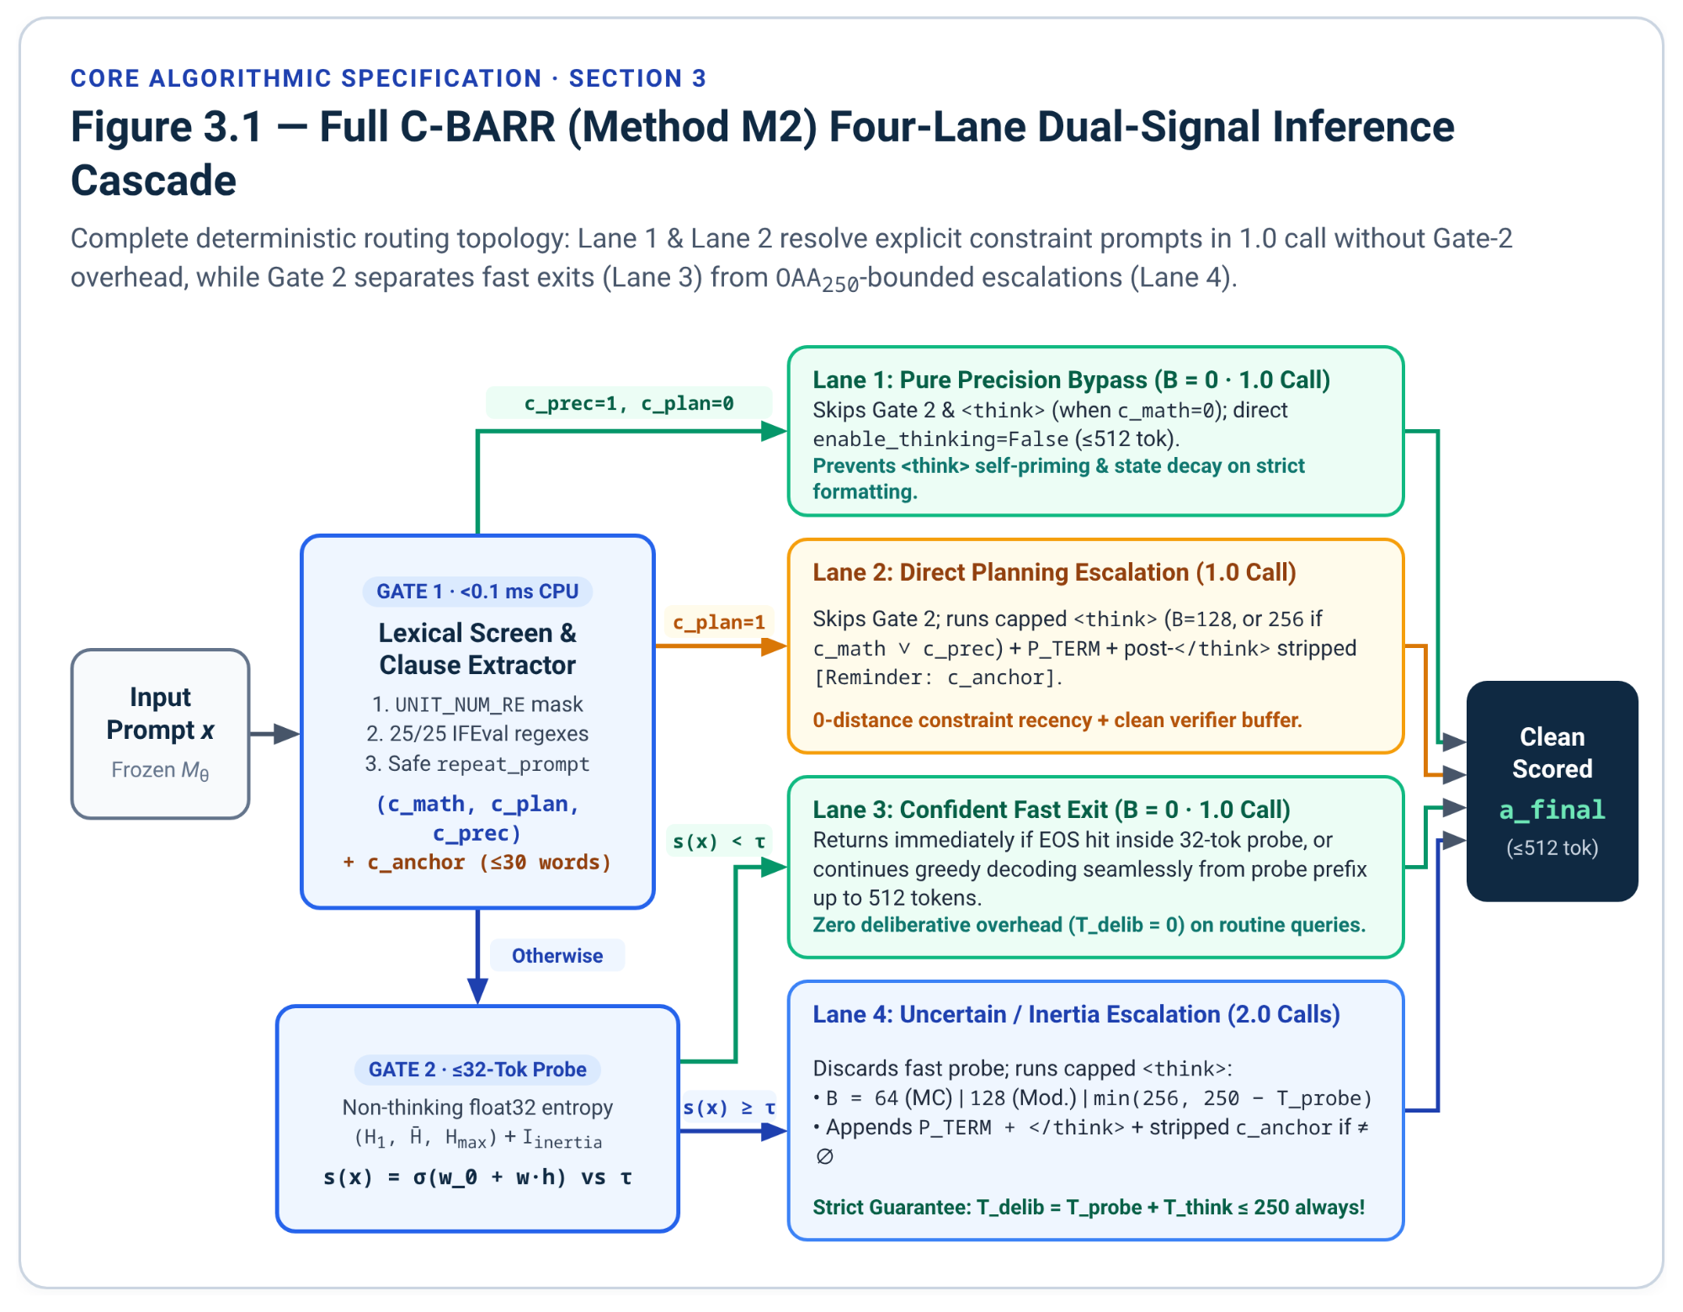

3.1 Gate 1: Numeral-Masked Lexical Screening and Recursive-Safe Clause Extraction
Gate 1 executes on CPU in under 0.1 ms prior to any model forward pass, mapping $x$ to binary structural indicators $(ϕ_{sym},ϕ_{plan},ϕ_{prec})∈\{0,1\}^{3}$ and an extracted constraint summary $c_{anchor}(x)$ truncated to at most 30 words¹. Because instruction-following prompts routinely contain numeric count specifiers ("at least 300 words", "4 paragraphs", "1990s"), Gate 1 first masks unit-count expressions (UNIT_NUM_RE) with [UNIT_COUNT] before counting standalone numerals and checking arithmetic cues (MATH_CUE_RE) to set $ϕ_{sym}$¹. Next, PLANNING_RE and PRECISION_RE scan $x$ for verifiable constraint patterns. Whereas the original draft's regexes missed 11 of IFEval's 25 canonical templates and cross-matched postscript and repeat_prompt into PLANNING_RE¹, the upgraded patterns in Section 6.4 achieve 25/25 target-class recall across all canonical Zhou et al. (2023) templates¹⁹ (with change_case:capital_word_frequency intentionally activating both $ϕ_{prec}$ and $ϕ_{plan}$ because it couples uppercase lexical control with a global count threshold¹⁹; heavily paraphrased constraints in open-domain prompts that evade lexical rules fall through to Gate 2⁸⁴). Finally, to prevent self-referential corruption on combination:repeat_prompt—whose prompt text ends with "First repeat the request word for word without change... the request you need to repeat does not include this sentence"¹⁵—Gate 1 strips sentences matching REPEAT_PROMPT_RE during clause extraction and substitutes a safe meta-directive: "Repeat the user's complete original request word-for-word without change before answering."¹.

3.2 Gate 2: Fast Non-Thinking Entropy Probing and Thinking Inertia Detection
Prompts not resolved immediately by Gate 1 enter Gate 2, which renders the exact non-thinking chat template (enable_thinking=False, producing <think>\n\n</think>\n\n in Qwen3.5 and SmolLM3-3B²⁶) and appends a task-appropriate prefix: "Answer: " when multiple-choice options (A) and (B) are present, "#### " strictly when pure symbolic math is detected ($ϕ_{sym}=1,ϕ_{prec}=0,ϕ_{plan}=0$), and "" otherwise—eliminating the original draft's "#### " prefix injection on non-math prompts¹. The engine decodes up to 32 greedy tokens while computing exact float32 Shannon entropies over content tokens $j∈\{1,…,m_{content}\}$ (stripping trailing EOS markers <|im_end|>, <|endoftext|>, and <|end_of_text|> so deterministic turn-end tokens do not bias mean entropy downward)¹:
$H_{j}=-\sum_{v=1}^{|V|}{}p_{j}(v)logp_{j}(v)$, $p_{j}=softmax(z_{j}^{(fp32)})$

From this short probe, Gate 2 extracts initial commitment entropy $H_{first}=H_{1}$, trajectory mean and peak entropies $H_{mean}$ and $H_{max}$, and a binary Thinking Inertia flag $I_{inertia}∈\{0,1\}$ that fires when a structured math or multiple-choice probe exceeds 16 content tokens without hitting EOS or spontaneously leaks CoT discourse markers ("step", "because", "first", "let's", "therefore", "wait", "since") despite enable_thinking=False¹. The term follows Lei et al. (NeurIPS 2026)⁹⁷, who introduce Thinking Inertia for explicit reasoning that persists when thinking is disabled and measure it offline (ETR, QRel., EIR); C-BARR instead uses it online, as a runtime escalation feature. Gate 2 then evaluates a calibrated logistic escalation score:
$p_{esc}(x)=σ(w_{0}+w_{1}H_{first}+w_{2}H_{mean}+w_{3}H_{max}+w_{4}I_{inertia}+w_{5}ϕ_{sym})$

where weights $(w_{0},…,w_{5})$ are fitted via balanced L2-regularized logistic regression on seed_60 (N = 60) and the operating threshold $τ^{*}$ is selected on dev_60 (N = 60) to maximize cost-penalized utility $U_{0.05}$16. When $p_{esc}(x)<τ^{*}$, any probe that already emitted an EOS token returns immediately in 1.0 call; otherwise, complete_fast_probe continues greedy decoding from the exact 32-token prefix up to 512 total tokens so open-ended responses are never truncated at 32 tokens.

3.3 Method M2: Tight Budgeted Prefix Termination and Post-Think Re-Anchoring
All routing branches, LLM call counts, tight thinking token caps $B(x)∈\{64,128,256\}$, and post-</think> re-anchoring interventions in Full C-BARR (M2) follow a deterministic four-lane schedule calibrated solely on seed_60 and dev_601:
Routing Lane & Trigger Condition | Gate-2 Probe Executed | Tight Thinking Cap $B(x)$ | Calls | Prefix Termination & Constraint Re-Anchoring Intervention
Lane 1: Pure Precision Bypass ($ϕ_{prec}=1$, $ϕ_{plan}=0$, $ϕ_{sym}=0$) | No | 0 (Non-Thinking) | 1.0 | Direct enable_thinking=False generation (<=512 tokens); avoids <think> self-priming and state decay1.
Lane 2: Direct Planning Escalation ($ϕ_{plan}=1$) | No | 128 (256 if $ϕ_{prec}=1$ or $ϕ_{sym}=1$) | 1.0 | Capped <think> + \nOkay, I think I have finished thinking.\n</think>\n (if cap hit) + 1-line post-</think> stripped reminder [Reminder: strictly follow: c_anchor]\n16.
Lane 3: Confident Fast Exit (Gate 2 $p_{esc}(x)<τ^{*}$) | Yes (<=32 tok) | 0 (Non-Thinking) | 1.0 | Returns Gate-2 probe immediately if EOS hits, or continues prefix seamlessly up to 512 tokens.
Lane 4: Uncertain / High-Inertia Escalation (Gate 2 $p_{esc}(x)≥τ^{*}$) | Yes (<=32 tok) | 64 (MC) / 128 (Mod.) / 256 ($H_{max}≥τ_{H,high}$ or $I_{inertia}=1$) | 2.0 | Discards fast probe; runs capped <think> (deducting T_probe at B=256 so T_probe + T_think <= 250) + P_TERM\n</think>\n if truncated + post-</think> reminder if $c_{anchor}≠∅$16.
Capping <think> at $B∈\{64,128,256\}$ confers a decisive mathematical advantage on Overthinking-Adjusted Accuracy ($OAA_{250}$): B = 64 (at most 96 deliberative tokens even after a 32-token probe) and B = 128 (at most 160 deliberative tokens) stay strictly below the 250-token overthinking ceiling, and deducting T_probe at B = 256 (B_eff = min(256, 250 - T_probe)) guarantees $T_{delib}=T_{probe}+T_{think}≤250$ across 100% of M2 runs16! Furthermore, in addition to adaptive tiered M2, scripts/run_matrix.py evaluates fixed-budget M2-64, M2-128, and M2-256 sweeps directly from cached runs to trace the exact compute-accuracy Pareto frontier across $B∈\{64,128,256\}$16.
When an escalated run reaches $B(x)$ without emitting </think>, M2 appends the exact early-termination string \nOkay, I think I have finished thinking.\n</think>\n1. Whenever $c_{anchor}(x)$ is non-empty, M2 (anchor_locus="post_stripped") immediately prefills [Reminder: strictly follow: {anchor_clause}]\n right after </think>\n and decodes up to 512 answer tokens starting after that prefill16. Crucially, during generation of $a_{final}$, the model attends directly to the post-</think> reminder at zero token distance, while excluding the prefill string from the scored response buffer prevents artificial formatting violations on strict wrappers (json_format, quotation, english_lowercase, response_language, repeat_prompt), and every token of the prefill is still billed into $T_{inj}$ and $T_{tot}$15. Setting anchor_locus='pre_close' (M2-Pre) places the identical reminder right before </think>\n for a clean locus ablation1. Conversely, unassisted B1b (B = 2048) performs no budget-forcing intervention: if a model loops until exhausting all 2,048 tokens inside <think>, split_think_and_answer marks think_exhausted = True and extracts a_final = "", penalizing unclosed overthinking in accordance with standard LRM evaluation practice1.
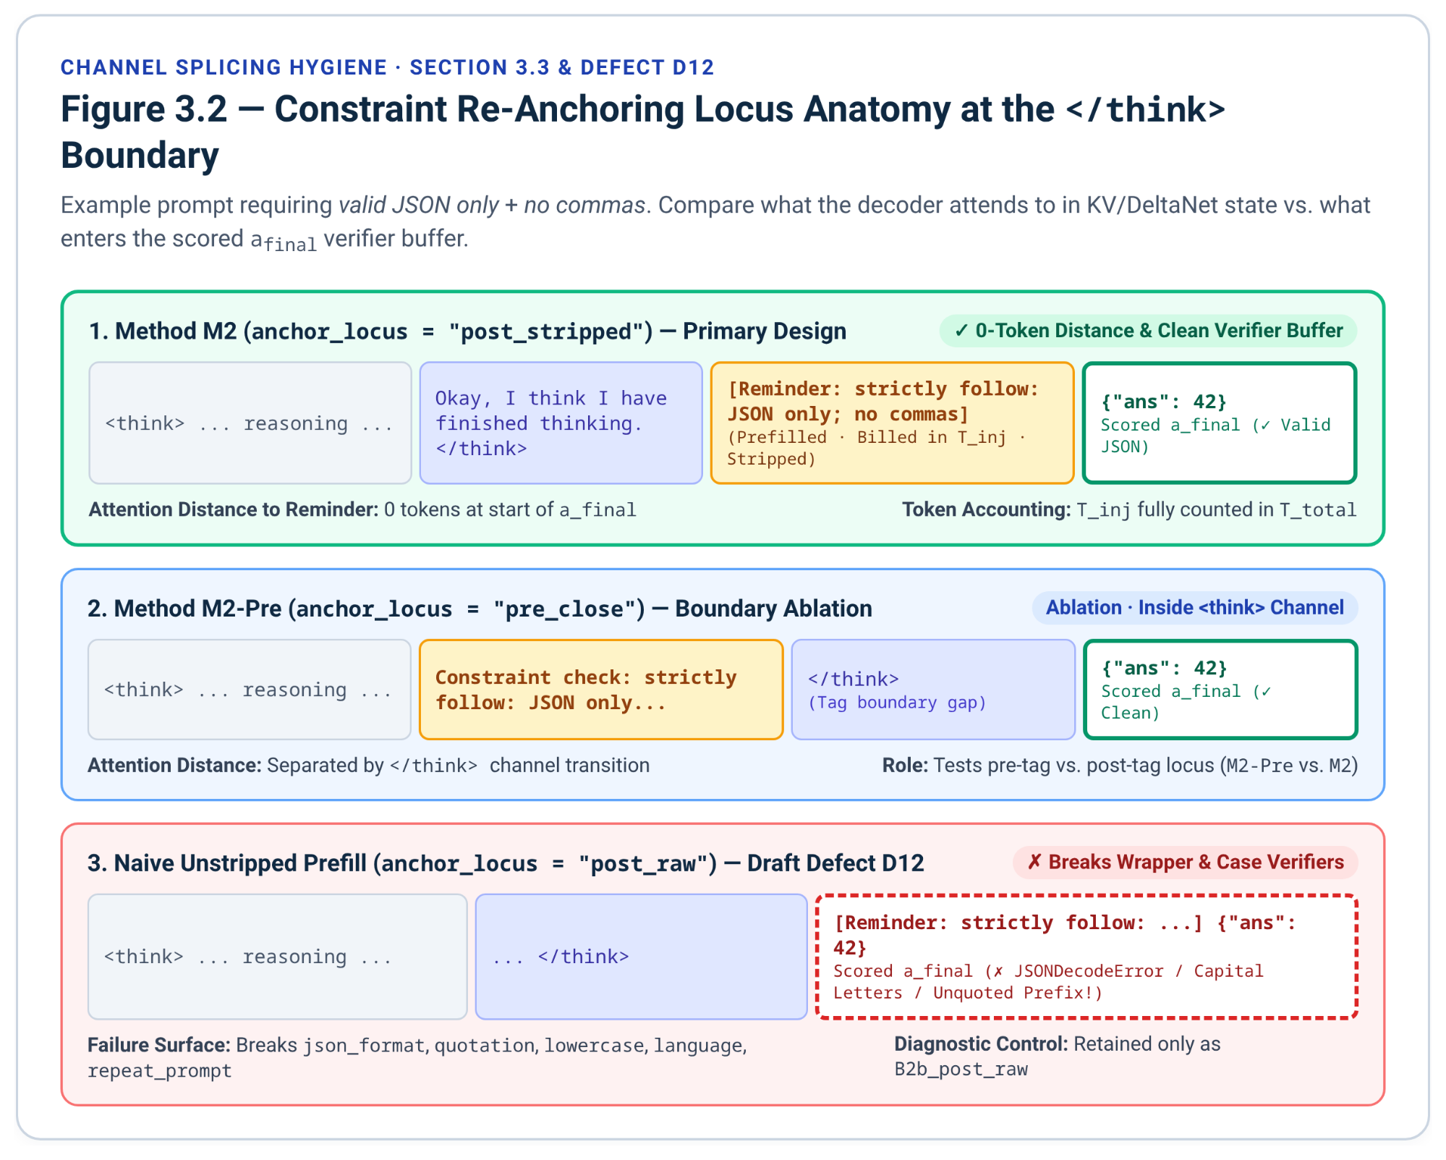

4. Evaluation Protocol, Efficiency-Adjusted Metrics, and Statistical Testing

4.1 Frozen Six-Slice Evaluation Suite (eval_450) and Decoding Regimes
Primary experiments run under deterministic greedy decoding (do_sample=False) on the frozen zero-overlap eval_450 suite (N = 450), partitioned into six slices¹: GSM-E (75 test problems with ≤2 reasoning steps), GSM-H (75 test problems with ≥4 steps)¹, CSQA (150 validation items), IFE-Plan (60 pure planning prompts), IFE-Prec (60 pure precision prompts), and IFE-Conf (30 mixed planning-and-precision prompts). Because Qwen3.5 model cards recommend stochastic sampling (temperature = 0.6 to 1.0, presence_penalty = 1.5 to 2.0) in production⁴, an auxiliary sampled check (temperature = 0.6, top_p = 0.95, 3 seeds) on Qwen3.5-0.8B and Qwen3.5-4B is recommended for the manuscript appendix to verify that C-BARR's gains hold under non-greedy decoding.
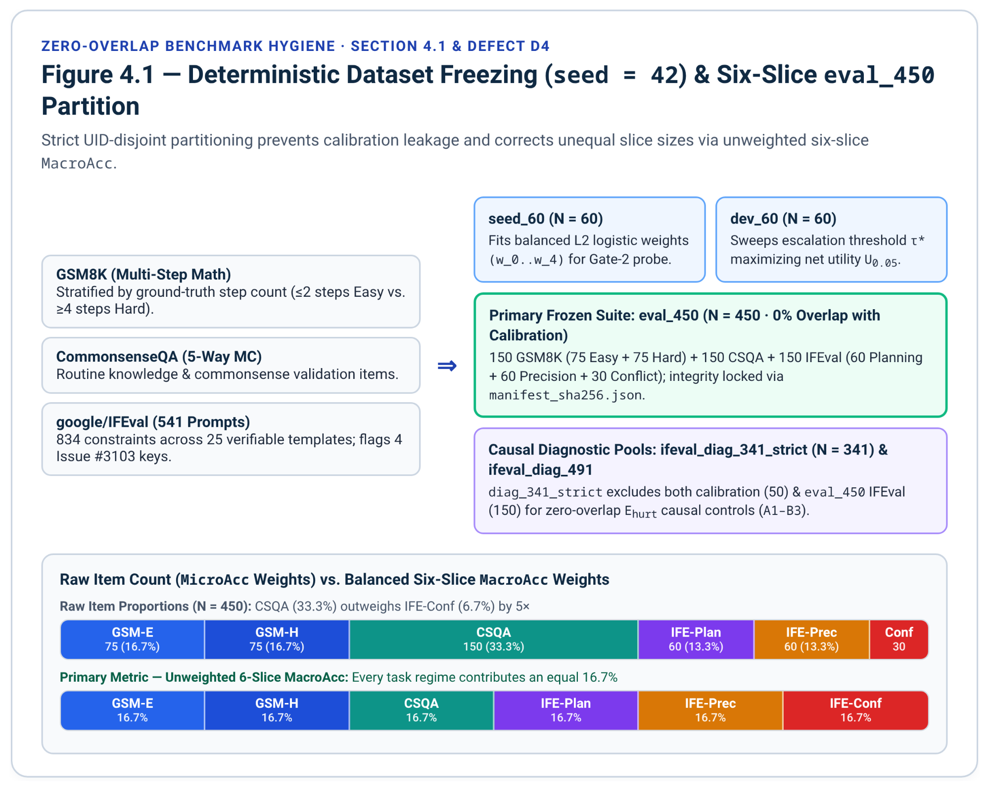

4.2 Forward-Pass Token Accounting and Overthinking-Adjusted Accuracy
For each prompt $i∈\{1,…,N\}$, binary correctness $z_{i}∈\{0,1\}$ is paired with complete forward-pass token accounting $T_{tot,i}=T_{probe,i}+T_{think,i}+T_{wasted,i}+T_{inj,i}+T_{final,i}$, where $T_{wasted,i}$ captures any post-</think> tokens generated during Stage 1 that are discarded when re-splicing $c_{anchor}(x)$ before Stage 2. To prevent the 150-item CSQA slice from outweighing the 30-item IFE-Conf slice, primary accuracy is reported as unweighted six-slice MacroAcc. Overthinking efficiency is quantified following OptimalThinkingBench (Aggarwal et al., 2025, arXiv:2508.13141) and Rakotonirina et al. (ACL 2026 Findings) via both point-threshold Overthinking-Adjusted Accuracy ($OAA_{250}$, crediting correct answers whose deliberative token count $T_{delib,i}=T_{probe,i}+T_{think,i}$ satisfies $T_{delib,i}≤250$) and the exact closed-form integral $AUC_{OAA}$ over $[0,t_{max}]$ (t_max = 2048; note upstream papers equivalently use < t or discrete sums over 0..t_max):
$OAA_{250}=\frac{1}{N}\sum_{i=1}^{N}{}z_{i}⋅I[T_{delib,i}≤250]$, $AUC_{OAA}(t_{max})=\frac{1}{N}\sum_{i=1}^{N}{}z_{i}⋅\max_{}\left(0,1-\frac{T_{delib,i}}{t_{max}}\right)$

4.3 Cost-Penalized Utility, Budget-Constrained Success Rate, and Paired Hypothesis Testing
Joint accuracy-cost trade-offs are further summarized by net linear utility $U_{0.05}=\frac{1}{N}\sum_{i=1}^{N}{}(z_{i}-0.05⋅T_{tot,i}/250)$ and Budget-Constrained Success Rate $BSR(B)=\frac{1}{N}\sum_{i=1}^{N}{}z_{i}⋅I[T_{tot,i}≤B]$ for total-token ceilings $B∈\{64,128,256,512,1024,2048\}$¹. Counterfactual headroom is bounded by Oracle_UB, which selects for each instance the minimum-$T_{tot}$ passing policy across B0, B1b, and M2 (B = 64, 128, 256)¹. Paired binary comparisons on eval_450 report both the exact two-sided binomial McNemar $p$-value and the Lancaster mid-$p$ McNemar value (which mitigates exact-binomial discreteness when discordant pair counts $n=b+c$ are small to moderate)¹, adjusted across baseline comparisons via the Holm-Bonferroni step-down procedure alongside 10,000-resample paired bootstrap 95% confidence intervals¹.
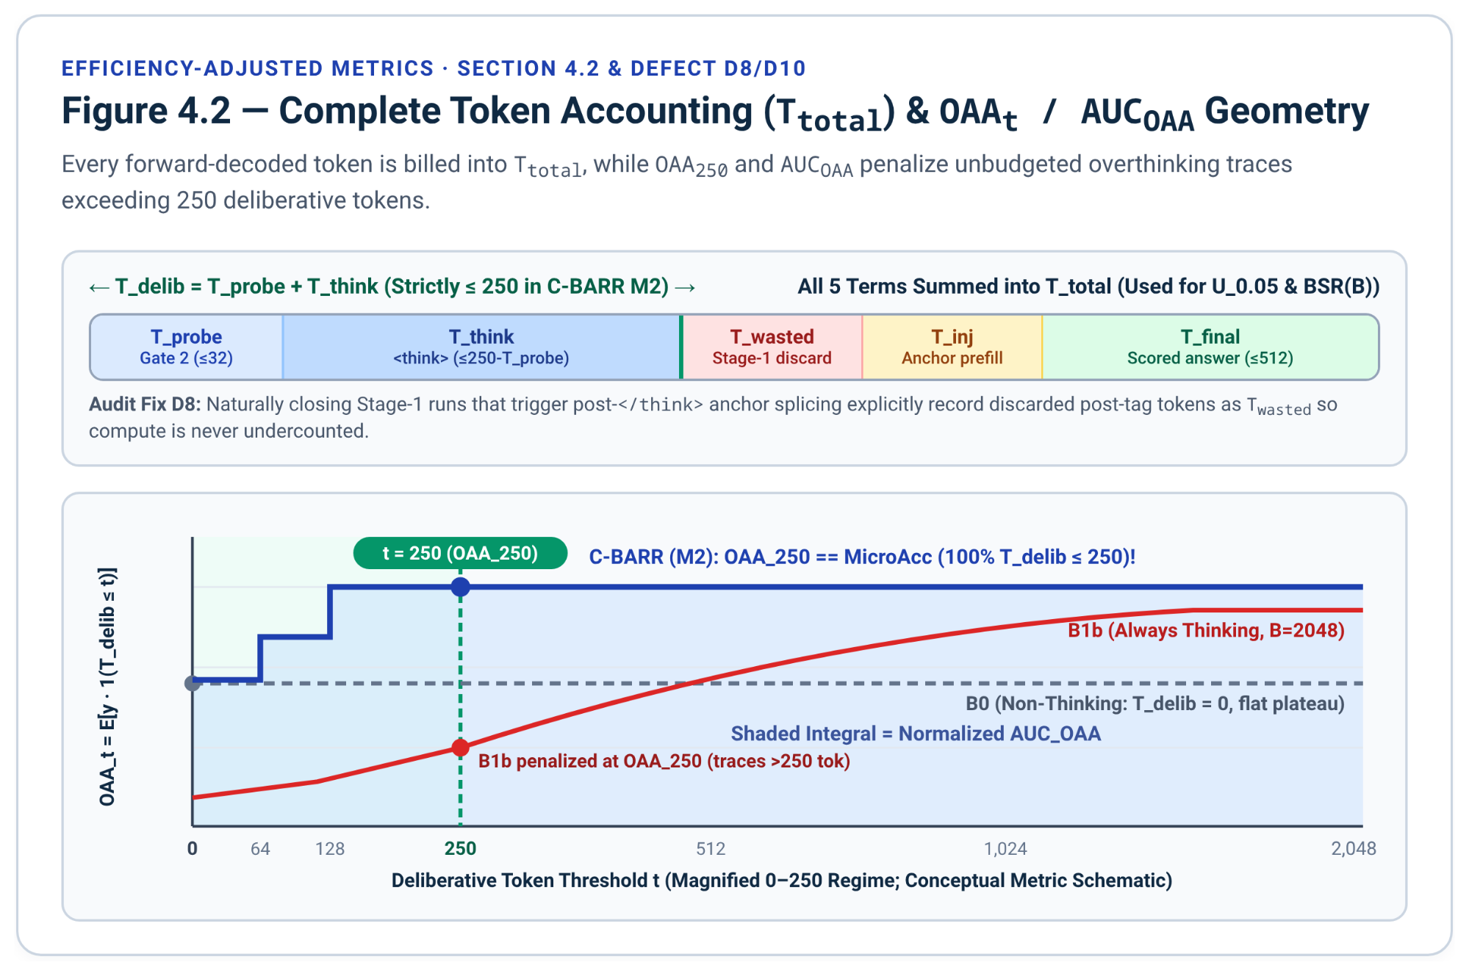

5. Comprehensive Technical Audit of Original Draft Defects
A systematic code and protocol audit of the baseline prototype modules (A.1–A.6)¹ and post-</think> reminder mechanics uncovered twelve concrete bugs, dependency failures, and missing files, all resolved in Section 6.
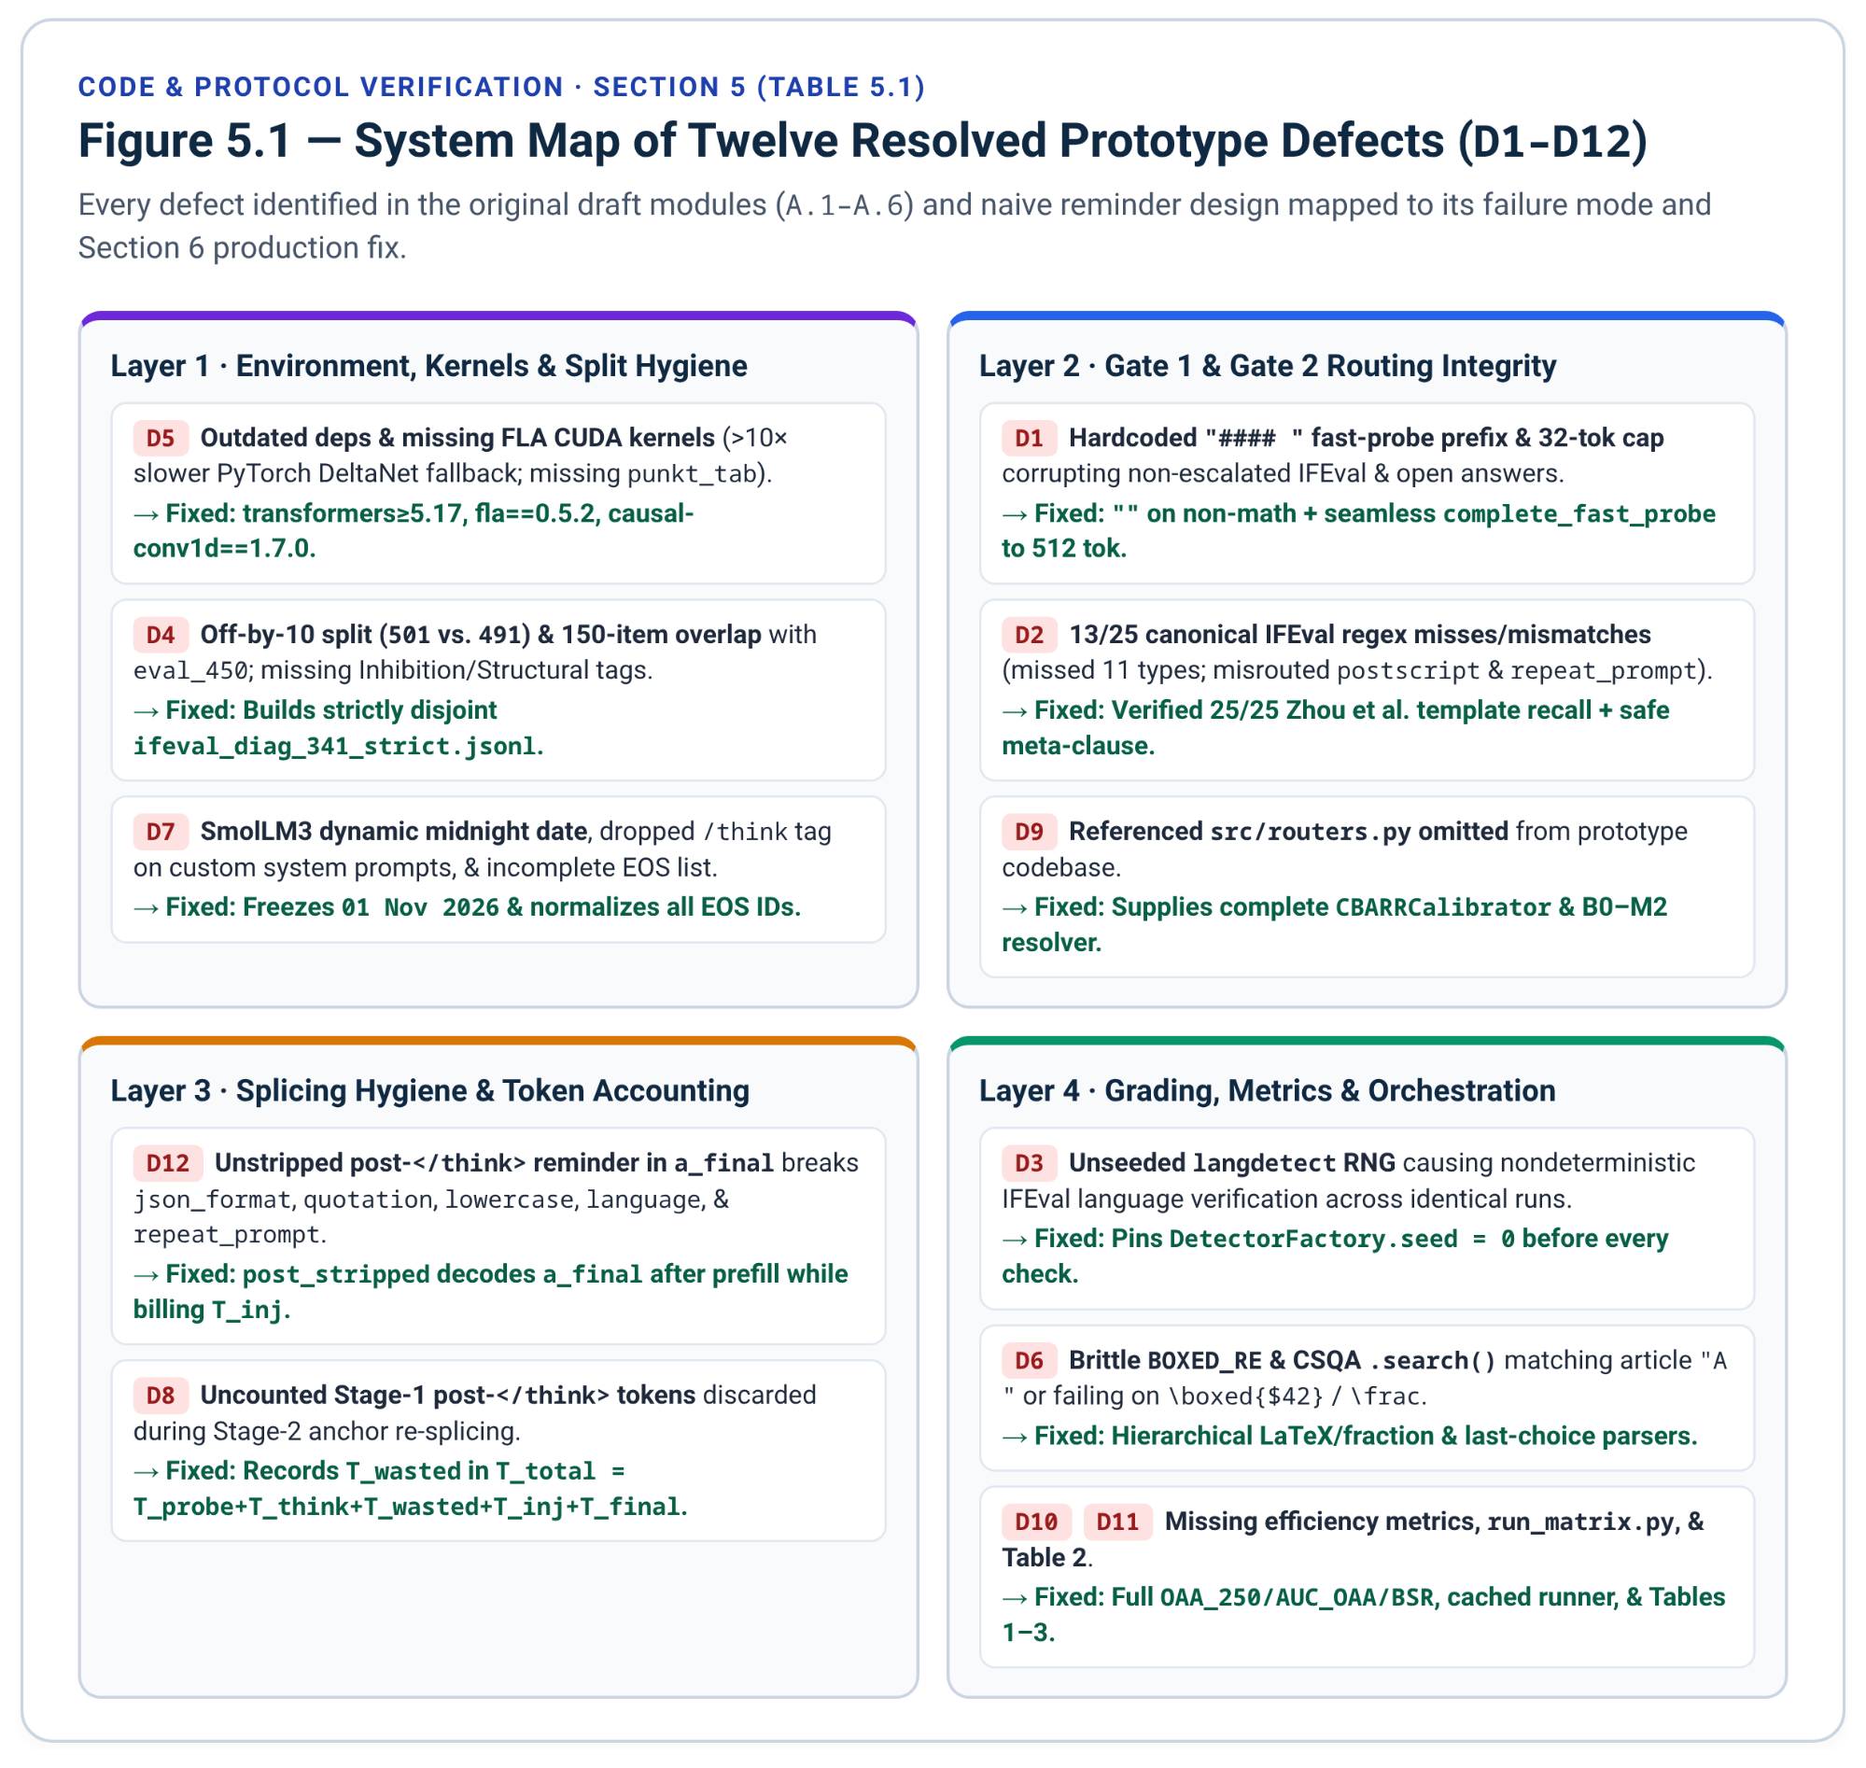
ID | File / Section in Draft | Defect / Discrepancy Identified in Original Draft | Impact if Run Unmodified | Resolution Implemented in Section 6
D1 | A.4 src/engine.py (run_gate2_fast_probe) | Hardcodes ans_prefix = "Answer: " if is_mc else "#### " and caps generation at max_new_tokens=32¹. | Non-escalated IFEval responses begin with "#### " and truncate at 32 tokens, systematically failing json_format, quotation, repeat_prompt, and number_words. | Applies "#### " only when $ϕ_{sym}=1$, $ϕ_{prec}=0$, $ϕ_{plan}=0$; uses "" on IFEval/open prompts and continues non-EOS probes up to 512 tokens (complete_fast_probe).
D2 | A.4 src/engine.py (PLANNING_RE, PRECISION_RE) | Misses 11 of 25 canonical IFEval templates and matches postscript and repeat_prompt in PLANNING_RE despite freeze_datasets.py assigning both to PRECISION_IDS (13/25 total mismatches)¹. | Gate 1 fails to detect precision fragility or extract anchor clauses on title, end_checker, placeholders, language, keywords:existence, and constrained_response. | Expanded PLANNING_RE and PRECISION_RE verified against all 25 Zhou et al. (2023) canonical templates with 0 target-class recall misses¹⁹.
D3 | A.3 src/graders.py (grade_ifeval_item) | Invokes instruction_following_eval without seeding langdetect.DetectorFactory¹, which uses an unseeded RNG internally¹⁷. | language:response_language scores fluctuate across repeated evaluations of identical text. | Pins DetectorFactory.seed = 0 and random.seed(0) at module import and prior to every grade_ifeval_item call¹⁸.
D4 | A.2 data/freeze_datasets.py | Names split ifeval_diag_501.jsonl (541 - 50 = 491, not 501) and omits eval_ifeval (150 items) from heldout_uids¹. | Misstates sample size (491 vs. 501), leaves complete 150-item overlap with eval_450, and omits Inhibition/Structural flags required by Table 3¹. | Builds both ifeval_diag_491.jsonl (calibration-disjoint) and ifeval_diag_341_strict.jsonl (eval_450-disjoint), flags Issue #3103 defect keys²⁴, and annotates Inhibition vs. Structural subtypes¹⁹.
D5 | A.1 Environment Setup | Lists transformers>=4.51 and vllm>=0.8; omits flash-linear-attention, causal-conv1d, instruction_following_eval, and NLTK punkt_tab¹. | SmolLM3-3B requires transformers>=4.53¹⁰; Qwen3.5 requires transformers>=4.57/>=5.17 and vllm>=0.17/nightly¹⁹; missing FLA/conv1d triggers >10x slower PyTorch fallback²⁷; missing punkt_tab crashes IFEval⁹⁵. | Updates A.1 with verified version bounds, flash-linear-attention==0.5.2, causal-conv1d==1.7.0²¹, sparse google-research checkout, and NLTK data bootstrap⁹⁶.
D6 | A.3 src/graders.py (grade_gsm8k, grade_csqa) | BOXED_RE fails on \boxed{$42}, spaces, \text{}, and \frac{}; grade_csqa uses .search() (first match instead of last), misses **Answer:** (C), and matches English article "A "¹. | Assigns false-zero grades to valid LaTeX-formatted math and self-correcting multiple-choice answers¹⁹. | Replaces regexes with hierarchical GSM8K and CSQA parsers verified across LaTeX, fraction, Markdown, self-correction, and article edge cases¹⁹.
D7 | A.4 src/engine.py (build_prompt_prefix, eos_ids) | SmolLM3-3B injects dynamic Today Date via strftime_now²⁹, omits /think or /no_think when system_prompt is passed, and eos_ids misses <|end_of_text|> (128001) and list-valued eos_token_id ([248046, 248044])⁷⁷. | Prompts change across midnight, custom system prompts drop mode directives on SmolLM3-3B, and unstripped EOS tokens bias Gate-2 probe entropy. | Freezes Today Date: 01 November 2026, injects /think or /no_think into system prompts, and normalizes int/list eos_token_id plus <|im_end|>, <|endoftext|>, and <|end_of_text|>.
D8 | A.4 src/engine.py (run_capped_think_and_anchor) | Discards post-</think> tokens generated in Stage 1 without recording their token cost when re-splicing an anchor clause for Stage 2¹. | Undercounts forward-decoded tokens on naturally closing Stage-1 runs that trigger anchor splicing. | Explicitly records T_wasted and sums T_probe + T_think + T_wasted + T_inj + T_final into T_total.
D9 | src/routers.py (Referenced, Omitted) | Introductory note cites src/routers.py and Table 1 lists B0–M2, but no baseline or router calibration module is included¹. | Cannot calibrate Gate 2 or execute the Table 1 systems. | Supplies complete src/routers.py (CBARRCalibrator + unified B0–M2 resolver across B in {64, 128, 256})¹⁶.
D10 | A.5 src/metrics.py | Omits MacroAcc, OAA_250, AUC_OAA, U_0.05, BSR(B), and causal decomposition shares required by Tables 1 and 3¹. | Cannot compute efficiency-adjusted metrics or causal attribution shares. | Implements MacroAcc, OAA_250, closed-form AUC_OAA, U_0.05, BSR(B), Lancaster mid-$p$ McNemar, and compute_causal_decomposition¹⁶.
D11 | scripts/run_matrix.py & Table 2 (Omitted) | A.1 lists scripts/run_matrix.py and A.6 skips directly from Table 1 to Table 3¹. | Lacks experiment orchestration/caching script and Table 2 LaTeX template. | Supplies incremental prefix-cached scripts/run_matrix.py and booktabs Table 2 alongside upgraded Tables 1 and 3.
D12 | A.4 src/engine.py (Post-</think> Prefill Hygiene) | Leaving an injected post-</think> reminder ([Constraint Check: ...]) unstripped inside the scored response string (B2_post_prefill in draft¹) prepends English mixed-case wrapper text to a_final. | Automatically breaks strict IFEval checkers for json_format, quotation, english_lowercase, english_capital, response_language, and repeat_prompt¹⁵. | Implements anchor_locus='post_stripped' (decoding a_final right after the prefilled post-</think> reminder while counting T_inj in T_total) alongside "pre_close" and "post_raw" ablations¹⁶.

6. Upgraded Production Implementation and LaTeX Suite

6.1 Repository Architecture and Validated Environment Setup
All source modules, cached data splits, and LaTeX templates organize cleanly into the repository directory layout detailed below¹.
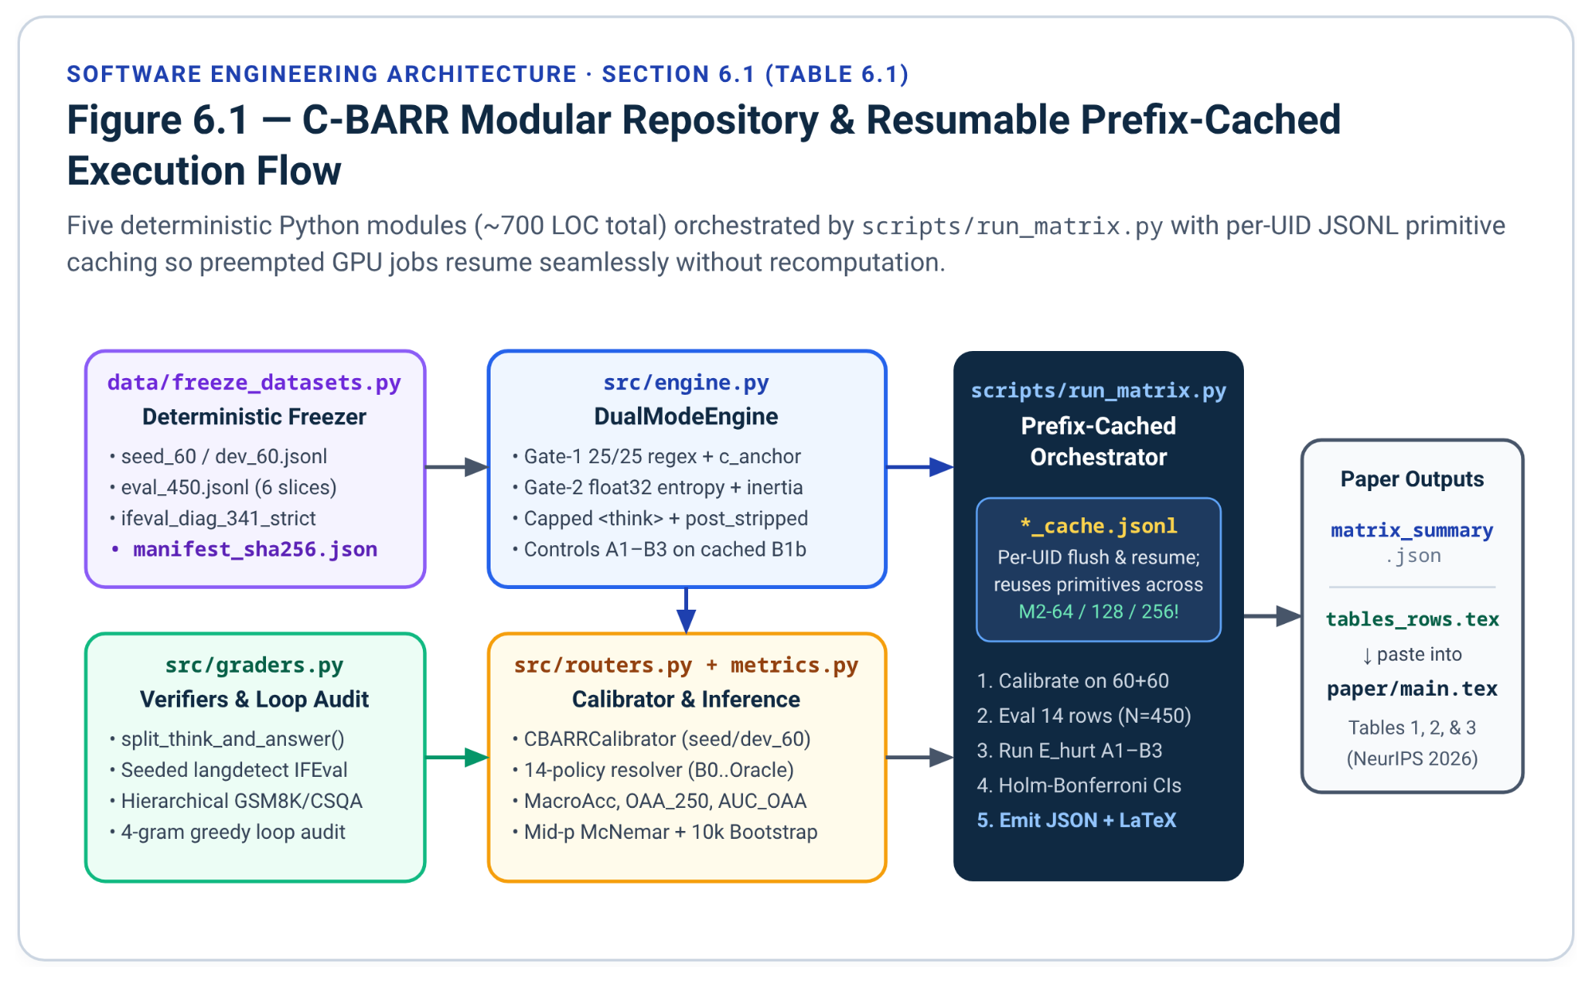
Path | Role in C-BARR Repository | Key Outputs and Responsibilities
data/freeze_datasets.py | Deterministic zero-overlap dataset builder (seed = 42) | Materializes seed_60.jsonl, dev_60.jsonl, eval_450.jsonl, ifeval_diag_491.jsonl, ifeval_diag_341_strict.jsonl, and manifest_sha256.json.
src/graders.py | Seeded channel parser, 4-gram loop audit, and verifiers | Strips <think> and special EOS markers; seeds DetectorFactory; grades GSM8K, CSQA, and IFEval (Inhibition + Structural).
src/engine.py | 25-template Gate 1, CBARRDualModeEngine, B in {64, 128, 256} termination, Controls A1-B3 | Normalizes Qwen3.5 (0.8B-9B) and SmolLM3-3B templates; logs float32 entropies; executes P_TERM + Post-</think> stripped (post_stripped) and Pre-</think> (pre_close) splices¹⁶.
src/routers.py | Two-stage seed_60/dev_60 calibrator and B0-M2 policy resolver | Fits logistic Gate-2 escalation weights on seed_60, tunes tau* on dev_60, and resolves B0-B2, M1a-M1c, fixed M2-64/128/256, and adaptive M2¹⁶.
src/metrics.py | Statistical inference, efficiency metrics, and causal attribution | Computes exact & mid-$p$ McNemar, Holm-Bonferroni, 10k paired bootstrap CIs, MacroAcc, OAA_250, AUC_OAA, U_0.05, BSR(B), Oracle_UB, and rho_recency vs. rho_interference¹⁶.
scripts/run_matrix.py | Incremental GPU cache runner and LaTeX row generator | Runs and caches primitives across splits, executes the Trace-Stripping vs. Post-Think Re-Anchoring diagnostic controls on E_hurt, and writes matrix_summary.json and tables_rows.tex.
paper/main.tex | 8-page LaTeX manuscript (CS388 report, then arXiv and a 2027 venue) | Integrates camera-ready booktabs Tables 1, 2, and 3.
Provision a Python 3.12 CUDA environment¹⁹ using the verified package versions and linear-attention kernels required for full-speed Qwen3.5²⁰ and SmolLM3-3B¹⁰ execution, plus the vendored instruction_following_eval checker and NLTK tokenizers⁸⁶:
# 1. Core PyTorch + Transformers (>=4.57 / v5.17+ supports both qwen3_5 and smollm3)
pip install --upgrade pip
pip install "torch>=2.6" "transformers>=5.17.0" accelerate datasets scipy scikit-learn \
nltk immutabledict langdetect absl-py

# 2. REQUIRED CUDA kernels for Qwen3.5 Gated DeltaNet layers (avoids >10x PyTorch fallback)
pip install "flash-linear-attention==0.5.2"
pip install "causal-conv1d==1.7.0" --no-build-isolation

# 3. Optional high-throughput serving engine (vLLM >= 0.17.0 required for qwen3_5;
# pass --language-model-only to skip ViT allocation on Qwen3.5 checkpoints)
pip install "vllm>=0.17.0"

# 4. Vendor upstream Google Research instruction_following_eval & required NLTK resources
git clone --depth 1 --filter=blob:none --sparse https://github.com/google-research/google-research.git /tmp/gr
cd /tmp/gr && git sparse-checkout set instruction_following_eval && cd -
cp -r /tmp/gr/instruction_following_eval ./instruction_following_eval
python -m nltk.downloader punkt punkt_tab stopwords averaged_perceptron_tagger_eng

6.2 Deterministic Zero-Overlap Dataset Freezer (data/freeze_datasets.py)
Execute python data/freeze_datasets.py once (seed = 42) to materialize all splits with automated UID disjointness assertions, SHA-256 integrity hashes, upstream defect flags (keys 30, 337, 2078, 3311), and Inhibition vs. Structural precision sub-tags¹⁹.
"""Deterministic zero-overlap dataset builder for C-BARR."""
from __future__ import annotations

import hashlib
import json
import pathlib
import random
from typing import Any
from datasets import load_dataset

# Exhaustive 25-type IFEval routing partition: 10 Planning + 15 Precision (5 Inhibition + 10 Structural)
PLANNING_IDS: frozenset[str] = frozenset({
"length_constraints:number_words",
"length_constraints:number_sentences",
"length_constraints:number_paragraphs",
"length_constraints:nth_paragraph_first_word",
"detectable_format:number_bullet_lists",
"detectable_format:multiple_sections",
"detectable_format:number_highlighted_sections",
"keywords:frequency",
"keywords:letter_frequency",
"combination:two_responses",
})

INHIBITION_IDS: frozenset[str] = frozenset({
"punctuation:no_comma",
"keywords:forbidden_words",
"change_case:english_lowercase",
"change_case:english_capital",
"language:response_language",
})

STRUCTURAL_IDS: frozenset[str] = frozenset({
"detectable_format:json_format",
"detectable_format:constrained_response",
"detectable_format:title",
"detectable_content:postscript",
"detectable_content:number_placeholders",
"startend:end_checker",
"startend:quotation",
"combination:repeat_prompt",
"keywords:existence",
"change_case:capital_word_frequency",
})

PRECISION_IDS: frozenset[str] = INHIBITION_IDS | STRUCTURAL_IDS
assert len(PLANNING_IDS) == 10 and len(PRECISION_IDS) == 15
assert not (PLANNING_IDS & PRECISION_IDS) and not (INHIBITION_IDS & STRUCTURAL_IDS)

# Upstream google/IFEval prompt-kwargs mismatch keys documented in google-research Issue #3103
KNOWN_UPSTREAM_DEFECT_KEYS: frozenset[int] = frozenset({30, 337, 2078, 3311})

def classify_ifeval_slice(inst_ids: list[str]) -> str:
has_plan = any(i in PLANNING_IDS for i in inst_ids)
has_prec = any(i in PRECISION_IDS for i in inst_ids)
if has_plan and has_prec:
return "ifeval_conflict"
if has_plan:
return "ifeval_planning"
return "ifeval_precision"

def classify_precision_subtypes(inst_ids: list[str]) -> dict[str, bool]:
return {
"has_inhibition": any(i in INHIBITION_IDS for i in inst_ids),
"has_structural": any(i in STRUCTURAL_IDS for i in inst_ids),
}

def build_all_splits(out_dir: str = "data", seed: int = 42) -> dict[str, str]:
rng = random.Random(seed)
out = pathlib.Path(out_dir)
out.mkdir(parents=True, exist_ok=True)

# 1. GSM8K: seed/dev from 'train' (7,473), eval_150 from 'test' (1,319)
gsm_train = list(load_dataset("openai/gsm8k", "main", split='train'))
gsm_test = list(load_dataset("openai/gsm8k", "main", split='test'))
rng.shuffle(gsm_train)
rng.shuffle(gsm_test)

def parse_gsm(ex: dict[str, Any], idx: int, split_tag: str) -> dict[str, Any]:
rationale, gold_str = ex["answer"].split("####")
steps = len([ln for ln in rationale.strip().splitlines() if ln.strip()])
gold_val = float(gold_str.strip().replace(",", ""))
sub = "gsm8k_easy" if steps <= 2 else ("gsm8k_hard" if steps >= 4 else "gsm8k_mid")
return {
"uid": f"gsm8k_{split_tag}_{idx}",
"dataset": "gsm8k",
"slice": sub,
"prompt": ex["question"].strip(),
"gold": gold_val,
"steps": steps,
"rationale_gold": rationale.strip(),
}

gsm_tr_parsed = [parse_gsm(e, i, "tr") for i, e in enumerate(gsm_train)]
gsm_te_parsed = [parse_gsm(e, i, "te") for i, e in enumerate(gsm_test)]

seed_gsm = gsm_tr_parsed[:15]
dev_gsm_easy = [x for x in gsm_tr_parsed[15:] if x["slice"] == "gsm8k_easy"][:10]
dev_gsm_hard = [x for x in gsm_tr_parsed[15:] if x["slice"] == "gsm8k_hard"][:10]
eval_gsm_easy = [x for x in gsm_te_parsed if x["slice"] == "gsm8k_easy"][:75]
eval_gsm_hard = [x for x in gsm_te_parsed if x["slice"] == "gsm8k_hard"][:75]

# 2. CommonsenseQA: seed/dev from 'train', eval_150 from 'validation'
csqa_train = list(load_dataset("tau/commonsense_qa", split='train'))
csqa_val = list(load_dataset("tau/commonsense_qa", split='validation'))
rng.shuffle(csqa_train)
rng.shuffle(csqa_val)

def parse_csqa(ex: dict[str, Any], idx: int, split_tag: str) -> dict[str, Any]:
labels = ex["choices"]["label"]
texts = ex["choices"]["text"]
opts = "\n".join(f"({lbl}) {txt}" for lbl, txt in zip(labels, texts))
return {
"uid": f"csqa_{split_tag}_{idx}",
"dataset": "csqa",
"slice": "csqa",
"prompt": f"{ex['question'].strip()}\n{opts}",
"gold": ex["answerKey"].strip().upper(),
}

seed_csqa = [parse_csqa(e, i, "tr") for i, e in enumerate(csqa_train[:15])]
dev_csqa = [parse_csqa(e, i, "tr") for i, e in enumerate(csqa_train[15:35], start=15)]
eval_csqa = [parse_csqa(e, i, "val") for i, e in enumerate(csqa_val[:150])]

# 3. IFEval: partition 541 prompts into seed (30), dev (20), eval (150),
# calibration-disjoint diag_491, and strictly eval-disjoint diag_341_strict
ifeval_raw = list(load_dataset("google/IFEval", split='train'))
assert len(ifeval_raw) == 541, f"Expected 541 IFEval rows, got {len(ifeval_raw)}"
rng.shuffle(ifeval_raw)

ifeval_all: list[dict[str, Any]] = []
for e in ifeval_raw:
inst_ids = list(e["instruction_id_list"])
sl = classify_ifeval_slice(inst_ids)
sub_flags = classify_precision_subtypes(inst_ids)
key_int = int(e["key"])
ifeval_all.append({
"uid": f"ifeval_{key_int}",
"key": key_int,
"dataset": "ifeval",
"slice": sl,
"prompt": e["prompt"],
"instruction_id_list": inst_ids,
"kwargs": e["kwargs"],
"has_inhibition": sub_flags["has_inhibition"],
"has_structural": sub_flags["has_structural"],
"has_upstream_defect": key_int in KNOWN_UPSTREAM_DEFECT_KEYS,
})

plan_pool = [x for x in ifeval_all if x["slice"] == "ifeval_planning"]
prec_pool = [x for x in ifeval_all if x["slice"] == "ifeval_precision"]
conf_pool = [x for x in ifeval_all if x["slice"] == "ifeval_conflict"]

assert len(plan_pool) >= 85, f"Insufficient pure-planning prompts: {len(plan_pool)}"
assert len(prec_pool) >= 85, f"Insufficient pure-precision prompts: {len(prec_pool)}"
assert len(conf_pool) >= 30, f"Insufficient conflict prompts: {len(conf_pool)}"

seed_ifeval = plan_pool[:15] + prec_pool[:15]
dev_ifeval = plan_pool[15:25] + prec_pool[15:25]
eval_ifeval = plan_pool[25:85] + prec_pool[25:85] + conf_pool[:30]

cal_uids = {x["uid"] for x in (seed_ifeval + dev_ifeval)}
eval_ifeval_uids = {x["uid"] for x in eval_ifeval}

diag_ifeval_491 = [x for x in ifeval_all if x["uid"] not in cal_uids]
diag_ifeval_341_strict = [
x for x in ifeval_all if x["uid"] not in (cal_uids | eval_ifeval_uids)
]

splits: dict[str, list[dict[str, Any]]] = {
"seed_60.jsonl": seed_gsm + seed_csqa + seed_ifeval,
"dev_60.jsonl": dev_gsm_easy + dev_gsm_hard + dev_csqa + dev_ifeval,
"eval_450.jsonl": eval_gsm_easy + eval_gsm_hard + eval_csqa + eval_ifeval,
"ifeval_diag_491.jsonl": diag_ifeval_491,
"ifeval_diag_341_strict.jsonl": diag_ifeval_341_strict,
}

assert len(splits["seed_60.jsonl"]) == 60
assert len(splits["dev_60.jsonl"]) == 60
assert len(splits["eval_450.jsonl"]) == 450
assert len(splits["ifeval_diag_491.jsonl"]) == 491
assert len(splits["ifeval_diag_341_strict.jsonl"]) == 341

u_seed = {x["uid"] for x in splits["seed_60.jsonl"]}
u_dev = {x["uid"] for x in splits["dev_60.jsonl"]}
u_eval = {x["uid"] for x in splits["eval_450.jsonl"]}
u_diag_strict = {x["uid"] for x in splits["ifeval_diag_341_strict.jsonl"]}
assert not (u_seed & u_dev)
assert not (u_seed & u_eval)
assert not (u_dev & u_eval)
assert not ((u_seed | u_dev | u_eval) & u_diag_strict)

manifest: dict[str, str] = {}
for fname, rows in splits.items():
fpath = out / fname
payload = "".join(json.dumps(r, ensure_ascii=False, sort_keys=True) + "\n" for r in rows)
fpath.write_text(payload, encoding='utf-8')
manifest[fname] = hashlib.sha256(payload.encode("utf-8")).hexdigest()

(out / "manifest_sha256.json").write_text(
json.dumps(manifest, indent=2, sort_keys=True) + "\n", encoding='utf-8'
)
return manifest

if __name__ == "__main__":
checksums = build_all_splits()
print("Frozen C-BARR splits with SHA-256 manifest:", json.dumps(checksums, indent=2))

6.3 Deterministic Channel Extraction, Loop Audit, and Verifiers (src/graders.py)
This module pins DetectorFactory.seed = 0 and random.seed(0) for reproducible langdetect evaluation, strips special turn-end markers across Qwen3.5 and SmolLM3-3B⁷⁶, resolves LaTeX/Markdown/self-correction grading edge cases¹⁹, and scores Inhibition and Structural precision subsets separately for Table 3.
"""Deterministic channel parsing, 4-gram loop audit, and GSM8K/CSQA/IFEval verifiers."""
from __future__ import annotations

from collections.abc import Sequence
import random
import re
from typing import Any
from langdetect import DetectorFactory

# Seed langdetect global RNG before importing instruction_following_eval
DetectorFactory.seed = 0

from instruction_following_eval import evaluation_main # noqa: E402

INHIBITION_IDS: frozenset[str] = frozenset({
"punctuation:no_comma",
"keywords:forbidden_words",
"change_case:english_lowercase",
"change_case:english_capital",
"language:response_language",
})

STRUCTURAL_IDS: frozenset[str] = frozenset({
"detectable_format:json_format",
"detectable_format:constrained_response",
"detectable_format:title",
"detectable_content:postscript",
"detectable_content:number_placeholders",
"startend:end_checker",
"startend:quotation",
"combination:repeat_prompt",
"keywords:existence",
"change_case:capital_word_frequency",
})

SPECIAL_END_TOKENS: Sequence[str] = (
"<|im_end|>",
"<|endoftext|>",
"<|end_of_text|>",
"</s>",
)

NUM_TOKEN_RE = re.compile(r"[-+]?(?:\d{1,3}(?:,\d{3})+|\d+)(?:\.\d+)?(?:/\d+)?")
BOXED_CONTENT_RE = re.compile(r"\\boxed\{\s*([^{}]+(?:\{[^{}]*\}[^{}]*)*)\s*\}")
HASH_ANS_RE = re.compile(r"####\s*\$?\s*([-+]?(?:\d{1,3}(?:,\d{3})+|\d+)(?:\.\d+)?)")
CUE_ANS_RE = re.compile(
r"(?:final\s+answer|the\s+answer|answer|equals|total\s+is)"
r"\s*\*{0,2}\s*(?:is|:|=)\s*\*{0,2}\s*\$?\s*"
r"([-+]?(?:\d{1,3}(?:,\d{3})+|\d+)(?:\.\d+)?)",
re.IGNORECASE,
)

MC_BOXED_RE = re.compile(r"\\boxed\{\s*\(?([A-E])\)?\s*\}", re.IGNORECASE)
MC_EXPLICIT_RE = re.compile(
r"(?:final\s+answer|correct\s+(?:answer|option|choice)|best\s+(?:answer|option|choice)|answer|option|choice)"
r"(?:\s+here)?(?:\s+would\s+be|\s+is|\*{0,2}\s*:)\s*\*{0,2}\s*\(?([A-E])\)?(?![a-zA-Z])",
re.IGNORECASE,
)
MC_LEADING_RE = re.compile(r"^\s*\*{0,2}\(?([A-E])\)?\*{0,2}(?:[\s.):,-]|$)")
MC_PAREN_RE = re.compile(r"\(([A-E])\)")

def strip_special_end_tokens(text: str) -> str:
cleaned = text
for tok in SPECIAL_END_TOKENS:
cleaned = cleaned.replace(tok, "")
return cleaned

def split_think_and_answer(
raw_text: str, expect_think_close: bool, is_prompted_cot: bool = False
) -> tuple[str, str, bool]:
"""Returns (think_trace, clean_final_answer, think_exhausted)."""
cleaned = strip_special_end_tokens(raw_text)
if is_prompted_cot:
if "Final Answer:" in cleaned:
cot_part, final_part = cleaned.rsplit("Final Answer:", 1)
return cot_part.strip(), final_part.strip(), False
return "", cleaned.strip(), False

if "</think>" in cleaned:
think_part, ans_part = cleaned.rsplit("</think>", 1)
think_part = re.sub(r"^\s*<think>\s*", "", think_part)
return think_part, ans_part.lstrip("\n").strip(), False

if expect_think_close or cleaned.lstrip().startswith("<think>"):
return re.sub(r"^\s*<think>\s*", "", cleaned), "", True

return "", cleaned.strip(), False

def has_4gram_repetition_loop(text: str, min_repeats: int = 4) -> bool:
"""Detects degenerate greedy decoding loops (>= 4 consecutive or >= 6 total 4-gram repeats)."""
tokens = text.lower().split()
if len(tokens) < 16:
return False
counts: dict[tuple[str, str, str, str], int] = {}
for i in range(len(tokens) - 3):
gram = (tokens[i], tokens[i + 1], tokens[i + 2], tokens[i + 3])
counts[gram] = counts.get(gram, 0) + 1
if counts[gram] >= 6:
return True
for i in range(len(tokens) - 4 * min_repeats + 1):
unit = tokens[i : i + 4]
if all(tokens[i + 4 * r : i + 4 * (r + 1)] == unit for r in range(1, min_repeats)):
return True
return False

def _parse_numeric_token(s: str) -> float | None:
s = s.strip().replace(",", "").rstrip(".")
if not s or s in ("-", "+"):
return None
if "/" in s:
num_s, den_s = s.split("/", 1)
den = float(den_s)
return float(num_s) / den if abs(den) > 1e-12 else None
try:
return float(s)
except ValueError:
return None

def grade_gsm8k(final_answer: str, gold: float) -> int:
if not final_answer:
return 0
boxed_matches = BOXED_CONTENT_RE.findall(final_answer)
if boxed_matches:
inner = re.sub(r"\\(?:text|mathrm|textbf|mathbf)\{[^{}]*\}", " ", boxed_matches[-1])
inner = inner.replace("\\$", "").replace("$", "").replace("\\%", "")
frac = re.search(r"\\d?frac\{\s*([-+]?\d+)\s*\}\{\s*([-+]?\d+)\s*\}", inner)
if frac and abs(float(frac.group(2))) > 1e-12:
val = float(frac.group(1)) / float(frac.group(2))
return int(abs(val - gold) < 1e-4)
nums = NUM_TOKEN_RE.findall(inner)
if nums:
val = _parse_numeric_token(nums[-1])
if val is not None:
return int(abs(val - gold) < 1e-4)

for pattern in (HASH_ANS_RE, CUE_ANS_RE):
matches = pattern.findall(final_answer)
if matches:
val = _parse_numeric_token(matches[-1])
if val is not None:
return int(abs(val - gold) < 1e-4)

nums = NUM_TOKEN_RE.findall(final_answer)
if not nums:
return 0
val = _parse_numeric_token(nums[-1])
return int(val is not None and abs(val - gold) < 1e-4)

def grade_csqa(final_answer: str, gold_letter: str) -> int:
if not final_answer:
return 0
gold_u = gold_letter.strip().upper()
for pattern in (MC_BOXED_RE, MC_EXPLICIT_RE):
matches = pattern.findall(final_answer)
if matches:
return int(matches[-1].upper() == gold_u)
m_lead = MC_LEADING_RE.match(final_answer)
if m_lead:
return int(m_lead.group(1).upper() == gold_u)
paren_matches = MC_PAREN_RE.findall(final_answer)
if paren_matches:
return int(paren_matches[-1].upper() == gold_u)
cleaned = re.sub(r"\bA\s+[a-z]{2,}\b", " ", final_answer)
letters = re.findall(r"\b([A-E])\b", cleaned)
return int(bool(letters) and letters[-1].upper() == gold_u)

def grade_ifeval_item(item: dict[str, Any], final_answer: str) -> dict[str, Any]:
"""Runs official google-research instruction_following_eval strict & loose verifiers."""
DetectorFactory.seed = 0
random.seed(0)

inst_ids: list[str] = list(item["instruction_id_list"])
inp = evaluation_main.InputExample(
key=item["key"],
instruction_id_list=inst_ids,
prompt=item["prompt"],
kwargs=[{k: v for k, v in kw.items() if v is not None} for kw in item["kwargs"]],
)
if not final_answer:
n_inst = len(inst_ids)
return {
"prompt_strict": 0,
"prompt_loose": 0,
"inst_strict_list": [False] * n_inst,
"inst_loose_list": [False] * n_inst,
"inhibition_strict_all": 0 if any(i in INHIBITION_IDS for i in inst_ids) else None,
"structural_strict_all": 0 if any(i in STRUCTURAL_IDS for i in inst_ids) else None,
}

out_strict = evaluation_main.test_instruction_following_strict(
inp, {item["prompt"]: final_answer}
)
out_loose = evaluation_main.test_instruction_following_loose(
inp, {item["prompt"]: final_answer}
)
strict_flags = list(out_strict.follow_instruction_list)
inh_indices = [idx for idx, iid in enumerate(inst_ids) if iid in INHIBITION_IDS]
str_indices = [idx for idx, iid in enumerate(inst_ids) if iid in STRUCTURAL_IDS]

return {
"prompt_strict": int(out_strict.follow_all_instructions),
"prompt_loose": int(out_loose.follow_all_instructions),
"inst_strict_list": strict_flags,
"inst_loose_list": list(out_loose.follow_instruction_list),
"inhibition_strict_all": (
int(all(strict_flags[idx] for idx in inh_indices)) if inh_indices else None
),
"structural_strict_all": (
int(all(strict_flags[idx] for idx in str_indices)) if str_indices else None
),
}

def grade_item(item: dict[str, Any], final_answer: str) -> dict[str, Any]:
"""Unified deterministic dispatcher across GSM8K, CommonsenseQA, and IFEval."""
ds = item["dataset"]
if ds == "gsm8k":
return {"z": grade_gsm8k(final_answer, float(item["gold"]))}
if ds == "csqa":
return {"z": grade_csqa(final_answer, str(item["gold"]))}
if ds == "ifeval":
res = grade_ifeval_item(item, final_answer)
res["z"] = res["prompt_strict"]
return res
raise ValueError(f"Unsupported dataset: {ds}")

6.4 Template-Normalized Dual-Mode Engine, Post-Think Re-Anchoring, and Diagnostic Controls (src/engine.py)
This module implements Gate 1's 25-template lexical router, Gate 2's 32-token fast entropy + Thinking Inertia probe, tight $B∈\{64,128,256\}$ early prefix termination (\nOkay, I think I have finished thinking.\n</think>\n), channel-stripped Post-</think> Constraint Re-Anchoring (anchor_locus="post_stripped", plus "pre_close" and "post_raw" ablations), and the Causal Diagnostic Controls (A1_strip, B2a_post_anchor, B1_pre_anchor, B2b_post_raw, A2_math_swap, B3_early_cut_no_anchor)¹.
"""Template-normalized routing, fast entropy/inertia probing, and C-BARR interventions."""
from __future__ import annotations

from collections.abc import Sequence
from dataclasses import dataclass
import re
import time
from typing import Any
import numpy as np
import torch
from transformers import AutoModelForCausalLM, AutoTokenizer

from src.graders import strip_special_end_tokens

UNIT_NUM_RE = re.compile(
r"\b\d+\s*(?:words?|sentences?|paragraphs?|sections?|bullets?|"
r"bullet points?|items?|lines?|characters?|letters?|times?|commas?|asterisks?|placeholders?)\b"
r"|\b(?:18|19|20)\d0s\b"
r"|\b\d+(?:st|nd|rd|th)\s+paragraph\b",
re.IGNORECASE,
)
STANDALONE_NUM_RE = re.compile(r"(?<!\w)-?\d+(?:\.\d+)?(?!\w)")
REPEAT_PROMPT_RE = re.compile(
r"(?:repeat the (?:request|prompt)|first[, ]+repeat)", re.IGNORECASE
)

# Aligned across all 15 PRECISION_IDS (5 Inhibition + 10 Structural)
PRECISION_RE = re.compile(
r"(without using|do not (?:use|include|mention|contain)|refrain from|no commas?|forbidden|"
r"\bjson\b|all lowercase|lowercase letters|no capital letters|"
r"all (?:capital|uppercase)|capital letters only|"
r"(?:words with all capital letters|all[- ]capital words)|"
r"(?:end|finish) your (?:entire )?response|exact phrase|no other words should follow|"
r"wrap your (?:entire )?response|double quotation marks|double quotes|"
r"answer with one of the following|constrained to|my answer is (?:yes|no|maybe)|"
r"double angular brackets|<<[^>]*>>|"
r"postscript|\bp\.p?\.s\.|"
r"placeholders?|square brackets|"
r"include (?:the )?keywords?|"
r"entire response should be in [a-z]+|no other language is allowed|"
r"repeat the (?:request|prompt)|first[, ]+repeat)",
re.IGNORECASE,
)

# Aligned across all 10 PLANNING_IDS
PLANNING_RE = re.compile(
r"((?:at least|less than|fewer than|more than|around|exactly|at most|\d+\+)\s*\d*\s*"
r"(?:words?|sentences?|paragraphs?|sections?|bullets?|bullet points?|times?)|"
r"(?:contain|have|include|write in)\s+"
r"(?:at least |less than |more than |around |exactly )?\d+\+?\s+"
r"(?:words?|sentences?|paragraphs?|sections?|bullets?|bullet points?)|"
r"\b\d+\s*-?\s*word\b|"
r"markdown divider|\*\s*\*\s*\*|"
r"\d+(?:st|nd|rd|th)\s+paragraph\s+must\s+start\s+with|"
r"bullet points?|multiple sections|section\s+x|highlighted sections|"
r"(?:letter|word)\s+['\"]?[a-z0-9_]+['\"]?\s+should\s+appear|"
r"two (?:different )?responses|\*{6})",
re.IGNORECASE,
)

MATH_CUE_RE = re.compile(
r"(=|%|\$|how many|how much|calculate|total|altogether|remaining|"
r"average|profit|difference|per hour|each day|ratio|twice|half)",
re.IGNORECASE,
)

INERTIA_MARKERS: Sequence[str] = (
"step", "because", "first", "let's", "therefore", "wait", "since"
)
REFLECTION_SPLIT_RE = re.compile(r"\b(?:Wait|Alternatively|Hmm)\b|\n\n")
P_TERM = "\nOkay, I think I have finished thinking."

@dataclass(frozen=True)
class Gate1Output:
phi_sym: int
phi_plan: int
phi_prec: int
anchor_clause: str

def run_gate1_lexical(prompt: str) -> Gate1Output:
masked = UNIT_NUM_RE.sub(" [UNIT_COUNT] ", prompt)
nums = STANDALONE_NUM_RE.findall(masked.replace(",", ""))
phi_sym = int(len(nums) >= 2 and bool(MATH_CUE_RE.search(masked)))
phi_plan = int(bool(PLANNING_RE.search(prompt)))
phi_prec = int(bool(PRECISION_RE.search(prompt)))

clauses: list[str] = []
if REPEAT_PROMPT_RE.search(prompt):
clauses.append(
"Repeat the user's complete original request word-for-word without change before answering."
)
for sent in re.split(r"(?<=[.!?])\s+|\n+", prompt.strip()):
if REPEAT_PROMPT_RE.search(sent):
continue
if PRECISION_RE.search(sent) or PLANNING_RE.search(sent):
clauses.append(sent.strip())

joined = " ".join(clauses)
words = joined.split()
if len(words) > 30:
joined = " ".join(words[:30])
return Gate1Output(
phi_sym=phi_sym, phi_plan=phi_plan, phi_prec=phi_prec, anchor_clause=joined
)

def _build_reanchor_block(
truncated: bool, anchor_clause: str, anchor_locus: str
) -> tuple[str, str]:
"""Returns (injected_close_block, visible_prefix_kept_in_scored_answer)."""
term = P_TERM if truncated else ""
if not anchor_clause:
return f"{term}\n</think>\n", ""

reminder_line = f"[Reminder: strictly follow: {anchor_clause}]"
if anchor_locus == "post_stripped":
return f"{term}\n</think>\n{reminder_line}\n", ""
if anchor_locus == "pre_close":
return f"{term}\nConstraint check: strictly follow: {anchor_clause}\n</think>\n", ""
if anchor_locus == "post_raw":
return f"{term}\n</think>\n{reminder_line}\n", f"{reminder_line}\n"
raise ValueError(f"Unsupported anchor_locus: {anchor_locus}")

class CBARRDualModeEngine:
"""Normalized text-only inference wrapper for Qwen3.5 (0.8B-9B) and SmolLM3-3B."""

def __init__(
self,
model_id: str,
device: str = "cuda",
dtype: torch.dtype = torch.bfloat16,
freeze_smollm3_date: str = "01 November 2026",
):
self.model_id = model_id
self.is_smollm3 = "smollm3" in model_id.lower()
self.freeze_smollm3_date = freeze_smollm3_date
self.device = device
self.tok = AutoTokenizer.from_pretrained(model_id)
# AutoModelForCausalLM loads Qwen3_5ForCausalLM on Qwen/Qwen3.5-* checkpoints,
# dropping the ViT vision tower and MTP heads to save GPU memory.
try:
loaded = AutoModelForCausalLM.from_pretrained(model_id, dtype=dtype)
except TypeError:
loaded = AutoModelForCausalLM.from_pretrained(model_id, torch_dtype=dtype)
self.model = loaded.to(device).eval()

raw_eos: list[int] = []
for src in (
self.tok.eos_token_id,
getattr(self.model.generation_config, "eos_token_id", None),
):
if isinstance(src, int):
raw_eos.append(src)
elif isinstance(src, (list, tuple)):
raw_eos.extend(int(x) for x in src if x is not None)
for tok_str in ("<|im_end|>", "<|endoftext|>", "<|end_of_text|>", "</s>"):
tid = self.tok.convert_tokens_to_ids(tok_str)
if isinstance(tid, int) and tid >= 0 and tid != self.tok.unk_token_id:
raw_eos.append(tid)
self.eos_ids: set[int] = set(raw_eos)

def build_prompt_prefix(
self,
user_prompt: str,
enable_thinking: bool,
system_prompt: str | None = None,
) -> str:
msgs: list[dict[str, str]] = []
if system_prompt is not None:
sys_txt = system_prompt
if self.is_smollm3 and "/think" not in sys_txt and "/no_think" not in sys_txt:
sys_txt = f"{sys_txt}\n{'/think' if enable_thinking else '/no_think'}"
msgs.append({"role": "system", "content": sys_txt})
elif self.is_smollm3:
msgs.append({"role": "system", "content": "/think" if enable_thinking else "/no_think"})
msgs.append({"role": "user", "content": user_prompt})

try:
rendered = self.tok.apply_chat_template(
msgs,
tokenize=False,
add_generation_prompt=True,
enable_thinking=enable_thinking,
)
except TypeError:
rendered = self.tok.apply_chat_template(
msgs, tokenize=False, add_generation_prompt=True
)

if self.is_smollm3 and self.freeze_smollm3_date:
rendered = re.sub(
r"Today Date: [^\n]+", f"Today Date: {self.freeze_smollm3_date}", rendered
)

if enable_thinking and system_prompt is None and not rendered.rstrip().endswith("<think>"):
rendered += "<think>\n"
return rendered

@torch.no_grad()
def _decode_raw(
self, prompt_str: str, max_new_tokens: int, log_entropies: bool = False
) -> dict[str, Any]:
t0 = time.perf_counter()
inp = self.tok(prompt_str, return_tensors='pt').to(self.device)
out = self.model.generate(
**inp,
max_new_tokens=max_new_tokens,
do_sample=False,
eos_token_id=sorted(self.eos_ids) if self.eos_ids else None,
pad_token_id=self.tok.pad_token_id or next(iter(self.eos_ids), 0),
return_dict_in_generate=True,
output_scores=log_entropies,
)
latency_ms = (time.perf_counter() - t0) * 1000.0
gen_ids = out.sequences[0, inp.input_ids.shape[1] :].tolist()
hit_eos = bool(gen_ids and gen_ids[-1] in self.eos_ids)

content_len = len(gen_ids)
while content_len > 0 and gen_ids[content_len - 1] in self.eos_ids:
content_len -= 1

step_entropies: list[float] = []
if log_entropies and out.scores:
for j in range(min(content_len, len(out.scores))):
log_p = torch.log_softmax(out.scores[j][0].float(), dim=-1)
p = torch.exp(log_p)
step_entropies.append(float(-torch.sum(p * log_p).item()))

return {
"raw_text": self.tok.decode(gen_ids, skip_special_tokens=False),
"total_gen_tokens": len(gen_ids),
"content_tokens": content_len,
"hit_eos": hit_eos,
"step_entropies": step_entropies,
"latency_ms": latency_ms,
}

def run_direct_non_thinking(self, prompt: str, max_new_tokens: int = 512) -> dict[str, Any]:
"""Executes B0 (Always Non-Thinking) or Gate-1 pure-precision bypass in 1.0 call."""
pref = self.build_prompt_prefix(prompt, enable_thinking=False)
res = self._decode_raw(pref, max_new_tokens=max_new_tokens, log_entropies=False)
a_final = strip_special_end_tokens(res["raw_text"]).strip()
return {
"t_think": "",
"a_final": a_final,
"T_probe": 0,
"T_think": 0,
"T_wasted": 0,
"T_inj": 0,
"T_final": res["total_gen_tokens"],
"T_total": res["total_gen_tokens"],
"calls": 1,
"truncated": False,
"think_exhausted": False,
"latency_ms": res["latency_ms"],
}

def run_prompted_mode(
self, prompt: str, mode: str, max_new_tokens: int = 2048
) -> dict[str, Any]:
"""Executes B1a (Prompted Step-by-Step CoT) or B2a (Self-Selective Prompting)."""
if mode == "B1a_cot":
sys_p = (
"Think step by step to solve the user's request, then write 'Final Answer:' "
"followed strictly by your final response."
)
elif mode == "B2a_self_select":
sys_p = (
"Decide whether this task benefits from step-by-step reasoning. If yes, reason "
"briefly and then write 'Final Answer:' followed by your response. If direct "
"answering is better (such as strict formatting constraints), write 'Final Answer:' "
"immediately followed by your response."
)
else:
raise ValueError(f"Unsupported prompted mode: {mode}")

pref = self.build_prompt_prefix(prompt, enable_thinking=False, system_prompt=sys_p)
res = self._decode_raw(pref, max_new_tokens=max_new_tokens, log_entropies=False)
cleaned = strip_special_end_tokens(res["raw_text"])
if "Final Answer:" in cleaned:
cot_part, ans_part = cleaned.rsplit("Final Answer:", 1)
t_cot_toks = len(self.tok.encode(cot_part, add_special_tokens=False))
t_final_toks = max(0, res["total_gen_tokens"] - t_cot_toks)
return {
"t_think": cot_part.strip(),
"a_final": ans_part.strip(),
"T_probe": 0,
"T_think": t_cot_toks,
"T_wasted": 0,
"T_inj": 0,
"T_final": t_final_toks,
"T_total": res["total_gen_tokens"],
"calls": 1,
"truncated": not res["hit_eos"],
"think_exhausted": False,
"latency_ms": res["latency_ms"],
}
return {
"t_think": "",
"a_final": cleaned.strip(),
"T_probe": 0,
"T_think": 0,
"T_wasted": 0,
"T_inj": 0,
"T_final": res["total_gen_tokens"],
"T_total": res["total_gen_tokens"],
"calls": 1,
"truncated": not res["hit_eos"],
"think_exhausted": False,
"latency_ms": res["latency_ms"],
}

def run_gate2_fast_probe(
self, prompt: str, g1: Gate1Output | None = None, probe_tokens: int = 32
) -> dict[str, Any]:
"""Runs 32-token non-thinking uncertainty probe without corrupting IFEval prefixes."""
g1 = g1 or run_gate1_lexical(prompt)
is_mc = "(A)" in prompt and "(B)" in prompt
is_pure_math = bool(g1.phi_sym and not g1.phi_prec and not g1.phi_plan)
ans_prefix = "Answer: " if is_mc else ("#### " if is_pure_math else "")

base_pref = self.build_prompt_prefix(prompt, enable_thinking=False) + ans_prefix
res = self._decode_raw(base_pref, max_new_tokens=probe_tokens, log_entropies=True)
ents = res["step_entropies"]
clean_fast = strip_special_end_tokens(res["raw_text"]).strip()
low = clean_fast.lower()

concise_probe = is_mc or is_pure_math
inertia = int(
(concise_probe and res["content_tokens"] > 16)
or any(w in low for w in INERTIA_MARKERS)
)
return {
"base_pref": base_pref,
"ans_prefix": ans_prefix,
"probe_raw_text": res["raw_text"],
"fast_answer": (ans_prefix + clean_fast).strip(),
"hit_eos": res["hit_eos"],
"T_probe": res["total_gen_tokens"],
"m_content": res["content_tokens"],
"H_first": ents[0] if ents else 0.0,
"H_mean": float(np.mean(ents)) if ents else 0.0,
"H_max": float(np.max(ents)) if ents else 0.0,
"step_entropies": ents,
"I_inertia": inertia,
"latency_ms": res["latency_ms"],
}

def complete_fast_probe(
self, probe_out: dict[str, Any], max_ans_tokens: int = 512
) -> dict[str, Any]:
"""Completes a non-escalated Gate-2 probe if 32 tokens did not yet reach EOS."""
if probe_out["hit_eos"] or max_ans_tokens <= probe_out["T_probe"]:
return {
"t_think": "",
"a_final": probe_out["fast_answer"],
"T_probe": 0,
"T_think": 0,
"T_wasted": 0,
"T_inj": 0,
"T_final": probe_out["T_probe"],
"T_total": probe_out["T_probe"],
"calls": 1,
"truncated": not probe_out["hit_eos"],
"think_exhausted": False,
"latency_ms": probe_out["latency_ms"],
}
rem = max_ans_tokens - probe_out["T_probe"]
cont_pref = probe_out["base_pref"] + probe_out["probe_raw_text"]
s_rem = self._decode_raw(cont_pref, max_new_tokens=rem, log_entropies=False)
combined = probe_out["ans_prefix"] + strip_special_end_tokens(
probe_out["probe_raw_text"] + s_rem["raw_text"]
)
tot_toks = probe_out["T_probe"] + s_rem["total_gen_tokens"]
return {
"t_think": "",
"a_final": combined.strip(),
"T_probe": 0,
"T_think": 0,
"T_wasted": 0,
"T_inj": 0,
"T_final": tot_toks,
"T_total": tot_toks,
"calls": 1,
"truncated": not s_rem["hit_eos"],
"think_exhausted": False,
"latency_ms": probe_out["latency_ms"] + s_rem["latency_ms"],
}

def run_capped_think_and_anchor(
self,
prompt: str,
budget_b: int,
anchor_clause: str = "",
max_ans_tokens: int = 512,
allow_budget_force: bool = True,
anchor_locus: str = "post_stripped",
) -> dict[str, Any]:
"""Executes capped <think> (B in {64, 128, 256}) + P_TERM + Post/Pre-</think> re-anchoring."""
pref = self.build_prompt_prefix(prompt, enable_thinking=True)
s1 = self._decode_raw(pref, max_new_tokens=budget_b, log_entropies=False)
raw1 = s1["raw_text"]
clean_raw1 = re.sub(r"^\s*<think>\s*", "", raw1)

if "</think>" in clean_raw1:
t_think, t_after = clean_raw1.split("</think>", 1)
t_think_toks = len(self.tok.encode(t_think, add_special_tokens=False))
if not anchor_clause and s1["hit_eos"]:
t_final_clean = strip_special_end_tokens(t_after).lstrip("\n").strip()
t_final_toks = max(0, s1["total_gen_tokens"] - t_think_toks)
return {
"t_think": t_think,
"a_final": t_final_clean,
"T_probe": 0,
"T_think": t_think_toks,
"T_wasted": 0,
"T_inj": 0,
"T_final": t_final_toks,
"T_total": s1["total_gen_tokens"],
"calls": 1,
"truncated": False,
"think_exhausted": False,
"latency_ms": s1["latency_ms"],
}
if not anchor_clause and not s1["hit_eos"]:
after_clean_toks = max(0, s1["total_gen_tokens"] - t_think_toks)
rem_ans = max(1, max_ans_tokens - after_clean_toks)
s2 = self._decode_raw(pref + clean_raw1, max_new_tokens=rem_ans, log_entropies=False)
a_final = strip_special_end_tokens(t_after + s2["raw_text"]).lstrip("\n").strip()
tot = s1["total_gen_tokens"] + s2["total_gen_tokens"]
return {
"t_think": t_think,
"a_final": a_final,
"T_probe": 0,
"T_think": t_think_toks,
"T_wasted": 0,
"T_inj": 0,
"T_final": after_clean_toks + s2["total_gen_tokens"],
"T_total": tot,
"calls": 1,
"truncated": False,
"think_exhausted": False,
"latency_ms": s1["latency_ms"] + s2["latency_ms"],
}

t_wasted = max(0, s1["total_gen_tokens"] - t_think_toks)
close_block, vis_prefix = _build_reanchor_block(False, anchor_clause, anchor_locus)
cont_prefix = pref + t_think + close_block
truncated = False
else:
if not allow_budget_force:
return {
"t_think": strip_special_end_tokens(clean_raw1),
"a_final": "",
"T_probe": 0,
"T_think": s1["total_gen_tokens"],
"T_wasted": 0,
"T_inj": 0,
"T_final": 0,
"T_total": s1["total_gen_tokens"],
"calls": 1,
"truncated": True,
"think_exhausted": True,
"latency_ms": s1["latency_ms"],
}
t_think = strip_special_end_tokens(clean_raw1)
t_think_toks = s1["total_gen_tokens"]
t_wasted = 0
close_block, vis_prefix = _build_reanchor_block(True, anchor_clause, anchor_locus)
cont_prefix = pref + t_think + close_block
truncated = True

t_inj_toks = len(self.tok.encode(close_block, add_special_tokens=False))
s2 = self._decode_raw(cont_prefix, max_new_tokens=max_ans_tokens, log_entropies=False)
s2_clean = strip_special_end_tokens(s2["raw_text"]).lstrip("\n").strip()
a_final = f"{vis_prefix}{s2_clean}".strip() if vis_prefix else s2_clean
tot = t_think_toks + t_wasted + t_inj_toks + s2["total_gen_tokens"]
return {
"t_think": t_think,
"a_final": a_final,
"T_probe": 0,
"T_think": t_think_toks,
"T_wasted": t_wasted,
"T_inj": t_inj_toks,
"T_final": s2["total_gen_tokens"],
"T_total": tot,
"calls": 1,
"truncated": truncated,
"think_exhausted": False,
"latency_ms": s1["latency_ms"] + s2["latency_ms"],
}

def run_diagnostic_control(
self, prompt: str, cached_t_think: str, math_filler_pool_ids: list[int], mode: str
) -> str:
"""Executes Causal Diagnostic Controls (Trace Stripping vs. Post-Think Re-Anchoring + A2/B1/B3)."""
pref = self.build_prompt_prefix(prompt, enable_thinking=True)
g1 = run_gate1_lexical(prompt)
reminder_line = f"[Reminder: strictly follow: {g1.anchor_clause}]"

if mode == "A1_strip":
clamped = self.build_prompt_prefix(prompt, enable_thinking=False)
elif mode == "B2a_post_anchor":
clamped = f"{pref}{cached_t_think}\n</think>\n{reminder_line}\n"
elif mode == "B2b_post_raw":
clamped = f"{pref}{cached_t_think}\n</think>\n{reminder_line}\n"
elif mode == "B1_pre_anchor":
clamped = (
f"{pref}{cached_t_think}\n"
f"Constraint check: strictly follow: {g1.anchor_clause}\n</think>\n"
)
elif mode == "A2_math_swap":
n_toks = len(self.tok.encode(cached_t_think, add_special_tokens=False))
repeats = (n_toks // max(1, len(math_filler_pool_ids))) + 1
pooled = (math_filler_pool_ids * repeats)[:n_toks]
matched_math = self.tok.decode(pooled, skip_special_tokens=True)
clamped = f"{pref}{matched_math}\n</think>\n"
elif mode == "B3_early_cut_no_anchor":
m = REFLECTION_SPLIT_RE.search(cached_t_think[32:]) if len(cached_t_think) > 32 else None
prefix_think = (
cached_t_think[: 32 + m.start()] if m else cached_t_think[: len(cached_t_think) // 2]
)
clamped = f"{pref}{prefix_think}{P_TERM}\n</think>\n"
else:
raise ValueError(f"Unknown diagnostic control mode: {mode}")

out = self._decode_raw(clamped, max_new_tokens=512, log_entropies=False)
res_clean = strip_special_end_tokens(out["raw_text"]).lstrip("\n").strip()
if mode == "B2b_post_raw":
return f"{reminder_line}\n{res_clean}"
return res_clean

6.5 Dual-Signal Router, Tight {64, 128, 256} Budget Selector, and Two-Stage Calibrator (src/routers.py)
This module supplies src/routers.py¹, calibrating the Gate-2 logistic weights on seed_60 and the escalation probability threshold $τ^{*}$ on dev_60 across the tight $B∈\{64,128,256\}$ cap schedule before resolving baselines (B0–B2), dual-signal router ablations (M1a, M1b, M1c), fixed-cap sweeps (M2_B64, M2_B128, M2_B256), adaptive M2 (Post-Think Stripped Re-Anchor), and M2_Pre (Pre-Think Re-Anchor ablation)¹⁶.
"""Cascaded C-BARR calibration (seed_60 -> dev_60) and unified B0-M2 policy execution."""
from __future__ import annotations

from dataclasses import dataclass
from typing import Any
import numpy as np
from sklearn.linear_model import LogisticRegression

from src.engine import Gate1Output, run_gate1_lexical

@dataclass
class CalibratedRouterParams:
coef: list[float]
intercept: float
tau_prob: float
tau_h_high: float
m2_escalation_rate_dev: float

def _build_gate2_feature_vec(g1: Gate1Output, probe: dict[str, Any]) -> np.ndarray:
return np.array(
[
float(probe["H_first"]),
float(probe["H_mean"]),
float(probe["H_max"]),
float(probe["I_inertia"]),
float(g1.phi_sym),
],
dtype=np.float64,
)

def select_tiered_budget(
prompt: str, g1: Gate1Output, probe: dict[str, Any] | None, tau_h_high: float
) -> int:
"""Assigns C-BARR Stage-2 thinking cap B(x) in {64, 128, 256}."""
is_mc = "(A)" in prompt and "(B)" in prompt
if is_mc and g1.phi_sym == 0:
return 64
if g1.phi_plan == 1 and (g1.phi_prec == 1 or g1.phi_sym == 1):
return 256
if probe is not None and (probe["H_max"] >= tau_h_high or probe["I_inertia"] == 1):
return 256
if g1.phi_plan == 1:
return 128
return 128

class CBARRCalibrator:
"""Two-stage zero-leakage calibrator using seed_60 for weights and dev_60 for tau*."""

def __init__(self, lam_utility: float = 0.05, norm_tokens: float = 250.0, seed: int = 42):
self.lam_utility = lam_utility
self.norm_tokens = norm_tokens
self.seed = seed

def fit(
self,
seed_records: list[dict[str, Any]],
dev_records: list[dict[str, Any]],
) -> CalibratedRouterParams:
X_seed, y_seed = [], []
h_max_thinking_helped: list[float] = []

for rec in seed_records:
X_seed.append(_build_gate2_feature_vec(rec["g1"], rec["probe"]))
z_fast = int(rec["fast_done"]["z"])
z_slow = int(rec["m2_b128"]["z"])
need_slow = int((z_slow > z_fast) or (z_fast == 0 and rec["probe"]["I_inertia"] == 1))
y_seed.append(need_slow)
if z_slow > z_fast:
h_max_thinking_helped.append(float(rec["probe"]["H_max"]))

X_arr = np.vstack(X_seed)
y_arr = np.asarray(y_seed, dtype=int)

if len(np.unique(y_arr)) < 2:
coef = [0.6, 0.8, 0.4, 1.0, 0.5]
intercept = -1.0
else:
clf = LogisticRegression(C=1.0, class_weight='balanced', random_state=self.seed)
clf.fit(X_arr, y_arr)
coef = [float(c) for c in clf.coef_[0]]
intercept = float(clf.intercept_[0])

tau_h_high = (
float(np.median(h_max_thinking_helped)) if h_max_thinking_helped else 0.85
)

best_tau = 0.50
best_u = -1e9
best_esc_rate = 0.35

w_vec = np.asarray(coef, dtype=np.float64)
for tau in np.linspace(0.15, 0.85, 29):
utilities: list[float] = []
escalations: list[int] = []
for rec in dev_records:
g1: Gate1Output = rec["g1"]
prompt_str = rec["item"]["prompt"]
if g1.phi_prec == 1 and g1.phi_plan == 0 and g1.phi_sym == 0:
z_sel = rec["b0"]["z"]
t_sel = rec["b0"]["T_total"]
escalations.append(0)
elif g1.phi_plan == 1:
b_dir = select_tiered_budget(prompt_str, g1, None, tau_h_high)
slow_rec = rec[f"m2_b{b_dir}"]
z_sel = slow_rec["z"]
t_sel = slow_rec["T_total"]
escalations.append(1)
else:
feat = _build_gate2_feature_vec(g1, rec["probe"])
logit = float(np.dot(w_vec, feat) + intercept)
prob = 1.0 / (1.0 + np.exp(-logit))
if prob >= tau:
b_esc = select_tiered_budget(prompt_str, g1, rec["probe"], tau_h_high)
slow_rec = rec[f"m2_b{b_esc}"]
z_sel = slow_rec["z"]
t_sel = rec["probe"]["T_probe"] + slow_rec["T_total"]
escalations.append(1)
else:
z_sel = rec["fast_done"]["z"]
t_sel = rec["fast_done"]["T_total"]
escalations.append(0)
utilities.append(float(z_sel) - self.lam_utility * (float(t_sel) / self.norm_tokens))

mean_u = float(np.mean(utilities))
if mean_u > best_u:
best_u = mean_u
best_tau = float(tau)
best_esc_rate = float(np.mean(escalations))

return CalibratedRouterParams(
coef=coef,
intercept=intercept,
tau_prob=best_tau,
tau_h_high=tau_h_high,
m2_escalation_rate_dev=best_esc_rate,
)

def score_gate2_probability(
g1: Gate1Output, probe: dict[str, Any], params: CalibratedRouterParams
) -> float:
feat = _build_gate2_feature_vec(g1, probe)
logit = float(np.dot(np.asarray(params.coef), feat) + params.intercept)
return float(1.0 / (1.0 + np.exp(-logit)))

def resolve_all_variants_for_item(
cache_row: dict[str, Any],
params: CalibratedRouterParams,
rng_b2b: np.random.Generator,
target_esc_prob: float,
) -> dict[str, dict[str, Any]]:
"""Resolves B0-B2, M1a (Lexical), M1b (Entropy/Inertia), M1c, M2_{64,128,256}, M2, and M2_Pre."""
prompt_str = cache_row["item"]["prompt"]
g1 = run_gate1_lexical(prompt_str)
probe = cache_row["probe"]
p_esc = score_gate2_probability(g1, probe, params)
gate2_esc = p_esc >= params.tau_prob

def _merge_probe_and_slow(slow_run: dict[str, Any]) -> dict[str, Any]:
merged = dict(slow_run)
merged["T_probe"] = probe["T_probe"]
merged["T_total"] = probe["T_probe"] + slow_run["T_total"]
merged["calls"] = 2
merged["latency_ms"] = probe["latency_ms"] + slow_run["latency_ms"]
return merged

def _route_with_slow_target(
direct_slow: dict[str, Any], esc_slow: dict[str, Any]
) -> dict[str, Any]:
if g1.phi_prec == 1 and g1.phi_plan == 0 and g1.phi_sym == 0:
return cache_row["b0"]
if g1.phi_plan == 1:
return direct_slow
return _merge_probe_and_slow(esc_slow) if gate2_esc else cache_row["fast_done"]

# M1a: Gate-1 zero-cost lexical router; M1b: Gate-2 fast-pass entropy+inertia; M1c: Cascade
m1a = cache_row["b1b"] if (g1.phi_sym == 1 or g1.phi_plan == 1) else cache_row["b0"]
m1b = _merge_probe_and_slow(cache_row["b1b"]) if gate2_esc else cache_row["fast_done"]
m1c = _route_with_slow_target(cache_row["b1b"], cache_row["b1b"])

# Fixed-cap M2 sweeps across B in {64, 128, 256}
m2_b64 = _route_with_slow_target(cache_row["m2_b64"], cache_row["m2_b64"])
m2_b128 = _route_with_slow_target(cache_row["m2_b128"], cache_row["m2_b128"])
m2_b256 = _route_with_slow_target(cache_row["m2_b256_direct"], cache_row["m2_b256"])

# Adaptive tiered M2 (B in {64, 128, 256} + Post-Think Stripped Re-Anchoring)
b_dir = select_tiered_budget(prompt_str, g1, None, params.tau_h_high)
b_esc = select_tiered_budget(prompt_str, g1, probe, params.tau_h_high)
dir_key = "m2_b256_direct" if b_dir == 256 else f"m2_b{b_dir}"
m2 = _route_with_slow_target(cache_row[dir_key], cache_row[f"m2_b{b_esc}"])

# Locus ablation M2_Pre (Pre-</think> Re-Anchoring under identical routing & caps)
dir_pre_key = "m2_pre_b256_direct" if b_dir == 256 else f"m2_pre_b{b_dir}"
m2_pre = _route_with_slow_target(cache_row[dir_pre_key], cache_row[f"m2_pre_b{b_esc}"])

b2b = (
_merge_probe_and_slow(cache_row["b1b"])
if rng_b2b.random() < target_esc_prob
else cache_row["fast_done"]
)

return {
"B0": cache_row["b0"],
"B1a": cache_row["b1a"],
"B1b": cache_row["b1b"],
"B2a": cache_row["b2a"],
"B2b": b2b,
"M1a": m1a,
"M1b": m1b,
"M1c": m1c,
"M2_B64": m2_b64,
"M2_B128": m2_b128,
"M2_B256": m2_b256,
"M2_Pre": m2_pre,
"M2": m2,
}

6.6 Statistical Inference, Overthinking-Adjusted Accuracy, and Causal Attribution Suite (src/metrics.py)
This module implements exact two-sided and Lancaster mid-$p$ McNemar tests, Holm-Bonferroni adjustment, 10,000-resample paired bootstrap confidence intervals, MacroAcc, OAA_250, closed-form AUC_OAA, U_0.05, BSR(B) across $B∈\{64,128,256,512,1024,2048\}$, Oracle_UB, and compute_causal_decomposition for the Trace-Stripping vs. Post-Think Re-Anchoring causal analysis¹⁶.
"""Statistical inference, Holm-Bonferroni, OAA_250 / AUC_OAA, BSR(B), and Causal Attribution Audit."""
from __future__ import annotations

from collections.abc import Sequence
import math
from typing import Any
import numpy as np

SLICE_ORDER: Sequence[str] = (
"gsm8k_easy",
"gsm8k_hard",
"csqa",
"ifeval_planning",
"ifeval_precision",
"ifeval_conflict",
)

def exact_and_midp_mcnemar(z_base: list[int], z_method: list[int]) -> dict[str, float]:
b_only = sum(1 for a, b in zip(z_base, z_method) if a == 1 and b == 0)
m_only = sum(1 for a, b in zip(z_base, z_method) if a == 0 and b == 1)
n = b_only + m_only
if n == 0:
return {"base_wins": 0, "method_wins": 0, "discordant_n": 0, "p_exact": 1.0, "p_midp": 1.0}
k = min(b_only, m_only)
tail_le_k = sum(math.comb(n, i) for i in range(k + 1)) / (2**n)
prob_eq_k = math.comb(n, k) / (2**n)
p_exact = min(1.0, 2.0 * tail_le_k)
p_midp = min(1.0, 2.0 * tail_le_k - prob_eq_k)
return {
"base_wins": b_only,
"method_wins": m_only,
"discordant_n": n,
"p_exact": p_exact,
"p_midp": p_midp,
}

def holm_bonferroni(p_values: list[float]) -> list[float]:
m = len(p_values)
order = np.argsort(p_values)
adjusted = [0.0] * m
running_max = 0.0
for rank, idx in enumerate(order):
adj = min(1.0, p_values[idx] * (m - rank))
running_max = max(running_max, adj)
adjusted[idx] = running_max
return adjusted

def paired_bootstrap_diff_ci(
metric_a: np.ndarray, metric_b: np.ndarray, n_boot: int = 10000, seed: int = 42
) -> tuple[float, float, float]:
"""Returns (mean_diff_b_minus_a, ci_2.5, ci_97.5)."""
rng = np.random.default_rng(seed)
diffs = np.asarray(metric_b, dtype=np.float64) - np.asarray(metric_a, dtype=np.float64)
boot_means = rng.choice(diffs, size=(n_boot, len(diffs)), replace=True).mean(axis=1)
lo, hi = np.percentile(boot_means, [2.5, 97.5])
return float(diffs.mean()), float(lo), float(hi)

def compute_oaa_t(z: list[int], t_delib: list[int], threshold_t: int = 250) -> float:
"""Overthinking-Adjusted Accuracy at thinking-token threshold t (Aggarwal et al., 2025)."""
return float(np.mean([zi * int(ti <= threshold_t) for zi, ti in zip(z, t_delib)]))

def compute_auc_oaa(z: list[int], t_delib: list[int], t_max: int = 2048) -> float:
"""Exact closed-form Area Under the Overthinking-Adjusted Accuracy curve on [0, t_max]."""
arr_z = np.asarray(z, dtype=np.float64)
arr_t = np.asarray(t_delib, dtype=np.float64)
weights = np.clip((t_max - arr_t) / max(1, t_max), 0.0, 1.0)
return float(np.mean(arr_z * weights))

def compute_bsr_curve(
z: list[int],
t_tot: list[int],
budgets: Sequence[int] = (64, 128, 256, 512, 1024, 2048),
) -> dict[int, float]:
"""Budget-Constrained Success Rate BSR(B) across total-token SLA ceilings."""
arr_z = np.asarray(z, dtype=np.float64)
arr_t = np.asarray(t_tot, dtype=np.float64)
return {b: float(np.mean(arr_z * (arr_t <= b))) for b in budgets}

def compute_causal_decomposition(
z_strip: list[int],
z_post_anchor: list[int],
z_pre_anchor: list[int],
z_post_raw: list[int],
) -> dict[str, float]:
"""Quantifies Recency Decay vs. Semantic Interference shares on E_hurt (Causal Attribution)."""
if not z_strip:
return {
"recency_recovery_share_pct": 0.0,
"residual_interference_share_pct": 0.0,
"locus_gap_pre_minus_post_pp": 0.0,
"wrapper_corruption_penalty_pp": 0.0,
}
r_strip = float(np.mean(z_strip))
r_post = float(np.mean(z_post_anchor))
r_pre = float(np.mean(z_pre_anchor))
r_raw = float(np.mean(z_post_raw))
denom = max(1e-9, r_strip)
return {
"recency_recovery_share_pct": 100.0 * (r_post / denom),
"residual_interference_share_pct": 100.0 * max(0.0, r_strip - max(r_post, r_pre)) / denom,
"locus_gap_pre_minus_post_pp": 100.0 * (r_pre - r_post),
"wrapper_corruption_penalty_pp": 100.0 * (r_post - r_raw),
}

def evaluate_system_table(
items: list[dict[str, Any]],
runs: list[dict[str, Any]],
lam_utility: float = 0.05,
norm_tokens: float = 250.0,
) -> dict[str, Any]:
"""Computes slice accuracies, MacroAcc, OAA_250, AUC_OAA, U_0.05, BSR(B), T_tot, and Calls."""
slice_scores: dict[str, list[int]] = {s: [] for s in SLICE_ORDER}
z_all, t_delib_all, t_tot_all, calls_all = [], [], [], []
loop_flags, exhaust_flags = [], []

for item, r in zip(items, runs):
zi = int(r["z"])
t_delib = int(r.get("T_probe", 0)) + int(r.get("T_think", 0))
t_tot = int(r["T_total"])
slice_scores[item["slice"]].append(zi)
z_all.append(zi)
t_delib_all.append(t_delib)
t_tot_all.append(t_tot)
calls_all.append(int(r.get("calls", 1)))
loop_flags.append(int(r.get("has_4gram_loop", False)))
exhaust_flags.append(int(r.get("think_exhausted", False)))

per_slice_acc = {
s: (float(np.mean(vals)) if vals else 0.0) for s, vals in slice_scores.items()
}
macro_acc = float(np.mean(list(per_slice_acc.values())))
u_vec = np.asarray(z_all, dtype=np.float64) - lam_utility * (
np.asarray(t_tot_all, dtype=np.float64) / norm_tokens
)

return {
"slice_acc": per_slice_acc,
"micro_acc": float(np.mean(z_all)),
"macro_acc": macro_acc,
"oaa_250": compute_oaa_t(z_all, t_delib_all, threshold_t=250),
"auc_oaa_2048": compute_auc_oaa(z_all, t_delib_all, t_max=2048),
"u_005": float(np.mean(u_vec)),
"mean_t_tot": float(np.mean(t_tot_all)),
"mean_calls": float(np.mean(calls_all)),
"loop_rate": float(np.mean(loop_flags)),
"exhaust_rate": float(np.mean(exhaust_flags)),
"bsr": compute_bsr_curve(z_all, t_tot_all),
"z_vec": z_all,
"u_vec": u_vec.tolist(),
}

def compute_4regime_and_oracle(
items: list[dict[str, Any]],
b0_runs: list[dict[str, Any]],
b1b_runs: list[dict[str, Any]],
candidate_run_lists: list[list[dict[str, Any]]],
) -> dict[str, Any]:
"""Computes Helped/Hurt/Tie-Pass/Tie-Fail counts and minimal-token Oracle_UB."""
z_b0 = [int(r["z"]) for r in b0_runs]
z_b1b = [int(r["z"]) for r in b1b_runs]
helped = sum(1 for a, b in zip(z_b0, z_b1b) if a == 0 and b == 1)
hurt = sum(1 for a, b in zip(z_b0, z_b1b) if a == 1 and b == 0)
tie_pass = sum(1 for a, b in zip(z_b0, z_b1b) if a == 1 and b == 1)
tie_fail = sum(1 for a, b in zip(z_b0, z_b1b) if a == 0 and b == 0)

oracle_synthesized: list[dict[str, Any]] = []
for i in range(len(items)):
passing = [cfg[i] for cfg in candidate_run_lists if int(cfg[i]["z"]) == 1]
if passing:
best = dict(min(passing, key=lambda r: int(r["T_total"])))
best["calls"] = 1
oracle_synthesized.append(best)
else:
fallback = dict(candidate_run_lists[0][i])
fallback["calls"] = 1
oracle_synthesized.append(fallback)

oracle_table = evaluate_system_table(items, oracle_synthesized)
n = max(1, len(z_b0))
return {
"helped_rate": helped / n,
"hurt_rate": hurt / n,
"flip_rate": (helped + hurt) / n,
"tie_pass_rate": tie_pass / n,
"tie_fail_rate": tie_fail / n,
"oracle_summary": oracle_table,
}

6.7 Cached Experiment Matrix Runner and LaTeX Row Generator (scripts/run_matrix.py)
This orchestrator incrementally caches atomic generations across the $B∈\{64,128,256\}$ grid on disk so interrupted GPU sessions resume cleanly, calibrates C-BARR on seed_60 and dev_60, scores B0 through M2 (plus fixed-cap sweeps and M2_Pre) on eval_450, executes the Trace-Stripping vs. Post-Think Re-Anchoring Causal Diagnostic Control on held-out IFEval $E_{hurt}$ prompts, and emits formatted LaTeX table rows.
"""End-to-end cached execution matrix for Cascaded Budgeted Adaptive Reasoning Routing (C-BARR)."""
from __future__ import annotations

import argparse
import json
import pathlib
from typing import Any
import numpy as np

from src.engine import CBARRDualModeEngine, run_gate1_lexical
from src.graders import grade_item, has_4gram_repetition_loop
from src.metrics import (
SLICE_ORDER,
compute_4regime_and_oracle,
compute_causal_decomposition,
evaluate_system_table,
exact_and_midp_mcnemar,
holm_bonferroni,
)
from src.routers import CBARRCalibrator, resolve_all_variants_for_item

def _load_jsonl(path: pathlib.Path) -> list[dict[str, Any]]:
return [json.loads(line) for line in path.read_text(encoding="utf-8").splitlines() if line]

def _annotate_run(item: dict[str, Any], run_dict: dict[str, Any]) -> dict[str, Any]:
out = dict(run_dict)
verdict = grade_item(item, out["a_final"])
out.update(verdict)
combined_txt = f"{out.get('t_think', '')} {out.get('a_final', '')}".strip()
out["has_4gram_loop"] = has_4gram_repetition_loop(combined_txt)
return out

def cache_split_primitives(
engine: CBARRDualModeEngine,
items: list[dict[str, Any]],
cache_path: pathlib.Path,
full_eval_modes: bool = True,
run_calib_tiers: bool = True,
) -> list[dict[str, Any]]:
"""Executes and incrementally caches atomic primitives per item to prevent GPU re-runs."""
existing: dict[str, dict[str, Any]] = {}
if cache_path.exists():
for row in _load_jsonl(cache_path):
existing[row["item"]["uid"]] = row

rows_out: list[dict[str, Any]] = []
with cache_path.open("a", encoding='utf-8') as f_append:
for item in items:
uid = item["uid"]
if uid in existing:
rows_out.append(existing[uid])
continue

prompt = item["prompt"]
g1 = run_gate1_lexical(prompt)
b0 = _annotate_run(item, engine.run_direct_non_thinking(prompt, max_new_tokens=512))
probe = engine.run_gate2_fast_probe(prompt, g1=g1, probe_tokens=32)
fast_done = _annotate_run(item, engine.complete_fast_probe(probe, max_ans_tokens=512))
b1b = _annotate_run(
item,
engine.run_capped_think_and_anchor(
prompt, budget_b=2048, anchor_clause='', allow_budget_force=False
),
)

rec: dict[str, Any] = {
"item": item,
"b0": b0,
"probe": {k: v for k, v in probe.items() if k != "step_entropies"},
"fast_done": fast_done,
"b1b": b1b,
}

if run_calib_tiers or full_eval_modes:
# Deduct T_probe at B=256 when escalated from Gate 2 so T_probe + T_think <= 250 (OAA_250)
b256_after_probe = max(64, min(256, 250 - int(probe["T_probe"])))
rec["m2_b64"] = _annotate_run(
item,
engine.run_capped_think_and_anchor(
prompt,
budget_b=64,
anchor_clause=g1.anchor_clause,
allow_budget_force=True,
anchor_locus='post_stripped',
),
)
rec["m2_b128"] = _annotate_run(
item,
engine.run_capped_think_and_anchor(
prompt,
budget_b=128,
anchor_clause=g1.anchor_clause,
allow_budget_force=True,
anchor_locus='post_stripped',
),
)
rec["m2_b256"] = _annotate_run(
item,
engine.run_capped_think_and_anchor(
prompt,
budget_b=b256_after_probe,
anchor_clause=g1.anchor_clause,
allow_budget_force=True,
anchor_locus='post_stripped',
),
)
rec["m2_b256_direct"] = _annotate_run(
item,
engine.run_capped_think_and_anchor(
prompt,
budget_b=256,
anchor_clause=g1.anchor_clause,
allow_budget_force=True,
anchor_locus='post_stripped',
),
)

if full_eval_modes:
b256_after_probe = max(64, min(256, 250 - int(probe["T_probe"])))
rec["b1a"] = _annotate_run(item, engine.run_prompted_mode(prompt, "B1a_cot"))
rec["b2a"] = _annotate_run(item, engine.run_prompted_mode(prompt, "B2a_self_select"))
for b_val, k_suf in (
(64, "b64"),
(128, "b128"),
(b256_after_probe, "b256"),
(256, "b256_direct"),
):
rec[f"m2_pre_{k_suf}"] = _annotate_run(
item,
engine.run_capped_think_and_anchor(
prompt,
budget_b=b_val,
anchor_clause=g1.anchor_clause,
allow_budget_force=True,
anchor_locus='pre_close',
),
)

f_append.write(json.dumps(rec, ensure_ascii=False) + "\n")
f_append.flush()
rows_out.append(rec)
return rows_out

def run_section6_diagnostics(
engine: CBARRDualModeEngine,
diag_items: list[dict[str, Any]],
gsm_seed_items: list[dict[str, Any]],
out_dir: pathlib.Path,
) -> dict[str, Any]:
"""Runs Causal Diagnostic Controls (Trace Stripping vs. Post-Think Re-Anchoring) on E_hurt."""
filler_text = " ".join(x.get("rationale_gold", "") for x in gsm_seed_items)
filler_ids = engine.tok.encode(filler_text, add_special_tokens=False)

e_hurt: list[dict[str, Any]] = []
cache_path = out_dir / "diag_ehurt_cache.jsonl"
cached_rows = cache_split_primitives(
engine, diag_items, cache_path, full_eval_modes=False, run_calib_tiers=False
)
for row in cached_rows:
if int(row["b0"]["z"]) == 1 and int(row["b1b"]["z"]) == 0 and row["b1b"]["t_think"]:
e_hurt.append(row)

modes = (
"A1_strip",
"B2a_post_anchor",
"B1_pre_anchor",
"B2b_post_raw",
"A2_math_swap",
"B3_early_cut_no_anchor",
)
per_mode_z: dict[str, list[int]] = {}
summary: dict[str, Any] = {}

for m in modes:
all_pass, inh_pass, str_pass = [], [], []
for row in e_hurt:
ans = engine.run_diagnostic_control(
row["item"]["prompt"], row["b1b"]["t_think"], filler_ids, mode=m
)
g = grade_item(row["item"], ans)
all_pass.append(int(g["z"]))
if g.get("inhibition_strict_all") is not None:
inh_pass.append(int(g["inhibition_strict_all"]))
if g.get("structural_strict_all") is not None:
str_pass.append(int(g["structural_strict_all"]))
per_mode_z[m] = all_pass
summary[m] = {
"n_ehurt": len(e_hurt),
"overall_recovery_pct": 100.0 * float(np.mean(all_pass)) if all_pass else 0.0,
"inhibition_recovery_pct": 100.0 * float(np.mean(inh_pass)) if inh_pass else 0.0,
"structural_recovery_pct": 100.0 * float(np.mean(str_pass)) if str_pass else 0.0,
}

summary["causal_attribution"] = compute_causal_decomposition(
z_strip=per_mode_z["A1_strip"],
z_post_anchor=per_mode_z["B2a_post_anchor"],
z_pre_anchor=per_mode_z["B1_pre_anchor"],
z_post_raw=per_mode_z["B2b_post_raw"],
)
return summary

def _format_latex_row(label: str, t: dict[str, Any], sig: str = "") -> str:
s_cols = " & ".join(f"{100.0 * t['slice_acc'][s]:.1f}" for s in SLICE_ORDER)
return (
f"{label} & {s_cols} & {100.0 * t['macro_acc']:.1f}{sig} & "
f"{100.0 * t['oaa_250']:.1f} & {100.0 * t['auc_oaa_2048']:.1f} & "
f"{100.0 * t['u_005']:.1f} & {t['mean_t_tot']:.0f} / {t['mean_calls']:.2f} \\\\"
)

def main() -> None:
parser = argparse.ArgumentParser(description="Run full C-BARR evaluation matrix.")
parser.add_argument("--model", type=str, default='Qwen/Qwen3.5-4B')
parser.add_argument("--data-dir", type=str, default='data')
parser.add_argument("--out-dir", type=str, default='outputs')
parser.add_argument("--strict-diag", action='store_true', help='Use 341 eval-disjoint pool')
args = parser.parse_args()

data_dir = pathlib.Path(args.data_dir)
tag = args.model.replace("/", "__")
out_dir = pathlib.Path(args.out_dir) / tag
out_dir.mkdir(parents=True, exist_ok=True)

seed_items = _load_jsonl(data_dir / "seed_60.jsonl")
dev_items = _load_jsonl(data_dir / "dev_60.jsonl")
eval_items = _load_jsonl(data_dir / "eval_450.jsonl")
diag_file = "ifeval_diag_341_strict.jsonl" if args.strict_diag else "ifeval_diag_491.jsonl"
diag_items = _load_jsonl(data_dir / diag_file)

engine = CBARRDualModeEngine(args.model)

seed_rows = cache_split_primitives(
engine, seed_items, out_dir / "seed_60_cache.jsonl", False, True
)
dev_rows = cache_split_primitives(
engine, dev_items, out_dir / "dev_60_cache.jsonl", False, True
)
for r in seed_rows + dev_rows:
r["g1"] = run_gate1_lexical(r["item"]["prompt"])

calibrator = CBARRCalibrator()
params = calibrator.fit(seed_rows, dev_rows)

eval_rows = cache_split_primitives(
engine, eval_items, out_dir / "eval_450_cache.jsonl", True, True
)
rng_b2b = np.random.default_rng(42)

variant_names = (
"B0",
"B1a",
"B1b",
"B2a",
"B2b",
"M1a",
"M1b",
"M1c",
"M2_B64",
"M2_B128",
"M2_B256",
"M2_Pre",
"M2",
)
per_system_runs: dict[str, list[dict[str, Any]]] = {k: [] for k in variant_names}

for row in eval_rows:
resolved = resolve_all_variants_for_item(
row, params, rng_b2b, target_esc_prob=params.m2_escalation_rate_dev
)
for k in variant_names:
per_system_runs[k].append(resolved[k])

tables: dict[str, Any] = {
k: evaluate_system_table(eval_items, per_system_runs[k]) for k in variant_names
}

comp_keys = [k for k in variant_names if k != "B1b"]
raw_p = [
exact_and_midp_mcnemar(tables["B1b"]["z_vec"], tables[k]["z_vec"])["p_exact"]
for k in comp_keys
]
adj_p = holm_bonferroni(raw_p)
for k, p_adj in zip(comp_keys, adj_p):
tables[k]["p_holm_vs_b1b"] = p_adj

oracle_info = compute_4regime_and_oracle(
eval_items,
per_system_runs["B0"],
per_system_runs["B1b"],
[
per_system_runs["B0"],
per_system_runs["B1b"],
[r["m2_b64"] for r in eval_rows],
[r["m2_b128"] for r in eval_rows],
[r["m2_b256_direct"] for r in eval_rows],
],
)

gsm_seed = [x for x in seed_items if x["dataset"] == "gsm8k"]
diag_summary = run_section6_diagnostics(engine, diag_items, gsm_seed, out_dir)

report = {
"model": args.model,
"calibrated_params": params.__dict__,
"systems": {
k: {mk: mv for mk, mv in v.items() if mk not in ("z_vec", "u_vec")}
for k, v in tables.items()
},
"oracle_and_4regime": {
k: (
{mk: mv for mk, mv in v.items() if mk not in ("z_vec", "u_vec")}
if k == "oracle_summary"
else v
)
for k, v in oracle_info.items()
},
"section6_diagnostics": diag_summary,
}
(out_dir / "matrix_summary.json").write_text(
json.dumps(report, indent=2) + "\n", encoding='utf-8'
)

tex_lines: list[str] = []
for k in variant_names:
sig = r"$^\dagger$" if tables[k].get("p_holm_vs_b1b", 1.0) < 0.05 else ""
tex_lines.append(_format_latex_row(k, tables[k], sig=sig))
tex_lines.append(_format_latex_row(r"\textit{Oracle\_UB}", oracle_info["oracle_summary"]))
(out_dir / "tables_rows.tex").write_text("\n".join(tex_lines) + "\n", encoding='utf-8')
print(f"Completed matrix run for {args.model}. Saved to {out_dir / 'matrix_summary.json'}")

if __name__ == "__main__":
main()

6.8 Booktabs LaTeX Templates (Tables 1, 2, and 3)
Paste the three complete booktabs templates below directly into paper/main.tex to populate Table 1 (Main eval_450 comparison across B0–B2, M1a Lexical Router, M1b Fast Entropy/Inertia Router, M1c Dual-Signal Cascade, fixed-cap sweeps $B∈\{64,128,256\}$, and Full M2 with Post-Think Re-Anchoring), Table 2 (Cross-scale 4-regime flip audit, 4-gram loop rate, and unclosed-<think> exhaustion across Qwen3.5-0.8B/2B/4B/9B and SmolLM3-3B), and Table 3 (the Mechanistic Causal Diagnostic Control comparing Trace Stripping against Post-Think Constraint Re-Anchoring across Inhibition and Structural precision subsets).
% Table 1: Main C-BARR Comparison on Frozen N=450 Suite
\begin{table}[t]
\centering
\caption{Main results across the frozen $N=450$ suite (\texttt{Qwen/Qwen3.5-4B} primary; \texttt{HuggingFaceTB/SmolLM3-3B} dense control). \textbf{M2} caps thinking at $B\in \{64,128,256\}$ via \texttt{P\_TERM} and injects a channel-stripped 1-line constraint reminder immediately after \texttt{</think>}. ${\overline{T}}_{\text{tot}}$ includes Gate-2 probe, \texttt{<think>}, injected reminder, and response tokens. $^\dagger p < 0.05$ vs.\ \textbf{B1b} (Holm-Bonferroni exact McNemar).}
\label{tab:main_results}
\resizebox{\textwidth}{!}{%
\begin{tabular}{lccccccccccc}
\toprule
\textbf{System Variant} & \textbf{GSM-E} & \textbf{GSM-H} & \textbf{CSQA} & \textbf{IFE-Plan} & \textbf{IFE-Prec} & \textbf{IFE-Conf} & \textbf{MacroAcc} $\uparrow$ & $\textbf{OAA}_{250}$ $\uparrow$ & $\textbf{AUC}_{\text{OAA}}$ $\uparrow$ & ${U}_{0.05}$ $\uparrow$ & ${\overline{T}}_{\text{tot}}$ / \textbf{Calls} $\downarrow$ \\
\midrule
B0: Always Non-Thinking ($B=0$) & -- & -- & -- & -- & -- & -- & -- & -- & -- & -- & -- / 1.00 \\
B1a: Prompted CoT (\textit{Step-by-step}) & -- & -- & -- & -- & -- & -- & -- & -- & -- & -- & -- / 1.00 \\
B1b: Always Thinking ($B=2048$) & -- & -- & -- & -- & -- & -- & -- & -- & -- & -- & -- / 1.00 \\
B2a: Self-Selective Prompting & -- & -- & -- & -- & -- & -- & -- & -- & -- & -- & -- / 1.00 \\
B2b: Budget-Matched Random Esc. & -- & -- & -- & -- & -- & -- & -- & -- & -- & -- & -- / $1+p$ \\
\midrule
M1a: Regex Constraint Router (Gate 1) & -- & -- & -- & -- & -- & -- & -- & -- & -- & -- & -- / 1.00 \\
M1b: Fast Entropy + Inertia Router (Gate 2) & -- & -- & -- & -- & -- & -- & -- & -- & -- & -- & -- / $1+p$ \\
M1c: Dual-Signal Cascade (Gate 1 + Gate 2) & -- & -- & -- & -- & -- & -- & -- & -- & -- & -- & -- / $1+p$ \\
\midrule
M2-64: C-BARR Fixed Cap ($B=64$ + Post-Anc.) & -- & -- & -- & -- & -- & -- & -- & -- & -- & -- & -- / $1+p$ \\
M2-128: C-BARR Fixed Cap ($B=128$ + Post-Anc.)& -- & -- & -- & -- & -- & -- & -- & -- & -- & -- & -- / $1+p$ \\
M2-256: C-BARR Fixed Cap ($B=256$ + Post-Anc.)& -- & -- & -- & -- & -- & -- & -- & -- & -- & -- & -- / $1+p$ \\
M2-Pre: Tiered $\{64,128,256\}$ + Pre-Anc. & -- & -- & -- & -- & -- & -- & -- & -- & -- & -- & -- / $1+p$ \\
\textbf{M2: Full C-BARR ($\{64,128,256\}$ + Post-Anc.)} & -- & -- & -- & -- & -- & -- & -- & -- & -- & -- & -- / $1+p$ \\
\midrule
\textit{Instance-Level Oracle\_UB} & -- & -- & -- & -- & -- & -- & -- & -- & -- & -- & -- / 1.00 \\
\bottomrule
\end{tabular}}
\end{table}

% Table 2: Cross-Scale 4-Regime Flip Audit, Loop Pathology, and C-BARR Recovery (Page 6)
\begin{table}[t]
\centering
\caption{Cross-scale 4-regime disagreement audit (\textbf{B0} vs.\ \textbf{B1b} on $N=450$), greedy 4-gram repetition loop rate, unclosed-\texttt{<think>} budget exhaustion rate ($B=2048$), and \textbf{M2 (Full C-BARR)} efficiency-adjusted gains across Hybrid Gated DeltaNet (\texttt{Qwen3.5}) and Dense GQA (\texttt{SmolLM3-3B}) backbones.}
\label{tab:scale_and_pathology}
\resizebox{\textwidth}{!}{%
\begin{tabular}{llcccccccc}
\toprule
\textbf{Model Backbone} & \textbf{Mixer Architecture} & \textbf{\% Helped} & \textbf{\% Hurt} & \textbf{B1b Loop\%} $\downarrow$ & \textbf{B1b Exh.\%} $\downarrow$ & \textbf{M2 Loop\%} $\downarrow$ & \textbf{B1b Macro} & \textbf{M2 Macro} $\uparrow$ & \textbf{Token Sav.\%} $\uparrow$ \\
\midrule
\texttt{Qwen3.5-0.8B} & 18 DeltaNet + 6 Attn & -- & -- & -- & -- & -- & -- & -- & -- \\
\texttt{Qwen3.5-2B} & 18 DeltaNet + 6 Attn & -- & -- & -- & -- & -- & -- & -- & -- \\
\texttt{Qwen3.5-4B} & 24 DeltaNet + 8 Attn & -- & -- & -- & -- & -- & -- & -- & -- \\
\texttt{Qwen3.5-9B} & 24 DeltaNet + 8 Attn & -- & -- & -- & -- & -- & -- & -- & -- \\
\midrule
\texttt{SmolLM3-3B} & 36 Full GQA (3:1 NoPE) & -- & -- & -- & -- & -- & -- & -- & -- \\
\bottomrule
\end{tabular}}
\end{table}

% Table 3: Section 6 Causal Diagnostic Control: Trace Stripping vs. Post-Think Re-Anchoring on E_hurt
\begin{table}[t]
\centering
\caption{Strict prompt-level recovery (\%) on held-out IFEval ``Hurt'' prompts ($\text{Pass}(\text{B0})=1\wedge \text{Pass}(\text{B1b})=0$ on $N=341$ strictly \texttt{eval\_450}-disjoint and $N=491$ calibration-disjoint pools), comparing \textbf{Trace Stripping} vs.\ \textbf{Post-Think Constraint Re-Anchoring} across Hybrid Gated DeltaNet (\texttt{Qwen3.5-4B}) and Dense GQA (\texttt{SmolLM3-3B}) to separate recency decay (${\rho }_{\text{recency}}$) from semantic interference (${\rho }_{\text{interference}}$).}
\label{tab:diagnostic_control}
\resizebox{\textwidth}{!}{%
\begin{tabular}{llcccc}
\toprule
\textbf{Intervention Condition (Fixed ${t}_{\text{think}}$)} & \textbf{Causal Factor Isolated} & \multicolumn{2}{c}{\textbf{Qwen3.5-4B (DeltaNet)}} & \multicolumn{2}{c}{\textbf{SmolLM3-3B (Dense)}} \\
\cmidrule(lr){3-4} \cmidrule(lr){5-6}
& & \textbf{Inhibition} & \textbf{Structural} & \textbf{Inhibition} & \textbf{Structural} \\
\midrule
B1b: Unmodified \texttt{<think>} ($|{t}_{\text{think}}|$) & Baseline failure state (0\%) & 0.0 & 0.0 & 0.0 & 0.0 \\
\textbf{Control A1: Trace Stripping} ($0$ toks) & Deletes \texttt{<think>}; removes decay + interference & -- & -- & -- & -- \\
\textbf{Control B2a: Post-Think Constraint Re-Anchor (Stripped)} & Keeps \texttt{<think>}; restores post-\texttt{</think>} recency & -- & -- & -- & -- \\
\midrule
Control B1: Pre-\texttt{</think>} Clause Re-Anchor & Tests pre- vs.\ post-\texttt{</think>} tag locus & -- & -- & -- & -- \\
Control B2b: Post-\texttt{</think>} Unstripped Visible Prefill & Quantifies wrapper verifier corruption & -- & -- & -- & -- \\
Control A2: Length-Matched Math Filler ($|{t}_{\text{think}}|$) & Keeps distance; removes task priming & -- & -- & -- & -- \\
Control B3: Intra-Trace Cut (No Re-Anchor) & Halves distance; keeps early priming & -- & -- & -- & -- \\
\midrule
\textit{Derived Recency-Decay Share (${\rho }_{\text{recency}}$, \%)} & ${R}_{\text{post}}/{R}_{\text{strip}}$ & -- & -- & -- & -- \\
\textit{Residual Semantic Interference (${\rho }_{\text{interf}}$, \%)}& $({R}_{\text{strip}}-\max\limits_{}({R}_{\text{post}},{R}_{\text{pre}}))/{R}_{\text{strip}}$ & -- & -- & -- & -- \\
\bottomrule
\end{tabular}}
\end{table}


7. Step-by-Step Research Execution Plan, Compute Budget, and 8-Page Paper Blueprint

7.1 Core Engineering and Analytic Pillars of the C-BARR Study
The C-BARR evaluation balances lightweight, zero-training inference engineering with controlled ablations, error taxonomy, and mechanistic causal analysis¹:
- Zero-Training, High-Precision Inference Engineering: Rather than building a fragile training pipeline or relying on an external 7B classifier trained on 50% of benchmark labels⁶, the unified codebase (~700 lines of deterministic Python across 5 modules) runs entirely at inference time on frozen weights with only 6 scalar parameters calibrated on seed_60 and dev_60 (120 held-out items, zero eval_450 leakage)¹.
- Four Orthogonal Analytic Contributions:
  - Ablation Ladder (M1a vs. M1b vs. M1c): Quantifies exact marginal gains of task-structure lexical signals (Gate 1) vs. model-internal token entropy + Thinking Inertia (Gate 2) vs. their cascade across six fine-grained task slices (GSM-E, GSM-H, CSQA, IFE-Plan, IFE-Prec, IFE-Conf)¹.
  - Sub-256-Token Compute Scaling (M2-64, M2-128, M2-256, Adaptive M2): Maps where accuracy saturates on GSM8K-Hard and IFEval-Planning while guaranteeing $T_{delib}≤250$ for OAA_250¹⁶.
  - Causal Disentanglement (Trace Stripping vs. Post-Think Constraint Re-Anchoring on $E_{hurt}$): Directly proves what fraction of built-in thinking failures on IFEval come from context-length recency decay ($ρ_{recency}$) versus semantic self-priming interference ($ρ_{interference}$), plus quantifies the channel-hygiene gap (B2a_post_anchor vs. B2b_post_raw vs. B1_pre_anchor)¹⁶.
  - Cross-Architecture Mechanistic Contrast (Qwen3.5 Hybrid Gated DeltaNet vs. SmolLM3-3B Dense Softmax GQA): Tests whether multiplicative fast-weight decay $\prod{}α_{j}$ in 75% linear-attention layers exacerbates recency forgetting relative to uncompressed full-attention KV caches¹⁰.

7.2 Seven-Phase Step-by-Step Execution Playbook
Follow the seven sequential phases below—with explicit CLI commands and pass/fail verification gates at each step—to execute the entire study without wasted GPU hours.
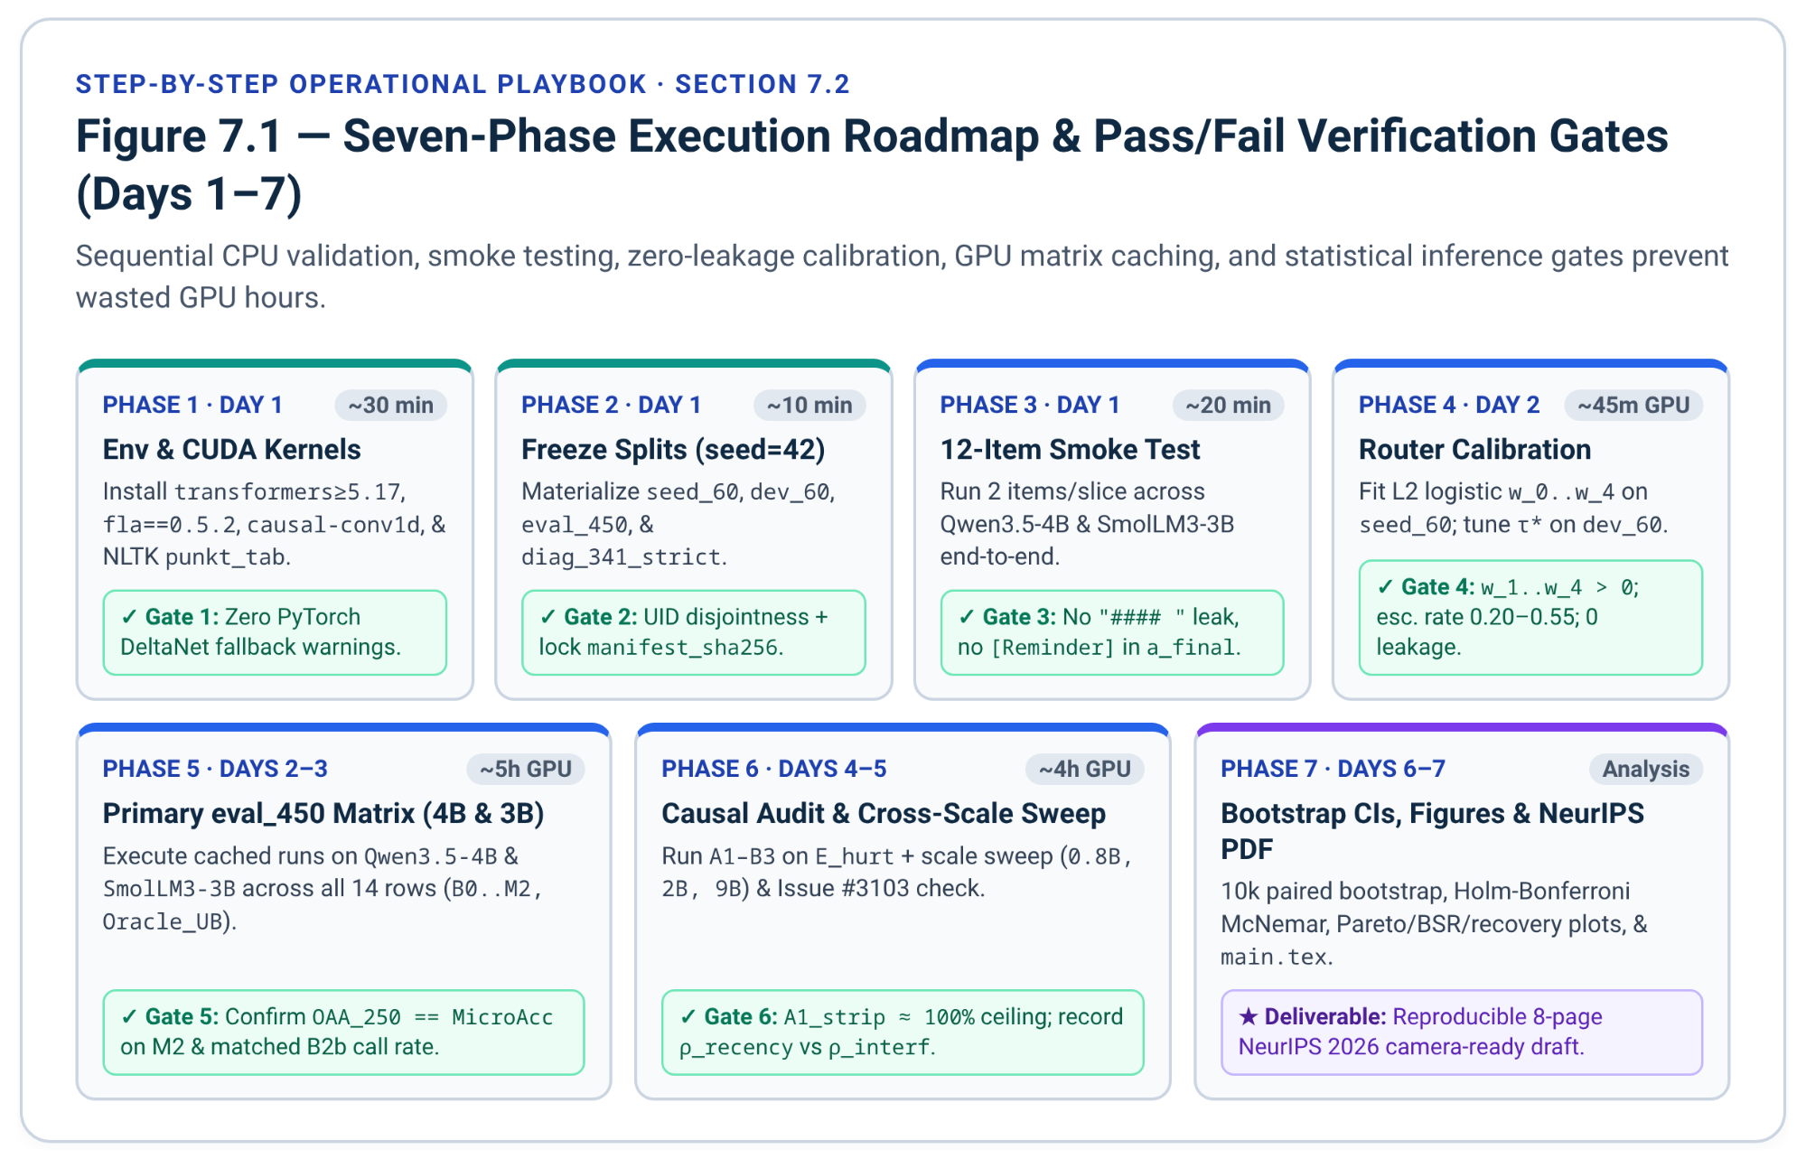

Phase 1: Workspace Provisioning and CUDA Kernel Verification (Day 1, ~30 Minutes)
- Create the repository folders (data/, src/, scripts/, paper/, outputs/) with empty src/__init__.py and place the five Python files from Sections 6.2–6.7¹.
- Run the installation commands in Section 6.1 to install torch>=2.6, transformers>=5.17.0, flash-linear-attention==0.5.2, and causal-conv1d==1.7.0²¹, vendor instruction_following_eval⁸⁶, and download NLTK punkt_tab⁹⁵.
- Verification Gate 1: Execute a 1-line kernel check to ensure transformers does not print the >10x slower PyTorch fallback warning (chunk_gated_delta_rule is falling back or causal_conv1d_fn is falling back)²¹:
python -c "import fla, causal_conv1d; from langdetect import DetectorFactory; print('FLA + causal_conv1d + langdetect OK')"

Phase 2: Deterministic Split Freezing and Integrity Check (Day 1, ~10 Minutes)
- Run python data/freeze_datasets.py once (seed = 42) to build seed_60.jsonl, dev_60.jsonl, eval_450.jsonl, ifeval_diag_491.jsonl, ifeval_diag_341_strict.jsonl, and manifest_sha256.json¹.
- Verification Gate 2: Confirm all five files exist, UID intersection assertions pass with zero errors, and eval_450.jsonl contains exact counts (75 gsm8k_easy, 75 gsm8k_hard, 150 csqa, 60 ifeval_planning, 60 ifeval_precision, 30 ifeval_conflict)¹. Record manifest_sha256.json in your lab log and never modify data/ afterward.

Phase 3: End-to-End 12-Example Pipeline Smoke Test (Day 1, ~20 Minutes)
- Before launching multi-hour runs, slice 2 items per eval_450 category (12 items total) into /tmp/smoke_12.jsonl and run CBARRDualModeEngine across Qwen/Qwen3.5-4B and HuggingFaceTB/SmolLM3-3B.
- Verification Gate 3: Inspect the raw JSON outputs on the 12 items to confirm:
  - B0 and non-escalated Gate-2 IFEval outputs do not start with "#### " and do not truncate mid-sentence at 32 tokens;
  - M2 truncated traces contain \nOkay, I think I have finished thinking.\n</think>\n inside the context prompt¹⁶, while a_final under post_stripped contains zero leaked [Reminder: ...] wrapper text¹⁶;
  - SmolLM3-3B rendered prompts show the frozen Today Date: 01 November 2026 string rather than changing across midnight²⁹.

Phase 4: Zero-Leakage Router Calibration on seed_60 and dev_60 (Day 2, ~45 Minutes GPU)
- scripts/run_matrix.py automatically executes seed_60 and dev_60 first, fitting CBARRCalibrator logistic coefficients $(w_{0},…,w_{5})$ and $τ_{H,high}$ on seed_60 and sweeping $τ∈[0.15,0.85]$ on dev_60 to maximize $U_{0.05}$¹⁶.
- Verification Gate 4: Inspect calibrated_params in matrix_summary.json after calibration completes: confirm positive entropy/inertia weights (w_1, w_2, w_3, w_4 > 0), reasonable dev escalation rate (m2_escalation_rate_dev typically between 0.20 and 0.55), and verify that eval_450 was never touched during parameter fitting.

Phase 5: Primary eval_450 Matrix Execution (Qwen3.5-4B & SmolLM3-3B) (Days 2–3, ~5 Hours GPU)
- Launch the full cached evaluation matrix on both primary backbones (using --strict-diag first so diagnostic controls run on the 341 strictly eval_450-disjoint IFEval items):
python scripts/run_matrix.py --model Qwen/Qwen3.5-4B --strict-diag
python scripts/run_matrix.py --model HuggingFaceTB/SmolLM3-3B --strict-diag
- Because cache_split_primitives flushes each completed UID to eval_450_cache.jsonl, any preempted job resumes from the exact last item without recomputing prior generations.
- Verification Gate 5: Check that tables_rows.tex contains all 14 rows (B0–B2b, M1a–M1c, M2_B64, M2_B128, M2_B256, M2_Pre, M2, and Oracle_UB), verify M2 achieves T_delib <= 250 (OAA_250 == MicroAcc on eval_450)¹⁶, and verify B2b mean call count matches M2 within sampling noise (1 + p).

Phase 6: Causal Diagnostic Control & Cross-Scale Sweep (0.8B, 2B, 9B) (Days 4–5, ~4 Hours GPU)
- Re-run scripts/run_matrix.py without --strict-diag (reusing cached overlapping items) if you wish to report both the N = 341 strictly disjoint and N = 491 calibration-disjoint $E_{hurt}$ pools in Table 3¹⁶, and compute sensitivity after excluding the four Issue #3103 upstream IFEval keys (30, 337, 2078, 3311)²⁴.
- Run the cross-scale Qwen3.5 checkpoints to populate Table 2 (loop_rate, exhaust_rate, % Helped, % Hurt, and M2 token savings across model scale)⁴:
python scripts/run_matrix.py --model Qwen/Qwen3.5-0.8B --strict-diag
python scripts/run_matrix.py --model Qwen/Qwen3.5-2B --strict-diag
python scripts/run_matrix.py --model Qwen/Qwen3.5-9B --strict-diag
- Verification Gate 6: Inspect section6_diagnostics.causal_attribution in matrix_summary.json for Qwen3.5-4B and SmolLM3-3B: verify A1_strip approaches ~100% recovery on $E_{hurt}$, compare B2a_post_anchor vs. B1_pre_anchor vs. B2b_post_raw, and record $ρ_{recency}$ and $ρ_{interference}$ across Inhibition and Structural subsets¹⁶.

Phase 7: Statistical Inference, Pareto Visualization, and Manuscript Assembly (Days 6–7)
- Compute 10,000-resample paired bootstrap 95% CIs (paired_bootstrap_diff_ci) for MacroAcc, OAA_250, and U_0.05 (M2 - B1b, M2 - B0, and M2 - M1c), alongside Holm-Bonferroni adjusted exact and mid-$p$ McNemar tests¹.
- Plot three high-density figures:
  - The accuracy-vs.-mean-tokens Pareto curve (B0, B1a, B1b, B2a, B2b, M1a, M1b, M1c, M2-64/128/256, M2, Oracle_UB);
  - The BSR(B) curve across total-token SLA ceilings $B∈\{64,128,256,512,1024,2048\}$; and
  - The grouped bar chart of $E_{hurt}$ recovery (Trace Stripping vs. Post-Think Re-Anchoring vs. Math Filler) across Qwen3.5-4B and SmolLM3-3B.
- Paste tables_rows.tex directly into the booktabs templates in paper/main.tex (Section 6.8) and compile the 8-page manuscript PDF (UT Austin CS388 report first, then the arXiv and 2027-venue version)¹.

7.3 GPU Memory, Token Volume, and Wall-Clock Compute Budget
Because AutoModelForCausalLM drops the vision encoder and MTP heads when loading Qwen/Qwen3.5-* as Qwen3_5ForCausalLM²⁰, every primary and control checkpoint fits comfortably on a single 24 GB consumer/cloud GPU (RTX 4090, L4, or A10G), while Qwen3.5-9B runs cleanly on a single 24 GB–40 GB GPU in bfloat16:
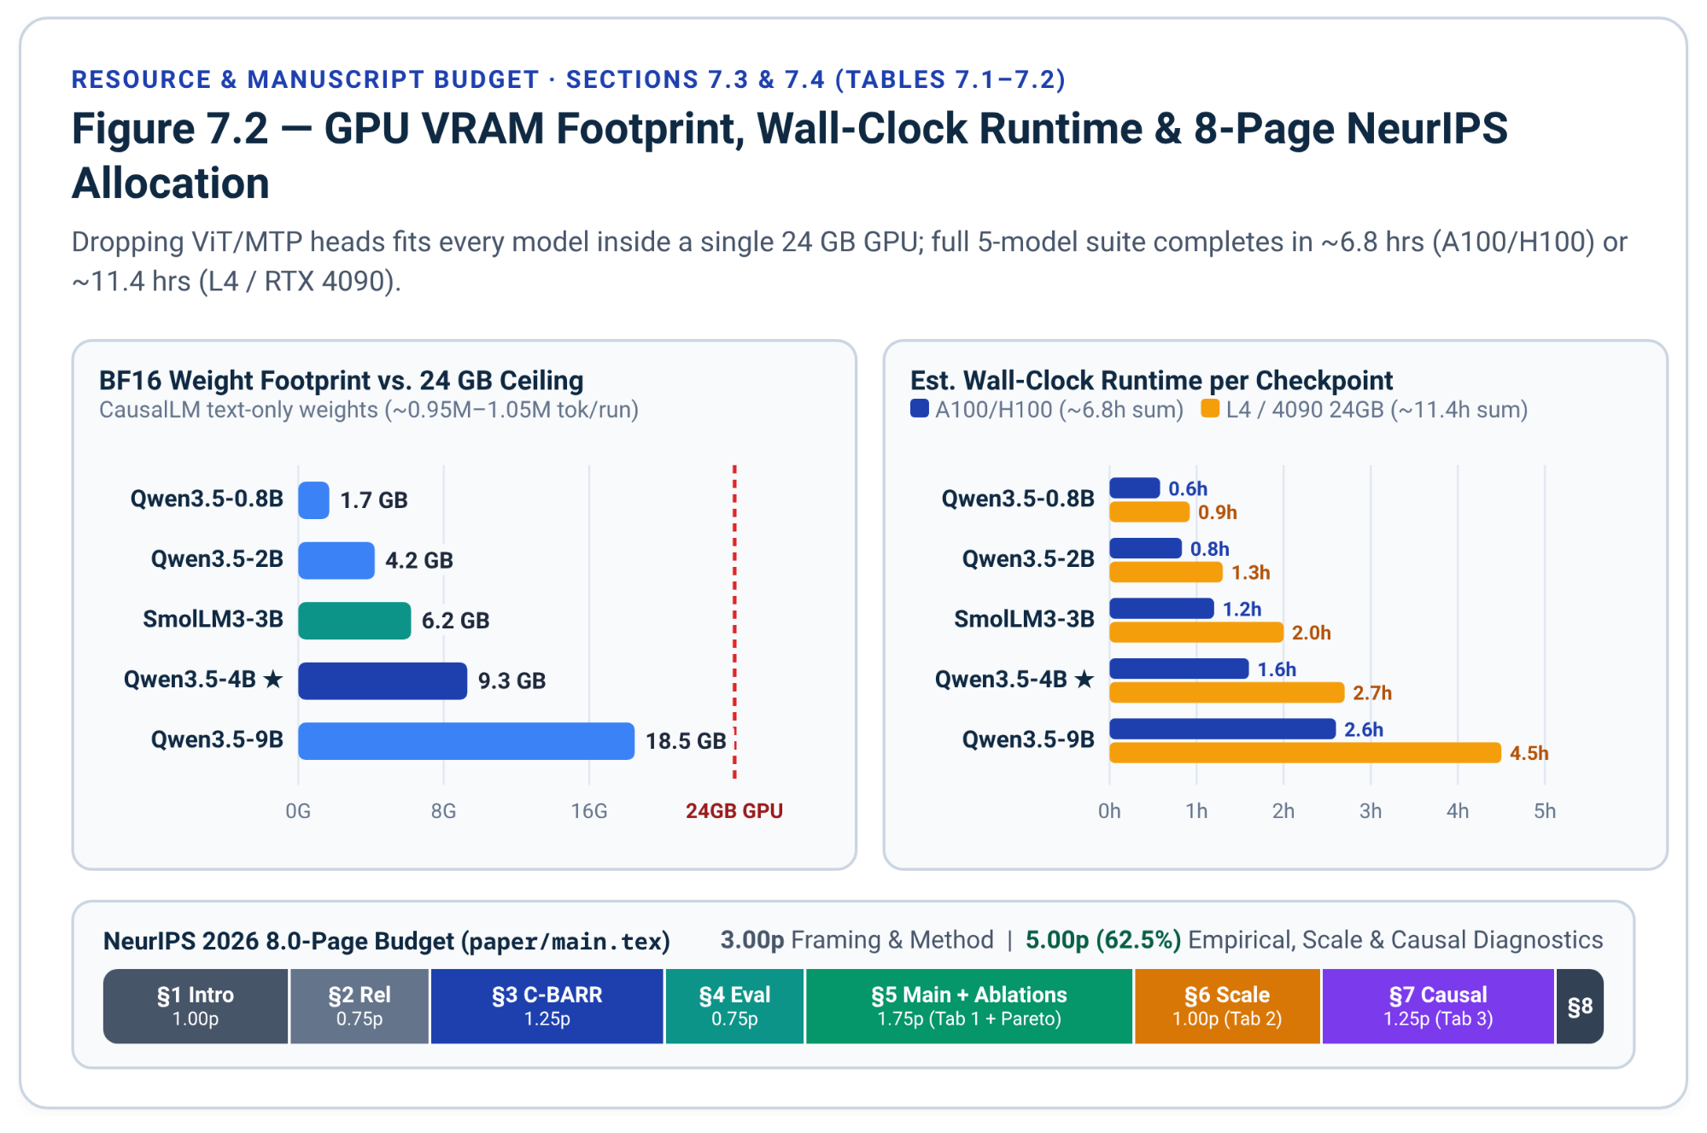
Model Checkpoint | BF16 Weight Footprint | Min Recommended GPU VRAM | Est. Atomic Tokens (seed_60 + dev_60 + eval_450) | Est. Runtime (1x A100-40GB / H100) | Est. Runtime (1x L4 / RTX 4090 24GB)
Qwen/Qwen3.5-0.8B⁴ | ~1.7 GB | 8 GB | ~0.95M tokens | ~35 min | ~55 min
Qwen/Qwen3.5-2B¹² | ~4.2 GB | 12 GB | ~0.95M tokens | ~50 min | ~1.3 hrs
HuggingFaceTB/SmolLM3-3B¹³ | ~6.2 GB | 16 GB | ~1.05M tokens | ~1.2 hrs | ~2.0 hrs
Qwen/Qwen3.5-4B (Primary)¹⁰ | ~9.3 GB | 16-24 GB | ~1.05M tokens | ~1.6 hrs | ~2.7 hrs
Qwen/Qwen3.5-9B (Scale Upper)¹¹ | ~18.5 GB | 24-40 GB | ~1.05M tokens | ~2.6 hrs | ~4.5 hrs (24GB tight KV)

7.4 Eight-Page Manuscript Blueprint and Contingency Matrix
Submission target (updated 14 Nov 2026). This blueprint was drafted for NeurIPS 2026, whose paper deadline (6 May 2026) has passed. The manuscript now ships first as the UT Austin CS388 report (Track A) and then as an arXiv preprint plus a 2027 conference submission (Track B: ICML 2027, ACL 2027 via ACL Rolling Review, or NeurIPS 2027). The 8-page allocation below is unchanged; deadlines and the venue comparison are in the Detailed Master Plan (section 5) and the Free Fast Venues tab.
Structure paper/main.tex to balance methodological formulation and empirical analysis directly in page allocation (1.75 pages motivation/method vs. 6.25 pages controlled experiments, ablations, and mechanistic diagnostics)¹:
Section in paper/main.tex | Target Length | Core Content, Tables, and Figures | Pre-Registered Contingency if Empirical Surprise Occurs
§1. Introduction & Motivation | 1.0 page | Overthinking vs. constraint-drift dilemma⁷; preview of C-BARR dual-signal architecture and causal attribution findings. Attribute Thinking Inertia to Lei et al.⁹⁷ at first use. | If Qwen3.5-4B shows small net B1b - B0 IFEval delta, highlight bidirectional flip rate (10%-24%)⁷ and huge token waste (OAA_250)³⁰.
§2. Related Work & Backbones | 0.75 page | Contrast against s1⁵, NoThinking²³, DEER⁹, EntroCut⁸, Classifier-Selective⁶; Gated DeltaNet (Qwen3.5) vs. Dense GQA (SmolLM3)¹⁰. Add the 2026 neighbors DART⁹⁸, Save Thinking?⁹⁹, PAC¹⁰⁰ / B-PAC¹⁰¹, Prompt Repetition¹⁰² and Spotlight¹⁰³. | Keep concise; cite exact fast-weight decay equation $S_{t}$⁶⁸ to ground Section 6.
§3. C-BARR Method (Dual-Signal Cascade) | 1.25 pages | Gate 1 regex router + clause extractor, Gate 2 32-token entropy + inertia probe, $B∈\{64,128,256\}$ P_TERM + Post-Think Stripped Re-Anchor (M2), architecture diagram. | If B=256 slightly underfits multi-step GSM-H (>6 steps), report one auxiliary B=512 point on the Pareto plot while keeping {64, 128, 256} as primary OAA_250-optimal M2.
§4. Experimental Setup & Metrics | 0.75 page | Zero-overlap seed_60 / dev_60 / eval_450 / diag_341 protocol; MacroAcc, OAA_250, AUC_OAA, U_0.05, BSR(B), McNemar + Holm-Bonferroni¹. | Report clean-subset IFEval check excluding Issue #3103 keys (30, 337, 2078, 3311) in a 2-sentence footnote²⁴.
§5. Main Results & Ablations | 1.75 pages | Table 1 (B0–M2 + Oracle_UB), Pareto frontier figure, Lexical Gate 1 (M1a) vs. Entropy/Inertia Gate 2 (M1b) vs. Cascade (M1c), and B in {64, 128, 256} cap sweep. | If M2_Pre beats M2 (Post-Stripped) on Inhibition rules, report both in Table 1 as a novel locus discovery!
§6. Cross-Scale & Loop Audit | 1.0 page | Table 2 (Qwen3.5 0.8B/2B/4B/9B + SmolLM3-3B): 4-gram greedy loop rates⁴, B=2048 exhaustion, and BSR(B) curves. | If GPU time is tight, 0.8B + 4B + SmolLM3-3B already spans 5x scale + architectural control cleanly.
§7. Causal Diagnostic Analysis | 1.25 pages | Table 3: Trace Stripping (A1) vs. Post-Think Re-Anchoring (B2a), Pre-Anchor (B1), Unstripped (B2b), and Math Filler (A2) on $E_{hurt}$; $ρ_{recency}$ vs. $ρ_{interference}$ across DeltaNet vs. Dense GQA¹⁶. | If diag_341_strict yields <25 E_hurt items on Qwen3.5-4B, report both diag_341_strict and diag_491 (both 100% calibration-disjoint) for statistical power¹⁶.
§8. Conclusion & Limitations | 0.25 page | Summary of findings, greedy vs. stochastic sampling caveat⁴, and paraphrased-constraint boundary cases⁸⁴. | Note optional 3-seed temperature=0.6 validation in Appendix.

Nov 9, 2026
- Long Do, tuanb2610@gmail.com - read to fully understand
- Long Do - try to start implementing phase 1-3 from 10/11/2026

C-BARR Master Execution & Submission Plan
This master plan unifies engineering patches, GPU execution, causal diagnostics, novelty compliance, and dual-track delivery for Cascaded Budgeted Adaptive Reasoning Routing (C-BARR) across Tabs 1–7, the UT Austin CS388 alignment (Tab 9), the November 8, 2026 Exposure Audit (Tab 10), and the state-intervention extensions (NLP Draft Note).
- Scope: Pre-flight fixes for four codebase defects (D13–D16), deterministic split freezing, GPU runs across five checkpoints (Qwen3.5 0.8B/2B/4B/9B and SmolLM3-3B), E_hurt causal attribution, 2026 bibliography/anonymization updates, and manuscript delivery.
- Non-Scope: Backbone SFT/RL weight updates, external 7B router training, and multilingual transfer.
- Prerequisites: Python 3.12, CUDA 12.x, 1× 24–40 GB GPU (L4, RTX 4090, or A100), 35 GB disk for JSONL caches, and private repository storage until arXiv release.

Executive Summary: Binding Decisions & Immediate Actions
Running Tab 6 and Tab 7 unmodified introduces four silent defects (D13–D16) and targets a closed cycle (NeurIPS 2026). The table below locks six pre-flight decisions:

Decision Area | Gap in Draft (Tabs 6–7 & 10) | Binding Action | Pass Gate
1. Lane-2 Cap (D13) | m2_b256_direct uses budget_b=256, failing OAA_250 (T_delib ≤ 250) upon truncation. | Cap m2_b256_direct and m2_pre_b256_direct at budget_b=250 across all scripts. | OAA_250 == MicroAcc on 100% of M2 runs.
2. Answer Cap (D14) | max_ans_tokens=512 truncates ≥ 400-word and dual-response IFEval items (~700 tokens). | Raise max_ans_tokens (and B0 max_new_tokens) to 1024 across B0, Gate 2, M2, and controls. | 0 artificially truncated valid length responses.
3. Cache Dedup (D15) | cache_split_primitives runs 14 passes/item (6,300 calls), repeating identical greedy runs. | Alias m2_pre_* = m2_* when anchor_clause == "", reuse b0 on empty prefix, and reuse natural b1b. | Cuts ≥ 1,350 calls/model (≥ 21.4%), bit-identical JSONL.
4. Spillover Metric (D16) | BSR(B) tracks SLA success, leaving post-</think> CoT spillover after P_TERM cuts unlogged. | Log has_cot_spillover(a_final) in src/graders.py alongside BSR(B), loop_rate, and exhaust_rate. | Quantifies post-cut CoT leakage in §5 & §7.
5. Audit & Anonymity | "Thinking Inertia" collides with arXiv:2610.11765; 5 2026 papers missing; .bib leaks author URLs. | Cite Lei et al. + 5 2026 baselines; scrub Refs #1–3, #16; rename CBARRDualModeEngine. | 0 author leaks in PDF; complete 2026 table.
6. Venue Roadmap | Tab 7 targets NeurIPS 2026 (review cycle closed ahead of Dec 2026 conference). | Ship Track A (UT Austin CS388) first; target Track B (arXiv + ICML / ACL ARR / NeurIPS 2027). | CS388 locked first; 8-page venue + arXiv next.
Execute these five Day-1 pre-flight actions in strict order before launching eval_450 runs:
- Apply patches D13–D16 across src/graders.py, src/engine.py, and scripts/run_matrix.py, and rename DualModeEngine to CBARRDualModeEngine.
- Verify flash-linear-attention==0.5.2 and causal-conv1d==1.7.0 CUDA kernels so Qwen3.5 avoids the > 10× slower PyTorch fallback.
- Run data/freeze_datasets.py (seed = 42) once, record manifest_sha256.json, and mark data/*.jsonl read-only.
- Pass the 12-item smoke gate (W3) on Qwen/Qwen3.5-4B and HuggingFaceTB/SmolLM3-3B.
- Add the six missing 2025–2026 citations to paper/references.bib and remove internal/resume entries (Refs #1, #2, #3, #16).

1. Pre-Flight Codebase Remediation (Patches D13–D16)
Audit of Tab 6 uncovered four issues beyond Tab 5 (D1–D12). Update the repository before W1 sign-off:
- D13 (scripts/run_matrix.py lines 1407, 1421): Set budget_b=250 on m2_b256_direct and m2_pre_b256_direct (and cap select_tiered_budget at 250) so truncated Lane-2 conflict items (T_probe = 0) never exceed T_delib ≤ 250 under OAA_250.
- D14 (src/engine.py lines 647, 753, 797, 923): Raise max_new_tokens / max_ans_tokens from 512 to 1024 so 400–500-word essays, repeat_prompt, and two_responses items never clip mid-output while B1a/B2a allow 2048 tokens.
- D15 (scripts/run_matrix.py lines 1356–1432): Under do_sample=False, skip duplicate GPU runs using three exact identities in cache_split_primitives:

fast_done = (

dict(b0)

if probe["ans_prefix"] == ""

else _annotate_run(item, engine.complete_fast_probe(probe, max_ans_tokens=1024))

)

def _run_or_reuse_m2(budget_val: int, locus: str) -> dict[str, Any]:

if (

not g1.anchor_clause

and not b1b["think_exhausted"]

and not b1b["truncated"]

and int(b1b["T_think"]) <= budget_val

):

return dict(b1b)

return _annotate_run(

item,

engine.run_capped_think_and_anchor(

prompt,

budget_b=budget_val,

anchor_clause=g1.anchor_clause,

max_ans_tokens=1024,

allow_budget_force=True,

anchor_locus=locus,

),

)

if not g1.anchor_clause:

for k_suf in ("b64", "b128", "b256", "b256_direct"):

rec[f"m2_pre_{k_suf}"] = dict(rec[f"m2_{k_suf}"])

- D16 (src/graders.py, src/metrics.py): Define SPILLOVER_RE = re.compile(r"^\s*(?:wait[,:\s]|let's\s+think|step\s+1\b|hmm[,:\s])", re.I) on a_final when truncated=True to separate Budget-Constrained Success Rate (BSR(B)) from post-</think> CoT spillover (spillover_rate).

2. Dataset Splits & Routing Heuristic Breakdown
All splits freeze deterministically at seed = 42 with zero UID overlap across calibration (seed_60, dev_60), evaluation (eval_450), and strict diagnostics (ifeval_diag_341_strict). The table below states all corpus partitions and routing thresholds once:

Partition / Heuristic | Pool Size | Count & Percentage Breakdown | Operational Function
seed_60.jsonl | 60 (100%) | 15 GSM-tr (25.0%), 15 CSQA-tr (25.0%), 15 IFE-Plan (25.0%), 15 IFE-Prec (25.0%) | Fits balanced L2 logistic weights (w_1..w_5, b) and median τ_H.
dev_60.jsonl | 60 (100%) | 10 GSM-E (16.7%), 10 GSM-H (16.7%), 20 CSQA-tr (33.3%), 10 IFE-Plan (16.7%), 10 IFE-Prec (16.7%) | Sweeps 29 thresholds τ ∈ [0.15, 0.85] maximizing U_0.05; sets B2b rate p.
eval_450.jsonl | 450 (100%) | 75 GSM-E (16.7%), 75 GSM-H (16.7%), 150 CSQA-val (33.3%), 60 IFE-Plan (13.3%), 60 IFE-Prec (13.3%), 30 IFE-Conf (6.7%) | Primary benchmark; MacroAcc weights all 6 slices equally (16.67% each).
google/IFEval Pool | 541 (100%) | 30 seed (5.5%), 20 dev (3.7%), 150 eval (27.7%), 341 diag_341_strict (63.0%); 491 diag_491 (90.8%); 4 defect keys (0.74%) | Isolates zero-overlap E_hurt causal pool (N = 341) + high-power N = 491 check.
Gate 1 25 Templates | 25 (100%) | 10 Planning (40.0%), 5 Inhibition Precision (20.0%), 10 Structural Precision (40.0%) | Pure Precision → Lane 1 (B = 0); Planning → Lane 2 (B ∈ {128, 250} + post_stripped).
M2 Budget Schedule | 4 Lanes | B = 0 (Lanes 1 & 3), B = 64 (MC esc.), B = 128 (mod. esc./plan), B_eff = min(250, 250 - T_probe) (hard/conflict) | Bounds deliberative cost at T_probe + T_think ≤ 250 (100% OAA_250 compliance).

3. Eight-Workstream Execution Schedule & Verification Gates
Execution follows a staged dependency graph: pre-flight validation (W1–W3) unlocks calibration (W4) and primary two-backbone evaluation (W5), which then branches into cross-scale sweeps (W6) and optional internal-state ablations (W7):
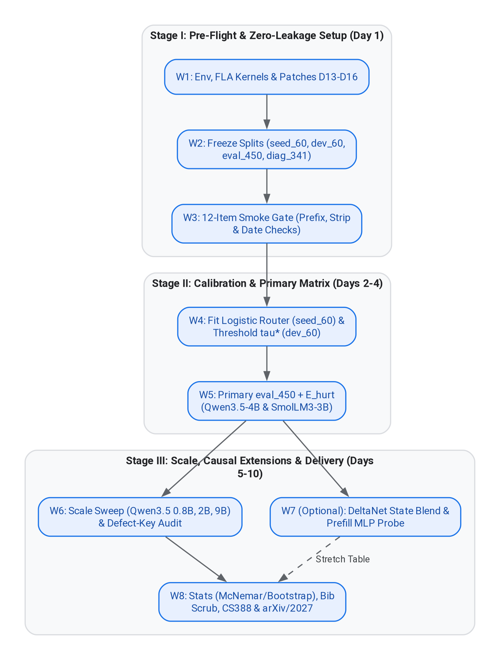
Open Interactive Mermaid Diagram
The table below specifies timelines, deduplicated GPU hours (A100-40GB / L4-24GB), commands, and pass/fail gates across W1–W8 (6.7h mandatory A100 compute, 7.7h with W7):

ID & Window | Workstream & Artifacts | GPU (A100 / L4) | Concrete Execution Steps | Quantitative Pass / Fail Gate
W1 (Day 1 AM) | Env, Kernels & D13–D16 (src/*.py, run_matrix.py) | 0.1h / 0.1h | Install torch≥2.6, transformers≥5.17.0, flash-linear-attention==0.5.2, causal-conv1d==1.7.0; vendor instruction_following_eval + NLTK punkt_tab; apply D13–D16. | 0 PyTorch DeltaNet fallback warnings; DetectorFactory.seed == 0; 25/25 regex template unit test passes.
W2 (Day 1 PM) | Split Freeze (data/*.jsonl, manifest_sha256.json) | 0.0h (CPU) | Run python data/freeze_datasets.py; set chmod 444 data/*.jsonl data/manifest_sha256.json. | Exact counts (60, 60, 450, 491, 341); pairwise UID intersections empty; slice counts 75/75/150/60/60/30.
W3 (Day 1 PM) | 12-Item Smoke Gate (/tmp/smoke_12.jsonl) | 0.2h / 0.3h | Run 2 items/slice on Qwen3.5-4B and SmolLM3-3B; inspect prefixes, a_final, and token sums. | 0 non-math "#### " prefixes; 0 leaked [Reminder: text in a_final; frozen Today Date: 01 November 2026.
W4 (Day 2) | Router Calibration (seed_60 & dev_60 caches) | 0.6h / 1.0h | Cache seed_60 + dev_60 across all 5 checkpoints; fit CBARRCalibrator and log calibrated_params. | 0.15 ≤ m2_escalation_rate_dev ≤ 0.65; eval_450 untouched during fitting.
W5 (Days 2–4) | Primary Matrix & E_hurt (Qwen3.5-4B & SmolLM3-3B) | 2.6h / 4.4h | Run run_matrix.py --strict-diag (N = 341) then reuse cache for N = 491 on Qwen3.5-4B (9.3 GB) and SmolLM3-3B (6.2 GB). | 14 Table-1 rows emitted; M2 OAA_250 == MicroAcc; abs(B2b_calls - M2_calls) ≤ 0.05; A1_strip recovery ≥ 85%.
W6 (Days 5–6) | Scale Sweep & Defect Check (Qwen3.5 0.8B, 2B, 9B) | 3.2h / 5.5h | Run --strict-diag on 0.8B (1.7 GB), 2B (4.2 GB), and 9B (18.5 GB); recompute IFEval excluding keys {30, 337, 2078, 3311}. | Table 2 completes across 5 models; clean-446 vs. full-450 sensitivity delta logged for §4 footnote.
W7 (Day 7, Opt.) | Tier 1 & 2 Stretch Ablations (state_blend, prefill_mlp) | 1.0h / 1.5h | Blend Qwen3.5-4B DeltaNet S_prompt (λ ∈ {0.25, 0.50}) at </think> on E_hurt; train 2-layer MLP on seed_60 + dev_60 prefill states. | Zero-token state recovery compared vs. B2a_post_anchor; MLP vs. regex recall compared on eval_450.
W8 (Days 8–10) | Stats, Plots, Audit & Delivery (paper/main.tex) | 0.0h (CPU) | Run 10,000-boot CIs + Holm-Bonferroni McNemar; plot 3 vector figures; scrub .bib; compile CS388 & 8-page venue PDFs. | All p_holm & CIs verified; 0 PDF metadata/bib leaks; main text strictly ≤ 8 pages.
Execute W2–W6 with crash-safe per-UID JSONL resumption via the commands below:

python data/freeze_datasets.py && chmod 444 data/*.jsonl data/manifest_sha256.json

for MODEL in Qwen/Qwen3.5-4B HuggingFaceTB/SmolLM3-3B; do

python scripts/run_matrix.py --model "${MODEL}" --strict-diag

python scripts/run_matrix.py --model "${MODEL}"

done

for MODEL in Qwen/Qwen3.5-0.8B Qwen/Qwen3.5-2B Qwen/Qwen3.5-9B; do

python scripts/run_matrix.py --model "${MODEL}" --strict-diag

done

4. Literature, Attribution & Double-Blind Remediation (Tab 10)
Status (14 Nov 2026): the document-side part of these edits is applied. Thinking Inertia is attributed to Lei et al. in the Executive Overview and Tabs 1 and 3; the five 2025–2026 neighbors are in Table 1.1 and Section 1.2; Works Cited has entries 97–103 and marks entries 1, 2, 3 and 16 as not for export; Tabs 6–7 use CBARRDualModeEngine and venue-neutral wording (rows 5–6 of the decision table above describe the draft before these edits). Still open: Figures 6.1, 7.1 and 7.2 (images that still show DualModeEngine or NeurIPS 2026), the repository itself, paper/references.bib, and the pdfinfo metadata check.
The Exposure Audit confirmed zero public leaks or scooping of C-BARR, while flagging three mandatory W8 edits:
- Attribute "Thinking Inertia" (§1.1, §3.2): Cite Lei et al. (arXiv:2610.11765, NeurIPS 2026) on first mention, contrasting their offline audit metrics (ETR, QRel., EIR) and prompt suppression (~15 pp open-ended loss) against Gate 2's online ≤ 32-token escalation feature I_inertia(x).
- Integrate Five 2025–2026 Baselines into Table 1.1 & §2:
  - DART (arXiv:2606.23181, EMNLP 2026 Findings): Needs k = 2 full stochastic drafts (T = 0.7), answer-equivalence checks invalid on open-ended IFEval essays, and 3.5K–5.4K math token budgets.
  - Save Thinking? (Zhu et al., 2026.findings-emnlp.761): Static P_TERM prefill and question-attention zeroing degrade multi-step math accuracy without adaptive escalation.
  - PAC / B-PAC Reasoning (arXiv:2510.09133, NeurIPS 2026; arXiv:2601.22446, ICML 2026): Assumes Think ≥ NoThink monotonicity, violated on IFEval-Precision constraints.
  - Prompt Repetition (Leviathan et al., arXiv:2512.14982): User-turn prompt duplication decays across CoT (5 wins, 22 ties), whereas post_stripped re-anchors at 0 token distance after </think>.
  - Spotlight Your Instructions (arXiv:2505.12025, EACL 2026): Pre-softmax attention steering fails on Qwen3.5's 75% Gated DeltaNet recurrent fast-weight layers (128 × 128 S_t).
- Scrub Identifying Metadata & Credit Primitives: Credit Ma et al. (arXiv:2504.09858) in §3.3 for P_TERM, and community fixes in §4.1 for DetectorFactory.seed = 0 and Issue #3103 keys. Delete Refs #1–3 (chuanzhidong.com/resume/) and #16 from references.bib (Ref #96 is a cited Hugging Face script, not the NLP Draft Note, and stays), and verify clean PDF metadata via pdfinfo.

5. Dual-Track Packaging & Stretch Extensions
Package the completed W1–W6 experimental artifacts across two coordinated submission tracks:
- Track A — UT Austin CS388 Deliverable (Immediate): Position under Inference and grounding — Reasoning Methods (primary) and Analysis and evaluation — Behavioral Evaluation and Robustness (secondary), centering on the B0–M2 ablation ladder and the Qwen3.5-4B vs. SmolLM3-3B E_hurt causal decomposition (ρ_recency vs. ρ_interference).
- Track B — arXiv Priority & 2027 Conference (ICML / ACL ARR / NeurIPS 2027): Post to arXiv immediately upon W8 completion, pairing the core study with two W7 ablations (≤ 1.5 GPU hours from NLP Draft Note):
  - Extension E1 — DeltaNet State Interpolation (Tier 1): Snapshot Qwen3.5-4B's 24 DeltaNet states S_prompt at prompt end on E_hurt and blend S_post = (1 - λ) S_end + λ S_prompt (λ ∈ {0.25, 0.50}) at </think> to benchmark 0-token state restoration against B2a_post_anchor.
  - Extension E2 — Prefill Hidden-State MLP (Tier 2, < 1M params): Train a 2-layer MLP (< 5 min) on layer-16 last-prompt-token activations across seed_60 + dev_60 to measure paraphrased constraint recall versus Gate 1 regexes.

6. Risk Register & Pre-Registered Contingencies
Important: Lock all contingency rules below prior to unblinding eval_450 outputs to preserve zero-leakage statistical validity.
The matrix below maps empirical and operational failure modes to pre-registered mitigations:

Risk Scenario | Trigger Threshold | Pre-Registered Action
R1. Small Net B1b - B0 IFEval Delta on Qwen3.5-4B | abs(B1b - B0) < 2.0 pp greedy | Emphasize bidirectional churn (10%–24% total flips) and B1b's OAA_250 collapse (> 300 deliberative tokens).
R2. Small E_hurt Pool in diag_341_strict | len(E_hurt) < 25 prompts | Report diag_341_strict alongside diag_491 (100% calibration-disjoint) in Table 3 with Wilson 95% CIs.
R3. B = 250 Underfits ≥ 6-Step GSM-H | M2 trails B1b by > 3.0 pp on GSM-H | Add one auxiliary M2-512 point on the Figure 1 Pareto curve while keeping {64, 128, 250} as OAA_250-optimal M2.
R4. M2_Pre Beats M2 on Inhibition Rules | B1_pre_anchor - B2a_post_anchor ≥ 3.0 pp | Report locus asymmetry (pre_close for global lexical inhibition vs. post_stripped for wrappers) as a §7 finding.
R5. flash-linear-attention Wheel Failure | pip build fails against host nvcc | Use matching CUDA 12 wheel or vllm/vllm-openai:v0.17.0 container; never run Qwen3.5 on PyTorch fallback.
R6. Greedy vs. Sampled Decoding Pushback | Reviewer requests stochastic regime check | Run 3-seed T = 0.6, top_p = 0.95, presence_penalty = 1.5 check on 0.8B and 4B (~2.5 GPU hrs) for Appendix B.

Works Cited & Reference Sources
Numbered references below correspond 1:1 to the inline citation superscripts across Tabs 1–7. Entries 1, 2 and 16 are this project's own internal specifications and entry 3 was a personal web page; none is a citable source, so they are marked below as not for export to references.bib (double-blind review), and superscripts 1 and 16 in Tabs 1–7 are self-citations to drop or rephrase in the manuscript. Entries 97–103 were added on 14 Nov 2026 (Thinking Inertia attribution and five 2025–2026 neighbors).
- [Internal document: exclude from references.bib] Cascaded Budgeted Adaptive Reasoning Routing (C-BARR): Research Plan & Architecture Specification
- [Internal document: exclude from references.bib] C-BARR Reference Specification & Experimental Protocol
- [Removed for double-blind review: personal web page, never cited inline. Exclude from references.bib.]
- Qwen/Qwen3.5-0.8B - Hugging Face, https://huggingface.co/Qwen/Qwen3.5-0.8B
- s1: Simple test-time scaling - ACL Anthology, https://aclanthology.org/2025.emnlp-main.1025.pdf
- The Pitfalls of Reasoning for Instruction-Following in LLMs - alphaXiv, https://www.alphaxiv.org/abs/2505.11423
- Constraint-Level Error Shifts in Instruction Following - arXiv, https://arxiv.org/pdf/2606.09662
- EntroCut: Entropy-Guided Adaptive Truncation for Efficient Chain-of, https://arxiv.org/pdf/2601.22617
- https://proceedings.iclr.cc/paper_files/paper/2026/file/8df90a1440ce782d1f5607b7a38f2531-Paper-Conference.pdf
- Qwen/Qwen3.5-4B - Hugging Face, https://huggingface.co/Qwen/Qwen3.5-4B
- Qwen/Qwen3.5-9B - Hugging Face, https://huggingface.co/Qwen/Qwen3.5-9B
- Qwen/Qwen3.5-2B - Hugging Face, https://huggingface.co/Qwen/Qwen3.5-2B
- HuggingFaceTB/SmolLM3-3B · Hugging Face, https://huggingface.co/HuggingFaceTB/SmolLM3-3B
- https://huggingface.co/HuggingFaceTB/SmolLM3-3B/blob/main/config.json
- https://arxiv.org/pdf/2311.07911
- [Internal document: exclude from references.bib] C-BARR Codebase & Causal Diagnostic Control Specification
- README.md · zakarth/ifeval-mini-120 at main - Hugging Face, https://huggingface.co/datasets/zakarth/ifeval-mini-120/blob/main/README.md
- jegreene/Swift-1.5-Qwen3.8-27B-heretic-GSQ-RCO-GGUF at 6499ba7, https://huggingface.co/jegreene/Swift-1.5-Qwen3.8-27B-heretic-GSQ-RCO-GGUF/commit/6499ba7bb17e822a6f903c8e3bd79ec5462d5a2f
- How to Deploy Qwen3.5-4B with vLLM - Overshoot AI, https://www.overshoot.ai/blogs/deploy-qwen3.5-4b
- qwen3.5-4b-lora-swanlab.md - GitHub, https://github.com/datawhalechina/hello-rocm/blob/master/docs/en/02-fine-tune/qwen3.5/qwen3.5-4b-lora-swanlab.md
- HopitAI/hopper - Hugging Face, https://huggingface.co/HopitAI/hopper
- Torch fallbacks of the linear-attention ops drop seq_idx / cu_seqlens, https://github.com/huggingface/transformers/issues/49472
- arXiv:2504.09858v1 [cs.AI] 14 Apr 2025, https://arxiv.org/pdf/2504.09858?
- instruction_following_eval: Prompt Errors And kwargs Errors #3103, https://github.com/google-research/google-research/issues/3103
- Download paper/main.pdf from Dhruv1000/qwen35-logra-ifbench, https://huggingface.co/Dhruv1000/qwen35-logra-ifbench/blob/bf0201392abadca182da5bba66439ed0738ea8fd/paper/main.pdf
- chat_template.jinja · Qwen/Qwen3.5-4B at main - Hugging Face, https://huggingface.co/Qwen/Qwen3.5-4B/blob/main/chat_template.jinja
- Do LLMs Trust the Accuser or the Accusation? Measuring Belief, https://aclanthology.org/2026.emnlp-main.1628.pdf
- huggingface-smol-training-playbook-made-by-crawl4ai.md · GitHub, https://gist.github.com/unclecode/e5da5fb6a1d37022b089e243e0d9e00e
- chat_template.jinja · HuggingFaceTB/SmolLM3-3B at main, https://huggingface.co/HuggingFaceTB/SmolLM3-3B/blob/main/chat_template.jinja
- OptimalThinkingBench: Evaluating Over and Underthinking in LLMs, https://arxiv.org/html/2508.13141v1
- Reinforcement Learning for Chain of Thought Compression ... - arXiv, https://arxiv.org/pdf/2601.06052
- When Built-in Thinking Helps and Hurts: Constraint-Level Error, https://www.researchgate.net/publication/406463399_When_Built-in_Thinking_Helps_and_Hurts_Constraint-Level_Error_Shifts_in_Instruction_Following
- Do NOT Think That Much for 2+3=? On the Overthinking of o1-Like, https://ai-search.io/papers/do-not-think-that-much-for-2-3-on-the-overthinking-of-o1-like-llms
- s1: Simple test-time scaling - alphaXiv, https://www.alphaxiv.org/abs/2501.19393
- unsloth/Qwen3.5-4B-Base - Hugging Face, https://huggingface.co/unsloth/Qwen3.5-4B-Base
- [2504.09858] Reasoning Models Can Be Effective Without Thinking, https://arxiv.org/abs/2504.09858
- Reasoning Models Can Be Effective Without Thinking - ResearchGate, https://www.researchgate.net/publication/390772410_Reasoning_Models_Can_Be_Effective_Without_Thinking
- (PDF) Budget-Aware LLM Agents. Evaluation, Failure Modes, and, https://www.researchgate.net/publication/405474946_Budget-Aware_LLM_Agents_Evaluation_Failure_Modes_and_Trainable_Cost_Control
- https://arxiv.org/pdf/2412.18547
- L1: Controlling How Long A Reasoning Model Thinks With, https://openreview.net/forum?id=4jdIxXBNve
- Wait, We Don't Need to “Wait”! Removing Thinking Tokens Improves, https://arxiv.org/html/2506.08343v2
- L1: Controlling How Long A Reasoning Model Thinks With ... - arXiv, https://arxiv.org/abs/2503.04697
- L1: Controlling How Long A Reasoning Model Thinks With, https://cmu-l3.github.io/l1/
- [2505.13379] Thinkless: LLM Learns When to Think - arXiv, https://arxiv.org/abs/2505.13379
- MAGO: BEYOND FIXED HYPERPARAMETERS WITH MULTI, https://proceedings.iclr.cc/paper_files/paper/2026/file/dfdc9c54cd62f2b2bfd8b090b3489b7f-Paper-Conference.pdf
- AdaptThink: Reasoning Models Can Learn When to Think - arXiv, https://arxiv.org/abs/2505.13417
- arXiv:2505.13417v1 [cs.CL] 19 May 2025, https://arxiv.org/pdf/2505.13417
- SelfBudgeter: Adaptive Token Allocation for Efficient LLM Reasoning, https://arxiv.org/abs/2505.11274
- Learning to Mitigate Under-Over Thinking via Adaptive, Attentive, https://openreview.net/pdf?id=ZSeKA0LrJg
- Correct, Concise and Complete: Multi-stage Training For Adaptive, https://aclanthology.org/2026.findings-acl.622/
- Multi-stage Training for Adaptive Reasoning - ACL Anthology, https://aclanthology.org/2026.findings-acl.622.pdf
- Neha Anna John - CatalyzeX, https://www.catalyzex.com/author/Neha%20Anna%20John
- Thinkless: LLM Learns When to Think - arXiv, https://arxiv.org/html/2505.13379v2
- When Thinking Fails: The Pitfalls of Reasoning for... - OpenReview, https://openreview.net/forum?id=w5uUvxp81b
- Switchable and Balanced Training for Efficient LLM Reasoning, https://ojs.aaai.org/index.php/AAAI/article/view/40799/44760
- [2505.14183] ThinkSwitcher: When to Think Hard, When to Think Fast, https://arxiv.org/abs/2505.14183
- ThinkSwitcher: When to Think Hard, When to Think Fast, https://aclanthology.org/2025.findings-emnlp.278.pdf
- ThinkSwitcher: When to Think Hard, When to Think Fast - arXiv, https://arxiv.org/html/2505.14183v1
- EntroCut: Entropy-Guided Adaptive Truncation for Efficient Chain-of, https://arxiv.org/abs/2601.22617
- Early Stopping in Large Reasoning Models: A Survey and Empirical, https://arxiv.org/html/2611.00166v1
- The Pitfalls of Reasoning for Instruction-Following in LLMs - arXiv, https://arxiv.org/abs/2505.11423
- ThinkJev: One Thought, Every Budget for Calibrated Typed ... - ai007, https://www.ai007.site/news/83148
- ThinkJev: One Thought, Every Budget for Calibrated Typed Decisions, https://arxiv.org/html/2610.37732v1
- litert-community/Qwen3.5-0.8B - Hugging Face, https://huggingface.co/litert-community/Qwen3.5-0.8B
- jaredpalmer/kev-0.8b - Hugging Face, https://huggingface.co/jaredpalmer/kev-0.8b
- Artificial Intelligence Nov 2026 - arXiv, https://arxiv.org/list/cs.AI/current
- GSM8K Arithmetic Benchmark Overview - Emergent Mind, https://www.emergentmind.com/topics/gsm8k-arithmetic-benchmark
- Gated Delta Networks: Improving Mamba2 with Delta Rule - arXiv, https://arxiv.org/pdf/2412.06464
- wejyy888/Qwen3.5-0.8B-PureText-ZH-EN-v5.2 - Hugging Face, https://huggingface.co/wejyy888/Qwen3.5-0.8B-PureText-ZH-EN
- README.md · techwithsergiu/Qwen3.5-text-2B at 6b04e0e, https://huggingface.co/techwithsergiu/Qwen3.5-text-2B/blob/6b04e0e5da581b8cd3821b69e198b7c7260c8612/README.md
- https://huggingface.co/art-dsit/qwen3.5-4b-no-robots-lora/resolve/main/README.md?download=true
- techwithsergiu/Qwen3.5-text-4B - Hugging Face, https://huggingface.co/techwithsergiu/Qwen3.5-text-4B
- flashback2k/FlashModel-Qwen3.5-9B · Hugging Face - Qwak, https://cdn-avatars.qwak.ai/flashback2k/FlashModel-Qwen3.5-9B
- Qwen3.5 / Qwen3.6 MoE · Halo Docs - White Circle, https://whitecircle.com/halo/docs/agent-docs/models/qwen3_5
- ruisv/bllm-qwen3.5-4b · Hugging Face, https://huggingface.co/ruisv/bllm-qwen3.5-4b
- tokenizer_config.json · Qwen/Qwen3.5-4B at main - Hugging Face, https://huggingface.co/Qwen/Qwen3.5-4B/blob/main/tokenizer_config.json
- Qwen/Qwen3.5-4B · Create generation_config.json - Hugging Face, https://huggingface.co/Qwen/Qwen3.5-4B/discussions/8/files
- HuggingFaceTB/SmolLM3-3B-ONNX at refs/pr/5, https://huggingface.co/HuggingFaceTB/SmolLM3-3B-ONNX/blame/refs%2Fpr%2F5/tokenizer_config.json
- tokenizer_config.json · HuggingFaceTB/SmolLM3-3B-Base at refs/pr, https://huggingface.co/HuggingFaceTB/SmolLM3-3B-Base/blob/refs%2Fpr%2F12/tokenizer_config.json
- README.md · HuggingFaceTB/SmolLM3-3B at main, https://huggingface.co/HuggingFaceTB/SmolLM3-3B/blob/main/README.md
- qwen3.5-gated-deltanet-analysis - GitHub Gist, https://gist.github.com/justinchuby/0213aa253664fb72e9adb0089816de15
- Gated Delta Networks: Improving Mamba2 with Delta Rule - arXiv, https://arxiv.org/html/2412.06464
- A Swap Is a Reflection: The Delta Rule Behind Qwen's Efficient VLMs, https://pub.towardsai.net/a-swap-is-a-reflection-the-delta-rule-behind-qwens-efficient-vlms-0634540426d6
- Revisiting the Reliability of Language Models in Instruction-Following, https://arxiv.org/html/2512.14754v1
- When Built-in Thinking Helps and Hurts: Constraint-Level Error, https://arxiv.org/abs/2606.09662
- google-research/instruction_following_eval/data/input_data.jsonl at, https://github.com/google-research/google-research/blob/master/instruction_following_eval/data/input_data.jsonl
- Yeganeh/IFEval-labeled · Datasets at Hugging Face, https://huggingface.co/datasets/Yeganeh/IFEval-labeled/viewer/
- The Thinking Leakage in Reinforcement Learning for LLMs, https://www.researchgate.net/publication/415747932_The_Thinking_Leakage_in_Reinforcement_Learning_for_LLMs
- Wait, We Don't Need to “Wait”! Removing Thinking Tokens Improves, https://aclanthology.org/2025.findings-emnlp.394.pdf
- IFEval-mini-120: 120-prompt IFEval subset covering all 25, https://huggingface.co/datasets/zakarth/ifeval-mini-120/commit/6aac2a189225bd2230c6290dcf1bc954a6039612
- scripts/m5c0_langdetect_effect.py · Dhruv1000/qwen35-logra, https://huggingface.co/Dhruv1000/qwen35-logra-ifbench/blob/bba9e53b8623caca6e9249b91ff7950d7bd30ee3/scripts/m5c0_langdetect_effect.py
- jegreene/Swift-1.5-Qwen3.8-27B-heretic-GSQ-RCO-GGUF at main, https://huggingface.co/jegreene/Swift-1.5-Qwen3.8-27B-heretic-GSQ-RCO-GGUF/blob/main/evaluation/score.py
- vLLM 0.17.0 部署Qwen3.5 关闭thinking模式 - MCP技术社区, https://mcp.csdn.net/6a3254e810ee7a33f27ed7f0.html
- tattrongvu/Jeffan-4B-2010 - Hugging Face, https://huggingface.co/tattrongvu/Jeffan-4B-2010
- https://huggingface.co/Dhruv1000/qwen35-logra-ifbench/resolve/main/scripts/m10_clean_repro.sh?download=true
- scripts/m10_clean_repro.sh · Dhruv1000/qwen35-logra-ifbench at, https://huggingface.co/Dhruv1000/qwen35-logra-ifbench/blob/main/scripts/m10_clean_repro.sh
- Lei, D., Lin, K. Q., Lu, P., Torr, P., and Zou, J. Thinking Inertia: LLMs Keep Thinking When Told Not To. NeurIPS 2026 (arXiv:2610.11765), https://arxiv.org/abs/2610.11765
- Lee, J., et al. DART: Draft-Agreement Routing for Training-Free Adaptive Thinking Budgets in Hybrid Reasoning Models. Findings of EMNLP 2026 (arXiv:2606.23181), https://arxiv.org/abs/2606.23181
- Zhu, R., et al. When Can Large Reasoning Models Save Thinking? Mechanistic Analysis of Behavioral Divergence in Reasoning. Findings of EMNLP 2026 (arXiv:2505.15276), https://arxiv.org/abs/2505.15276
- Zeng, H., Huang, J., Jing, B., Wei, H., and An, B. PAC Reasoning: Controlling the Performance Loss for Efficient Reasoning. NeurIPS 2026 (arXiv:2510.09133), https://arxiv.org/abs/2510.09133
- Yu, C., Zeng, H., Zhu, Y., Huang, J., Zeng, H., and Jing, B. Anytime Safe PAC Efficient Reasoning (B-PAC). ICML 2026 (arXiv:2601.22446), https://arxiv.org/abs/2601.22446
- Leviathan, Y., Kalman, M., and Matias, Y. Prompt Repetition Improves Non-Reasoning LLMs. arXiv:2512.14982, December 2025, https://arxiv.org/abs/2512.14982
- Venkateswaran, P., and Contractor, D. Spotlight Your Instructions: Instruction-following with Dynamic Attention Steering. EACL 2026 (arXiv:2505.12025), https://arxiv.org/abs/2505.12025

CS388 Research Track Alignment & Submission Positioning
The research in your NLP Research: C-BARR (Cascaded Budgeted Adaptive Reasoning Routing) document directly belongs to two primary areas in your list—Inference and grounding and Analysis and evaluation—with Reasoning Methods serving as the strongest overall fit.

Primary Track Match
- Inference and grounding — Reasoning Methods: C-BARR is fundamentally a training-free test-time compute and adaptive reasoning framework that routes queries between direct non-thinking decoding and capped chain-of-thought deliberation ($B∈\{64,128,256\}$ tokens) with post-thinking constraint re-anchoring.

Strong Secondary Track Matches
- Analysis and evaluation — Behavioral Evaluation and Robustness: The study audits the overthinking-constraint trade-off across GSM8K, CommonsenseQA, and 25 IFEval templates, measuring pass/fail flip rates, 4-gram repetition loops, budget exhaustion, and recovery under counterfactual trace interventions.
- Analysis and evaluation — Uncertainty and Calibration: Gate 2 uses 32-token fast-pass Shannon entropy ($H_{first},H_{mean},H_{max}$) and Thinking Inertia features fitted via two-stage logistic calibration (seed_60 and dev_60) to estimate escalation probabilities.
- Analysis and evaluation — Interpretability: Pillar 4 tests a mechanistic state-decay hypothesis comparing multiplicative fast-weight decay ($Π_{j}α_{j}$) in Qwen3.5 Gated DeltaNet layers against uncompressed softmax KV caches in SmolLM3-3B.
- Analysis and evaluation — Faithfulness of Reasoning Traces: The Causal Diagnostic Control manipulates generated reasoning traces (Trace Stripping, Math-Filler Swapping, and Pre/Post-Think Re-Anchoring) to separate context-length recency decay ($ρ_{recency}$) from semantic self-priming interference ($ρ_{interference}$).

Non-Matching Tracks
- Model development (SFT/Instruction Tuning, Reward-Based Post-Training, Cross-Lingual Transfer): C-BARR operates strictly at inference time on frozen model weights without SFT or RL updates, and evaluates English benchmarks rather than cross-lingual transfer.
- Inference and grounding (Example Selection for In-Context Learning, Factuality and Verification): The pipeline uses zero-shot chat templates rather than few-shot example retrieval, and focuses on structural instruction adherence rather than factual grounding.
Submission Recommendation
- If pitching the system and efficiency gains (Pillars 1–3): Submit under Inference and grounding — Reasoning Methods (or Uncertainty and Calibration if emphasizing Gate-2 entropy routing).
- If pitching the empirical audit and causal diagnostics (Pillar 4 & Section 2): Submit under Analysis and evaluation — Behavioral Evaluation and Robustness.

Public Indexing, Prior-Art, and Novelty Audit for Cascaded Budgeted Adaptive Reasoning Routing (C-BARR)
Audit Verdict (as of November 8, 2026): No public copy, preprint, code repository, or indexed leak of your C-BARR research specification or software suite was found across major academic, developer, and web indices. Searches across arXiv, ACL Anthology, OpenReview, NeurIPS/ICML/ICLR proceedings, Semantic Scholar, ResearchGate, Hugging Face, GitHub, and general web search returned zero NLP or machine learning matches for the title Cascaded Budgeted Adaptive Reasoning Routing, the acronym C-BARR, your custom Python identifiers (CBARRCalibrator, run_gate1_lexical), or your frozen evaluation split (eval_450)¹. Direct inspection of the personal website and GitHub profile cited in your document's bibliography (chuanzhidong.com and github.com/chuanzhidong) likewise confirmed that no repository, project listing, or note mentioning C-BARR or LLM reasoning routing is publicly visible¹. (As with any external audit, private repositories, paywalled corporate intranets, or double-blind submissions currently under confidential review cannot be observed until made public.)
From a scientific prior-art standpoint, your unified C-BARR methodology has not been scooped. Across the 2025–2026 test-time compute scaling, adaptive fast/slow routing, early-stopping, and instruction-following literature surveyed through early November 2026, no existing study combines a sub-millisecond lexical Planning/Precision constraint router (Gate 1), a 32-token greedy non-thinking entropy and inertia probe (Gate 2), tight sub-250-token <think> termination (64, 128, or 256 tokens), and channel-stripped post-</think> constraint re-anchoring, nor does any published work pair these interventions with a causal state-decay vs. semantic-interference audit across hybrid Gated DeltaNet (Qwen3.5) and dense Grouped-Query Attention (SmolLM3-3B) models¹.
At the same time, our cross-index audit identified three high-priority pre-publication issues you should address before submitting your manuscript:
- Direct Terminology Collision ("Thinking Inertia"): An October 2026 paper accepted at NeurIPS 2026—Thinking Inertia: LLMs Keep Thinking When Told Not To (arXiv:2610.11765, Lei et al.)—introduces the exact capitalized term "Thinking Inertia" for visible reasoning that persists when native thinking modes are disabled¹². Your draft uses this exact phrase for Gate 2's $I_{inertia}$ indicator without citing Lei et al. (2026)¹. Because Lei et al. treat Thinking Inertia strictly as an offline behavioral evaluation target rather than a runtime fast-to-slow routing signal¹³, citing them and contrasting your operational use will eliminate any appearance of unattributed terminology.
- Recent 2026 Neighboring Papers Missing from Your Related-Work Table: Several mid-to-late 2026 publications—including DART (arXiv:2606.23181, EMNLP 2026 Findings), When Can Large Reasoning Models Save Thinking? (2026.findings-emnlp.761, Zhu et al.), PAC / B-PAC / G-PAC Reasoning (NeurIPS 2026 & ICML 2026), Prompt Repetition (arXiv:2512.14982, Leviathan et al.), and Spotlight Your Instructions (arXiv:2505.12025, EACL 2026)—address individual pieces of hybrid-model routing or instruction retention without resolving your joint GSM8K + CommonsenseQA + IFEval trade-off⁹. Positioning C-BARR explicitly against them will substantially strengthen peer-review defense.
- Anonymization Hygiene & Conference Timeline: Your uploaded .docx contains self-identifying and internal draft entries in its bibliography (chuanzhidong.com/resume/ and internal specification notes) that must be removed before double-blind submission, and its execution plan targets NeurIPS 2026, whose review cycle has already concluded ahead of the December 2026 conference¹.

1. Public Indexing and Leak Verification Across Web and Code Repositories
To check whether your manuscript draft (NLP Research_ C-BARR .docx), codebase modules, dataset manifests, or related notes had been indexed or mirrored online, we queried exact method names, code symbols, benchmark split identifiers, and URLs embedded in your Works Cited list¹.
Fingerprint Category | Identifiers & Sources Audited | Public Matches Found | Verification Details
Framework Name & Acronym | "Cascaded Budgeted Adaptive Reasoning Routing", "C-BARR" + (reasoning / routing / Qwen3.5 / IFEval) | 0 NLP/ML matches | All scientific hits for "C-BARR" or "C. Barr" correspond to author initials in unrelated fields, such as C. Barr (2024) (SlicerChat for 3D Slicer), C. Barr Taylor, Roger C. Barr, E. T. Barr, and Barr and Feigenbaum (1981)².
C-BARR Code Symbols | CBARRCalibrator, run_gate1_lexical | 0 matches | Neither your router calibration class nor your Gate 1 lexical screening function appears in public GitHub, Hugging Face, Gist, or technical blog indices¹.
Generic Engine Class | DualModeEngine | 2 unrelated non-LLM hits | Appears only in an unrelated Chinese CSDN post on .ccxml file locking and an unrelated async software repo (42433422/neuro-ddd), plus dual-mode railway locomotive results³.
Custom Evaluation Suite | eval_450 alongside Qwen3.5-4B, SmolLM3-3B, IFEval, GSM8K, CommonsenseQA | 0 matches | No public benchmark or repository defines eval_450 (150 GSM8K + 150 CSQA + 150 IFEval) or your ifeval_diag_341_strict split¹. A Hugging Face dataset cited in your draft (zakarth/ifeval-mini-120) is a separate 120-prompt lm-eval-harness subset of IFEval committed on August 19 (6aac2a1)¹.
Linked Author Website & GitHub | chuanzhidong.com/resume/, chuanzhidong.com/projects/, github.com/chuanzhidong | 0 C-BARR / LLM hits | Reference #3 in your draft points to Dr. Chuanzhi "George" Dong's resume (listing UT Austin M.Sc. CS coursework including CS 388: Natural Language Processing)¹. Auditing his projects page (updated November 8, 2026) and GitHub profile shows only structural health monitoring, computer vision, ML textbook forks, and a May 2025 web app (Car Deals & Feels)⁷.
Cited HF Repo (Dhruv1000) | Dhruv1000/qwen35-logra-ifbench (paper/main.pdf, m5c0_langdetect_effect.py, m10_clean_repro.sh) | Unrelated draft (No leak) | Cited in your bibliography (Refs #25, #90, #94–95) for NLTK bootstrap and langdetect seeding¹; that repository contains unsubmitted drafts on single-GPU LoGRA gradient-sketched RLVR and verifier fault-injection testing, with no overlap with C-BARR²⁹.
Separating your end-to-end architecture into its constituent parts also clarifies which elements are wholly distinct to C-BARR versus where your codebase incorporates established public primitives that require clear in-text attribution:
C-BARR Module / Component | Originality & Attribution Status | Closest Public Work Found | Distinction in C-BARR & Citation Action
Unified Dual-Signal Cascade (M1c → M2) | Distinct to C-BARR | ThinkJev (arXiv:2610.37732); DART (arXiv:2606.23181)¹⁰ | Combines <0.1 ms CPU lexical constraint routing with a ≤32-token greedy entropy/inertia probe and sub-250-token re-anchored deliberation across math, MCQA, and open-ended IFEval¹.
Channel-Stripped Post-</think> Re-Anchor (post_stripped) | Distinct to C-BARR | Prompt Repetition (arXiv:2512.14982); Query Transfer (OpenReview:Pc7eA7Zb33)¹⁵ | Injects a concise extracted rule reminder immediately after </think> in the assistant prefill while stripping it from the scored output buffer so JSON, quote, case, and repeat-prompt verifiers do not break¹.
DeltaNet vs. Dense GQA $E_{hurt}$ Causal Suite | Distinct to C-BARR | Li et al. (arXiv:2505.11423); Kumar (arXiv:2606.09662)¹¹ | Contrasts Trace Stripping against Post-Think Stripped Re-Anchoring and Length-Matched Math Filler across hybrid linear-attention (Qwen3.5-4B) and dense GQA (SmolLM3-3B) to quantify recency decay vs. self-priming interference¹.
Exhaustive 25-Type Zero-Leakage Regex Router (Gate 1) | Operational Extension (Cite Diagnostic Source) | Kumar (arXiv:2606.09662)¹¹ | Converts Kumar's post-hoc descriptive 3-class analysis (5 Planning, 9 Precision, 11 Neutral) into an a priori 2-class operational router (10 Planning, 15 Precision) with numeral-masked math detection and recursive-safe repeat_prompt extraction¹.
Gate-2 Fast Entropy + Thinking Inertia Probe | Terminology Overlap (Must Cite 2610.11765) | Lei et al. (arXiv:2610.11765); Zhu et al. (2026.findings-emnlp.761)⁹ | Repurposes leaked reasoning under enable_thinking=False into a ≤32-token runtime escalation feature; must cite Lei et al. (NeurIPS 2026) for the exact term Thinking Inertia¹.
Tight $\{64,128,256\}$ $P_{TERM}$ Splice & Verifier Hygiene | Adopted Public Primitives (Cite Inline) | NoThinking (arXiv:2504.09858); Issue #3103; DetectorFactory.seed=0³³ | Already in your Works Cited¹; ensure main-body prose explicitly credits Ma et al. (2025) for "\nOkay, I think I have finished thinking.\n</think>\n" and community evaluations for langdetect seeding and defective IFEval key flags²⁸.

2. Scientific Prior-Art and Novelty Audit (2025–November 2026)
To evaluate how reviewers at a top-tier NLP or ML venue will judge C-BARR's novelty, we compared your specification against ten closely related 2025–2026 studies spanning training-free test-time scaling, fast/slow dual-mode routing, intra-trace early exit, and reasoning-induced instruction-following degradation.
Method / Study | Venue / Date | In Your Draft Bib? | Frozen Single Model | Greedy Pre-<think> Bypass | Open-Ended Generation | Tight ≤250 Tok Cap | Post-</think> Re-Anchor | IFEval Drift Protection
s1 Budget Forcing (Muennighoff et al.)¹ | EMNLP 2025 | Yes | Yes | No | Yes | Delimiter splice | No | No
NoThinking (Ma et al.)¹ | arXiv Apr 2025 | Yes | Yes | Static bypass only | Math / Code / Proofs | Budget forcing | No | No
Classifier-Selective (Li et al.)¹ | NeurIPS 2025 | Yes | No (Trains 7B router) | Yes (via 7B LLM) | Yes | No | No | Yes (50% data split)
DEER / EntroCut (Yang et al.; Yan et al.)¹ | ICLR / ICASSP 2026 | Yes | Yes | No (Enters <think>) | Math / STEM | No (876–8,295 tok) | No | No
Kumar (arXiv:2606.09662)¹ | arXiv Jun 2026 | Yes | Diagnostic only | No | Yes (IFEval) | No | No | Diagnostic only
DART (Lee et al., arXiv:2606.23181)³⁸ | EMNLP 2026 Findings | No — Add | Yes | Needs $K=2$ sampled drafts | Needs answer eq check | No (Multi-K math) | No | No
Save Thinking? (Zhu et al., findings-emnlp.761)⁹ | EMNLP 2026 Findings | No — Add | Yes | Static prefill + attn zeroing | Math only | Suppresses thinking | No | No
PAC / B-PAC Reasoning (Zeng et al.; Yu et al.)¹⁶ | NeurIPS / ICML 2026 | No — Add | 2-mode / 2-ckpt | Full NoThink pass | Yes (Arena / Magpie) | No | No | No (Assumes Think ≥ NoThink)
ThinkJev (Ding et al., arXiv:2610.37732)¹ | arXiv Oct 2026 | Yes | Yes | Yes (1 forward pass) | No (Closed-set options) | Anytime checkpoints | No | No
Thinking Inertia (Lei et al., arXiv:2610.11765)¹² | NeurIPS 2026 | No — Add | Benchmark / Audit | Prompt controls only | Yes (GSM8K / MATH) | No | No | No
C-BARR (Your Specification)¹ | Draft Spec | — | Yes | Yes (Gate 1 + ≤32-tok Gate 2) | Yes (Math, MC, IFEval) | Yes ({64, 128, 256}) | Yes (post_stripped) | Yes (Bypass + Re-Anchor)

2.1 Newly Published 2026 Routing and Inertia Papers to Cite
Four 2026 research lines absent from your current bibliography touch directly on Gate 2's probing signals or dual-mode routing and should be integrated into §1.2 and §3.2 of your manuscript.
First, Lei, Lin, Lu, Torr, & Zou (arXiv:2610.11765, October 2026, accepted at NeurIPS 2026) introduce the exact phrase "Thinking Inertia" in Thinking Inertia: LLMs Keep Thinking When Told Not To¹². Evaluating six open-weight and proprietary models across Boolean, multiple-choice, and open-ended benchmarks (reported in secondary paper analyses as Qwen3-4B, Qwen3-32B, Qwen3-235B-A22B, DeepSeek-V4-Flash, GPT-5.4, and Gemini-3-Flash-Preview across BoolQ, StrategyQA, MMLU, MMLU-Pro, GSM8K, and MATH¹⁴), Lei et al. show that disabling native thinking switches fails to stop visible step-by-step derivations in the answer channel—even DeepSeek-V4-Flash (284B) emits visible explicit inference in 99.9% of open-ended responses when thinking is switched off¹³. They propose three response-level evaluation metrics—Empty-Thinking Rate (ETR), Question-Pre-answer Relevance (QRel.), and an LLM-judged Explicit Inference Rate (EIR)—and identify a no-thinking–performance trade-off: across five models with disabled thinking, strict answer-only prompting lifts ETR from near zero to roughly 40% but cuts mean open-ended accuracy by about 15 percentage points¹³. Your draft currently cites Wenxuan Zhu et al.'s October 2026 preprint on RL Thinking Leakage (arXiv:2610.14270)¹, but does not cite Lei et al. (arXiv:2610.11765). Because Lei et al. do not build an online router or budget controller, citing them strengthens your paper: C-BARR turns Thinking Inertia from a post-hoc compliance failure into an online ≤32-token escalation feature ($I_{inertia}$) that routes complex queries into a capped <think> block instead of suppressing reasoning at the expense of accuracy¹.
Second, DART (Draft-Agreement Routing for Training-Free Adaptive Thinking Budgets in Hybrid Reasoning Models, Lee et al., arXiv:2606.23181, EMNLP 2026 Findings) is the closest training-free hybrid-reasoning router in the 2026 literature¹⁰. Stage 1 of DART draws $K=2$ independent stochastic NoThink drafts and accepts the direct response if both extracted answers match under a pluggable equivalence check eq (string normalization for math or sandboxed test execution for code); when the two drafts disagree, Stage 2 maps draft entropy to a query-specific thinking budget³⁸. Across Qwen3 (8B, 14B, 32B, plus 0.6B–32B scaling checks) and hosted DeepSeek-V3.2 on MATH-500, OlympiadBench, HumanEval, and MBPP, DART cuts thinking tokens by 32–73% while matching or beating Always-Thinking on 13 of 14 pairs³⁸. However, DART differs fundamentally from C-BARR: (1) DART requires $K=2$ full stochastic completions ($T>0$) rather than deterministic greedy decoding (do_sample=False) with a single ≤32-token probe¹; (2) DART's unanimity rule breaks down on open-ended generation and IFEval, where two valid 300-word essays are never equivalent under eq⁴⁰; (3) DART operates on multi-thousand-token competition-math trajectories (4K–64K axis scale in MATH-500 Pareto plots⁴⁰, summarized in a technical blog review at 3.5K vs. 5.4K mean tokens⁴⁸), far above C-BARR's ≤250-token $OAA_{250}$ deliberation ceiling¹; and (4) DART provides no lexical Precision bypass or post-</think> constraint re-anchoring.
Third, Zhu et al. (When Can Large Reasoning Models Save Thinking? Mechanistic Analysis of Behavioral Divergence in Reasoning, EMNLP 2026 Findings, 2026.findings-emnlp.761) prefill Assistant: <think> Okay, I think I have finished thinking. </think> on GSM8K, MATH500, and AIME2024 and study why models split into No-thinking (NT) versus Still-thinking (ST) (overriding the closed tag with markers like "wait" or "let me check")⁹. They show that high perplexity at the </think> boundary signals reasoning demand, and test an attention-intervention hook that zeros out attention to question tokens to force NT compliance—finding that suppressing ST degrades accuracy on harder math queries⁹. Citing Zhu et al. provides independent mechanistic support for Gate 2's combination of token entropy and CoT discourse markers while underscoring why C-BARR escalates high-uncertainty prompts to budgeted <think> rather than suppressing deliberation¹.
Fourth, PAC Reasoning (arXiv:2510.09133, NeurIPS 2026)¹⁶, B-PAC Reasoning (arXiv:2601.22446, ICML 2026)⁴², and G-PAC Reasoning (arXiv:2601.22790)⁵⁰—alongside Conformal Thinking (ICML 2026)⁵¹, collaborative GlimpRouter (arXiv:2601.05110, ACL 2026 Findings)⁵², and closed-set ThinkJev (arXiv:2610.37732, already cited in your draft)¹—calibrate uncertainty thresholds (including logits, perplexity, and entropy scores) to route between non-thinking (Qwen3-4B-Instruct-2507) and thinking (Qwen3-4B-Thinking-2507) models on MATH-500, MMLU-Pro, BBH, ZebraLogic, GPQA, Arena-Hard, and Magpie⁴³. Crucially, all PAC-routing formulations treat the unbounded thinking model as an "expert" oracle whose performance is assumed superior to non-thinking mode⁴³. C-BARR directly addresses the regime where that monotonicity assumption fails—namely strict surface-form IFEval constraints, where unbounded thinking degrades compliance unless bypassed (Gate 1) or post-</think> re-anchored (Method M2)¹.

2.2 Instruction-Following Mitigations and Architectural State-Decay Novelty
We also audited 2025–2026 instruction-following and attention-steering studies to verify the novelty of your Gate 1 operational taxonomy, your post_stripped assistant prefill, and your hybrid-vs.-dense $E_{hurt}$ causal experiment.
First, Kumar (June 2026, arXiv:2606.09662, When Built-in Thinking Helps and Hurts: Constraint-Level Error Shifts in Instruction Following)—and Kumar's subsequent August 2026 preprint on Circuit Condensation (arXiv:2608.27254)—propose no routing or mitigation system¹¹. Section 8 of arXiv:2606.09662 states explicitly that "the work is diagnostic: it does not introduce a new model, training method, dataset, or deployment system"¹¹. In your manuscript, make sure to distinguish Kumar's post-hoc descriptive Qwen3 grouping (5 Planning, 9 Precision, and 11 Neutral templates, paired with matched-length filtering and prefill activation patching) from C-BARR's a priori zero-leakage operational 2-class partition (10 Planning + 15 Precision, split into 5 Inhibition and 10 Structural), <0.1 ms numeral-masked regex router, and post-</think> causal intervention suite¹.
Second, Prompt Repetition (Leviathan, Kalman, & Matias, December 2025, arXiv:2512.14982), Query Transfer (OpenReview:Pc7eA7Zb33, ICLR 2027 submission), and Bridging Auxiliary Constraints (Zhao et al., June 2026, arXiv:2606.03624, TACL 2026) all intervene inside the user prompt rather than at the post-</think> boundary¹⁵. Leviathan et al. show that duplicating the user prompt improves non-reasoning LLMs on 47 of 70 benchmark tests (with 0 losses), including IFEval¹⁵, but becomes largely neutral once step-by-step reasoning is enabled (5 wins, 1 loss, 22 ties) because user-turn repetitions still sit hundreds of generated reasoning tokens behind the answer start¹⁵. Conversely, C-BARR prefills [Reminder: strictly follow: {anchor_clause}]\n immediately after </think> at zero token distance from the final answer while stripping the prefill from the scored response buffer (post_stripped) so strict format wrappers (json_format, quotation, english_lowercase, repeat_prompt) are not corrupted¹.
Third, Spotlight Your Instructions (Venkateswaran & Contractor, EACL 2026, arXiv:2505.12025) and InstaBoost (OpenReview:xDyJVMnab8) mitigate instruction forgetting at inference time by monkey-patching pre-softmax attention logits across all heads and layers so total attention on instruction tokens meets a target floor¹⁷. Citing these works directly reinforces C-BARR's architectural motivation: pre-softmax $N×N$ attention steering applies only to standard softmax attention layers (Llama 3.x, Qwen 2.5, Mistral, Granite)⁶⁰ and cannot be applied to the 75% Gated DeltaNet linear-attention layers (18 of 24 layers in Qwen3.5-0.8B/2B and 24 of 32 layers in Qwen3.5-4B/9B), which compress history into a fixed-size $128×128$ recurrent fast-weight matrix updated via multiplicative decay gates rather than a softmax query-key matrix¹. C-BARR's post-</think> token prefill refreshes both the Gated DeltaNet recurrent state and the 25% full-attention KV cache natively without custom attention-kernel hooks¹. Other recent instruction-reasoning studies—MathIF (arXiv:2505.14810, formatting rules on math problems)⁶¹, ReasonIF (arXiv:2510.15211, ACL 2026 Findings) and Yueh-Han et al. (ICML 2026) on obeying constraints inside the <think> trace itself⁶³, VerIH (arXiv:2511.04694, ACL 2026 Findings, RLVR for system-user hierarchy conflicts)⁶⁵, and IFEval++ (arXiv:2512.14754, reliable@k across paraphrased cousin prompts via rejection sampling)⁶⁸—address orthogonal settings and can be briefly noted in §2 or §8.

3. Pre-Publication Checklist to Protect Priority and Prepare Submission
- Keep Code, Splits, and Drafts Private Until Preprint Release: Because zero C-BARR files or custom identifiers currently appear in public indices, keep your GitHub repository, Hugging Face dataset/cache storage, and manuscript workspaces private—and avoid pasting full source files into public web tools that log or index prompts—until you post a timestamped preprint.
- Attribute "Thinking Inertia" and Add the Missing 2025–2026 Papers: Cite Lei et al. (arXiv:2610.11765, NeurIPS 2026) when introducing Thinking Inertia in §1 and §3.2 to distinguish their offline evaluation metrics (ETR, QRel., EIR) from Gate 2's runtime escalation signal ($I_{inertia}$), and add DART (arXiv:2606.23181, EMNLP 2026 Findings), Zhu et al. (2026.findings-emnlp.761, EMNLP 2026 Findings), PAC / B-PAC Reasoning (arXiv:2510.09133, arXiv:2601.22446), Leviathan et al. (arXiv:2512.14982), and Venkateswaran & Contractor (arXiv:2505.12025, EACL 2026) to §1.2 and §2⁹.
- State Inline Attribution for Adopted Evaluation & Decoding Primitives: Although Ma et al. (NoThinking, arXiv:2504.09858), google-research Issue #3103, and Hugging Face scripts using DetectorFactory.seed = 0 already appear in your Works Cited list¹, state explicitly in your §3.3 and §4.1 prose that $P_{TERM}$ ("\nOkay, I think I have finished thinking.\n</think>\n") adopts Ma et al.'s termination string and that seeding langdetect / random.seed(0) and flagging IFEval keys 30, 337, 2078, 3311 follow documented community reproducibility fixes²⁸.
- Scrub Self-Identifying and Internal Draft Entries Before Double-Blind Review: Remove References #1, #2, and #16 (C-BARR Specification / Codebase), Reference #3 (Dr. Chuanzhi “George” Dong ... https://chuanzhidong.com/resume/), and Reference #96 (NLP Draft Note) from your .bib file so your submission PDF contains no author-identifying metadata or internal notes¹.
- Optionally Namespace DualModeEngine to CBARRDualModeEngine: While CBARRCalibrator and run_gate1_lexical have zero public collisions, DualModeEngine shares a generic name with two unrelated non-ML repositories³; prefixing it with CBARR gives your open-source release a completely distinct search signature.
- Retarget Your Manuscript Blueprint from NeurIPS 2026 to 2027 Venues + arXiv: Because NeurIPS 2026 peer review has already concluded ahead of the December 2026 conference¹², update Part 7's formatting and submission schedule toward 2027 deadlines (such as ICML 2027, ACL 2027, EMNLP 2027, or NeurIPS 2027) and post your completed manuscript to arXiv once your eval_450 and $E_{hurt}$ tables are finalized to lock in public timestamped priority.

Works cited
- NLP Research_ C-BARR .docx
- MedOpenClaw and MedFlow-Bench: Auditing Medical Agents in, https://arxiv.org/html/2603.24649v2
- TI CCS自动目标配置管理系统：解决ccxml配置漂移与协作断点原创, https://blog.csdn.net/weixin_30175731/article/details/164357882
- Neuro-DDD 软件层架构框架- 完整技术文档 - GitHub, https://github.com/42433422/neuro-ddd/blob/main/neuro_ddd_software/SOFTWARE_FRAMEWORK.md
- qoranet/QORA-LLM-3B - Hugging Face, https://huggingface.co/qoranet/QORA-LLM-3B
- Dr. Chuanzhi “George” Dong (Chuan-Zhi Dong, C.Z. Dong, 董传智), https://chuanzhidong.com/resume/
- https://chuanzhidong.com/projects/
- https://gist.github.com/justinchuby/0213aa253664fb72e9adb0089816de15
- When Can Large Reasoning Models Save Thinking? Mechanistic, https://aclanthology.org/2026.findings-emnlp.761.pdf
- DART: Draft-Agreement Routing for Training-Free Adaptive Thinking, https://arxiv.org/abs/2606.23181
- https://arxiv.org/abs/2606.09662
- [2610.11765] Thinking Inertia: LLMs Keep Thinking When Told Not To, https://arxiv.org/abs/2610.11765
- Thinking Inertia: LLMs Keep Thinking When Told Not To, https://www.researchgate.net/publication/415468949_Thinking_Inertia_LLMs_Keep_Thinking_When_Told_Not_To
- Why do LLMs keep thinking even when instructed not to think?, https://www.wispaper.ai/en/research/why-do-llms-keep-thinking-even-when-instructed-not-to-think
- Prompt Repetition Improves Non-Reasoning LLMs - arXiv, https://arxiv.org/pdf/2512.14982
- Controlling the Performance Loss for Efficient Reasoning, https://neurips.cc/virtual/2026/poster/155512
- Instruction-following with Dynamic Attention Steering - ACL Anthology, https://aclanthology.org/2026.eacl-long.174/
- Rethinking System Design for Expressive Cryptography - UC Berkeley, https://escholarship.org/content/qt2wq2r01r/qt2wq2r01r.pdf?v=lg
- A comparative analysis of speech signal processing algorithms for, https://www.researchgate.net/publication/328313111_A_comparative_analysis_of_speech_signal_processing_algorithms_for_Parkinson's_disease_classification_and_the_use_of_the_tunable_Q-factor_wavelet_transform
- APrf Markus Wagner - Researcher Profiles - Adelaide University, https://researchers.adelaide.edu.au/profile/markus.wagner
- Artificial Intelligence : Strategies, Applications, and Models Through, https://theswissbay.ch/pdf/Gentoomen%20Library/Artificial%20Intelligence/General/Artificial%20Intelligence%20Strategies%2C%20Applications%2C%20and%20Models%20Through%20Search%20%202d%20ed%20-%20Christopher%20Thornton.pdf
- WDAP5 New Locomotive Engine Innovated by Indian Railways to, https://www.youtube.com/watch?v=u1X_j0oyqs0
- Elastic-Depth Inference via Fixed-Prefix Layer Looping, https://www.researchgate.net/publication/416825351_Accordion_Elastic-Depth_Inference_via_Fixed-Prefix_Layer_Looping
- Total counts of question, answer and distractor length, measured in, https://www.researchgate.net/figure/Total-counts-of-question-answer-and-distractor-length-measured-in-number-of-tokens_fig2_318560364
- ifeval_mini120.yaml · zakarth/ifeval-mini-120 at main - Hugging Face, https://huggingface.co/datasets/zakarth/ifeval-mini-120/blob/main/ifeval_mini120.yaml
- IFEval-mini-120: 120-prompt IFEval subset covering all 25, https://huggingface.co/datasets/zakarth/ifeval-mini-120/commit/6aac2a189225bd2230c6290dcf1bc954a6039612
- https://huggingface.co/Dhruv1000/qwen35-logra-ifbench/blob/main/scripts/m10_clean_repro.sh
- https://huggingface.co/Dhruv1000/qwen35-logra-ifbench/blob/bba9e53b8623caca6e9249b91ff7950d7bd30ee3/scripts/m5c0_langdetect_effect.py
- https://huggingface.co/Dhruv1000/qwen35-logra-ifbench/blob/bf0201392abadca182da5bba66439ed0738ea8fd/paper/main.pdf
- ThinkJev: One Thought, Every Budget for Calibrated Typed Decisions, https://arxiv.org/abs/2610.37732
- QUERY TRANSFER CAN REVISE RULES WITHOUT PRESERVING, https://openreview.net/pdf?id=Pc7eA7Zb33
- https://www.alphaxiv.org/abs/2505.11423
- Reasoning Models Can Be Effective Without Thinking - ResearchGate, https://www.researchgate.net/publication/390772410_Reasoning_Models_Can_Be_Effective_Without_Thinking
- https://github.com/google-research/google-research/issues/3103
- https://huggingface.co/jegreene/Swift-1.5-Qwen3.8-27B-heretic-GSQ-RCO-GGUF/blob/main/evaluation/score.py
- Modèle de raisonnement (reasoning model) : enjeux - Spentia, https://www.spentia.com/ressources/lexique-ia/modele-de-raisonnement
- Early Stopping in Large Reasoning Models: A Survey and Empirical, https://arxiv.org/html/2611.00166v1
- DART: Draft-Agreement Routing for Training-Free Adaptive Thinking, https://arxiv.org/html/2606.23181v2
- DART: Draft-Agreement Routing for Training-Free Adaptive Thinking, https://aclanthology.org/2026.findings-emnlp.1347/
- DART: Draft-Agreement Routing for Training-Free Adaptive Thinking, https://arxiv.org/pdf/2606.23181
- When Can Large Reasoning Models Save Thinking? Mechanistic, https://aclanthology.org/2026.findings-emnlp.761/
- [2601.22446] Anytime Safe PAC Efficient Reasoning - arXiv, https://arxiv.org/abs/2601.22446
- On the Provable Performance Guarantee of Efficient Reasoning, https://arxiv.org/pdf/2510.09133?
- ThinkJev: One Thought, Every Budget for Calibrated Typed Decisions, https://arxiv.org/html/2610.37732v1
- Thinking Inertia: LLMs Keep Thinking When Told Not To - arXiv, https://arxiv.org/html/2610.11765v1
- The Thinking Leakage in Reinforcement Learning for LLMs - arXiv, https://arxiv.org/abs/2610.14270
- The Thinking Leakage in Reinforcement Learning for LLMs, https://repository.kaust.edu.sa/bitstreams/463d1d79-a737-4cfc-b96e-eea4a411c63a/download
- DART：采样两份草稿估计思考预算，节省67% token 效果还更好原创, https://blog.csdn.net/qq_36671160/article/details/162371107
- Anytime Safe PAC Efficient Reasoning - OpenReview, https://openreview.net/pdf/cb9ea302a5d337597134485b72361d207b8c8b06.pdf
- Conditional Performance Guarantee for Large Reasoning Models, https://arxiv.org/html/2601.22790v1
- Conformal Thinking: Risk Control for Reasoning on a Compute Budget, https://icml.cc/virtual/2026/poster/61680
- Efficient Collaborative Inference by Glimpsing One Token of Thoughts, https://arxiv.org/abs/2601.05110
- Efficient Collaborative Inference by Glimpsing One Token of Thoughts, https://openreview.net/attachment?id=ruzJrMloJh&name=pdf
- Official code repository for "Anytime Safe PAC Efficient Reasoning"., https://github.com/ChengyaoYu1/B-PAC-Reasoning
- Post-Training that Concentrates a Behavior's Causal Circuit - arXiv, https://arxiv.org/pdf/2608.27254
- Bridging Auxiliary Constraints to Resolve Instruction Following in, https://arxiv.org/pdf/2606.03624
- Bridging Auxiliary Constraints to Resolve Instruction Following in, https://aclanthology.org/2026.tacl-1.60/
- Daily Papers - Hugging Face, https://huggingface.co/papers?q=PS%2B%20prompting
- Instruction Following by Boosting Attention of Large Language Models, https://openreview.net/pdf?id=xDyJVMnab8
- syedmohaiminulhoque/spotlight-attention-steering - Hugging Face, https://huggingface.co/syedmohaiminulhoque/spotlight-attention-steering
- https://huggingface.co/papers/2505.14810
- Evaluating Instruction Following in Large Reasoning Models - arXiv, https://arxiv.org/pdf/2505.14810
- ReasonIF: Large Reasoning Models Fail to Follow Instructions, https://aclanthology.org/2026.findings-acl.1456.pdf
- Reasoning Models Struggle to Control their Chains of Thought, https://proceedings.mlr.press/v306/yueh-han26a.html
- Reasoning Up the Instruction Ladder for Controllable Language, https://arxiv.org/abs/2511.04694
- Reasoning Up the Instruction Ladder for Controllable Language, https://arxiv.org/pdf/2511.04694
- ‪Zishuo Zheng‬ - ‪Google 学术搜索‬, https://scholar.google.com/citations?user=5qlNlOQAAAAJ&hl=zh-CN
- Revisiting the Reliability of Language Models in Instruction-Following, https://arxiv.org/abs/2512.14754
- Revisiting the Reliability of Language Models in Instruction-Following, https://arxiv.org/pdf/2512.14754

Future Improvements & Post-Training Extensions
While C-BARR pushes training-free inference routing near its theoretical ceiling, its reliance on surface regexes, discarded 32-token probes, abrupt token cutoffs, and text-based reminders leaves five structural bottlenecks. Relaxing the frozen-weight constraint—alongside deeper KV-cache and recurrent-state interventions—opens up three tiers of improvements that can Either extend the current paper's ablation suite or form a follow-up study.
C-BARR Component | Current Bottleneck | Proposed Upgrade | Training Cost | Primary Metric Gain
Gate 1 Router | Regex misses open-domain paraphrases | Prefill hidden-state MLP probe | Under 1M params | Higher open-domain recall
Gate 2 Probe | Discards 32 tokens on escalation | 4-token latent probe + draft reuse | Under 1M params | 8x lower probe token cost
Budget Cap (M2) | Abrupt cutoff & answer spillover | Budget-aware GRPO + spillover penalty | LoRA RL | Lower $BSR(B)$ & higher $OAA_{250}$
Re-Anchoring | 30-word text string bills tokens | DeltaNet state blend + RoPE reset | Zero (Inference) | Zero re-anchoring token cost
Cascade Topology | Up to 2.0 calls via external wrapper | Self-routed 1-call distillation | LoRA SFT | 1.0 call across all 4 lanes

Tier 1: Zero-Training State & KV-Cache Interventions
Currently, C-BARR treats the model as a black-box token generator, using text splicing (P_TERM and [Reminder: ...]) to control state decay and budgets. Intervening directly in the model's internal memory eliminates token overhead:
- Gated DeltaNet State Interpolation: Snapshot Qwen3.5's linear-attention recurrent state $S_{prompt}$ right after encoding the user prompt and blend it back at </think> ($S←(1-α)S+αS_{prompt}$) to erase recency decay at zero token cost.
- RoPE Position Resetting for GQA: In SmolLM3-3B and Qwen3.5 full-attention layers, shift rotary position embeddings upon </think> closure so answer generation attends to the prompt at zero effective token distance.
- Fast-Probe Draft Recycling: Instead of discarding Gate 2's 32-token non-thinking probe in Lane 4, splice those 32 tokens inside <think> as an initial draft to verify, converting wasted probe compute into a reasoning head start.

Tier 2: Lightweight Hidden-State Probing (Under 1M Trained Parameters)
Training tiny linear or MLP heads on frozen backbone activations removes the brittleness of Gate 1 regexes and Gate 2 vocabulary-dependent logit entropies (248K in Qwen3.5 vs. 49K in SmolLM3):
- Prefill Hidden-State Classifier: Train a 2-layer MLP on the last prompt token's middle-layer activation during initial prefill to replace Gate 1 regexes, catching paraphrased or implicit formatting constraints in under 0.2 ms.
- Early-Layer Epistemic Probing: Train a linear probe on hidden-state cosine velocity across the first 4 generated tokens rather than 32-token surface entropies, cutting Gate 2 probe latency by 8x.
- Continuous Soft Re-Anchoring Prefixes: Replace the truncated 30-word text reminder (c_anchor) with a learned attention-pooling projector that compresses prompt constraint tokens into 2–4 continuous virtual tokens after </think>.

Tier 3: Backbone Post-Training via LoRA SFT & GRPO
When C-BARR forces an early exit at $B∈\{64,128,256\}$ via \nOkay, I think I have finished thinking.\n</think>\n, the model is cut off mid-thought and frequently leaks chain-of-thought steps into the visible answer—tracked by the Budget Shifting Ratio ($BSR(B)$). Post-training the backbone directly resolves this:
- Budget-Conditioned Pace Training: Fine-tune the model with explicit budget tags (such as <think budget='64'>) via GRPO so it learns to summarize and pace its derivation to fit the budget rather than getting cut off mid-equation.
- Anti-Spillover RL Penalty: Add a direct reward penalty whenever CoT discourse markers ("Wait", "Step 1", "Therefore") appear after </think> following forced truncation, driving $BSR(B)$ toward zero and protecting strict IFEval wrappers.
- Native 1-Call Counterfactual Distillation: Use C-BARR's cached 4-lane evaluation matrix (B0, B1b, M2-64, M2-128, M2-256) as an oracle dataset to fine-tune the model to emit its own optimal routing and budget tag at token 1, collapsing the 2-call external cascade into a single native forward pass.
High-ROI Implementation Priority (Current Codebase)
If you want to add one extension directly into the current codebase with minimal GPU time, Gated DeltaNet State Interpolation (Tier 1) and the Prefill Hidden-State Classifier (Tier 2, trainable in under 5 minutes on seed_60 + dev_60 activations) offer the highest empirical return per hour of engineering.

Publication Venue Strategy for C-BARR: Free and Fast Journals, Conferences, and Preprint Pathways
For your Cascaded Budgeted Adaptive Reasoning Routing (C-BARR) manuscript—an 8-page, training-free test-time compute routing and mechanistic instruction-forgetting study across frozen 0.8B–9B language models—the strongest 100% free and fast peer-reviewed venue as of November 10, 2026 is Transactions on Machine Learning Research (TMLR) paired with an immediate arXiv (cs.CL / cs.LG) preprint¹. TMLR is a Diamond Open Access journal charging $0 to both authors and readers, accepts rolling submissions on OpenReview, enforces a 2-week reviewer turnaround for manuscripts up to 12 main pages (with an official target of ~9 weeks to decision and community-reported annual-report medians of roughly 3–4 months), publishes accepted camera-ready papers continuously without issue queues, and awards selected papers a Journal-to-Conference (J2C) Certification for optional presentation at NeurIPS, ICML, or ICLR². If you want a dedicated Natural Language Processing flagship journal at $0 cost, Transactions of the Association for Computational Linguistics (TACL) (monthly deadlines on the 1st of every month; 3-week review window; optional conference presentation) and the Short Paper track of Computational Linguistics (MIT Press; 2-week reviewer request; 34–47 day historical average to first decision) are your premier zero-fee alternatives⁶.
If you prefer conference proceedings—which offer predictable ~3-month submission-to-decision schedules—your best upcoming targets following your mid-November 2026 GPU runs are ACL 2027 (via ACL Rolling Review, due January 4, 2027), ICML 2027 (projected late January 2027), and the Conference on Language Modeling (COLM 2027, projected late March 2027), alongside ultra-fast non-archival workshops at EACL 2027 (due December 15, 2026, 3-week decisions) and ICLR 2027 (due late January to February 1, 2027, ~3.5-week decisions)¹¹. However, you must factor in a critical financial catch: while top ML and NLP conferences charge $0 in submission or open-access proceedings fees (aside from IJCAI's $100 secondary-paper fee, which is waived on your primary paper), they are not free to publish in unless you obtain a waiver, because every accepted paper requires at least one author to purchase a conference registration ($50–$350+ USD for student virtual passes and $200–$1,500+ USD for in-person passes across recent ICML, ACL, NeurIPS, and COLM schedules)¹⁶. Making a conference paper genuinely $0 out-of-pocket requires securing a Financial Aid / Diversity & Inclusion (D&I) registration waiver or completing Student Volunteer shifts²¹.
Three immediate November–December 2026 calendar and policy rules shape your submission timeline as you begin implementing Phases 1–3 on November 10, 2026¹. First, although Part 7 of your draft targets NeurIPS 2026, that submission cycle closed in May 2026 ahead of the December 6–12, 2026 conference¹, and main-track deadlines for AAAI 2027, ICLR 2027, EACL 2027, and NAACL/COLING 2027 have likewise passed²⁵. Second, TMLR pauses new submissions for the holidays from November 30, 2026 (11:59 PM AoE) through January 3, 2027, resuming January 4, 2027—meaning you must either submit by November 30 or use December to polish and submit on January 4²⁶. Third, TACL enforces a strict 9-month ban on any manuscript previously submitted to ACL Rolling Review (ARR) or *CL conferences—even if desk-rejected in ARR's new reviewer-capacity lottery—and OpenReview takes up to 2 weeks to moderate accounts registered with personal domains such as Gmail, requiring immediate institutional profile setup for all co-authors¹.

Cost and Speed Reality Check Across Publishing Models
Selecting a venue that is simultaneously free and quick requires distinguishing four publishing models in AI and NLP: preprint repositories, Diamond Open Access journals, peer-reviewed conferences, and commercial hybrid journals. Commercial Elsevier and Springer journals frequently advertise a median "Time to first decision" of 5 to 12 days, but publishing guides note that this metric blends rapid editorial desk rejections with externally reviewed papers; across empirical publication records, their actual median submission-to-acceptance timelines run 21 to 30 weeks (5 to 7 months)²⁸. By contrast, Diamond Open Access journals and flagship ML/NLP conferences complete peer review in roughly 5 to 16 weeks while publishing final articles Open Access immediately upon camera-ready verification or proceedings release².
The structural trade-off across these categories favors pairing an immediate preprint with a society- or community-backed Diamond Open Access journal if your budget is strictly $0, or targeting ICML/ACL/COLM if your university or a conference financial-aid grant covers registration. Because test-time compute routing is a rapidly moving subfield—with closely related preprints appearing in October and November 2026—waiting 6 months behind closed review before making your results public risks losing scientific priority¹.

Immediate Priority Step: Timestamp on arXiv ($0, 1–2 Days)
Regardless of which peer-reviewed journal or conference you select, upload your completed C-BARR LaTeX source to arXiv (cs.CL primary, cross-listed to cs.LG and cs.AI) as soon as your W1–W8 runs and bibliography updates finish¹. Your November 8, 2026 audit found zero public leaks or prior-art scoops of C-BARR, and posting on arXiv locks in a permanent, citable public timestamp for $0 within 24–48 hours—submissions finalized before 14:00 US Eastern Time Monday through Thursday are announced at 20:00 ET that same evening (Thursday–Friday submissions announce Sunday night, and weekend submissions announce Monday night)¹. Preprinting on arXiv is explicitly permitted without any pre-submission embargo by TMLR, TACL, Computational Linguistics, ACL Rolling Review, ICML, COLM, and IJCAI⁷. Two operational arXiv policies apply in late 2026: first-time cs.CL or cs.LG submitters without an auto-endorsed institutional email and claimed prior papers must obtain a one-click endorsement from an established arXiv author in that category³², and under arXiv's October 1, 2026 rate-limit policy, each individual submitter account is capped at 2 new submissions per calendar month and 3 active submissions in moderation³³.

Tier 1: Truly Free ($0) and Fast Peer-Reviewed Journals
When "free" means $0 submission fees, $0 open-access Article Processing Charges (APCs), $0 overlength page fees, and $0 mandatory conference registration or travel, Diamond Open Access journals are your strongest option.
Journal | Publisher / Indexing | Author Fees (Sub. / APC) | Review & Decision Speed | C-BARR Format & Page Rule | Review Blindness & Key Operational Catch
TMLR (Transactions on Machine Learning Research) | JMLR Inc. / OpenReview (Scopus, DOAJ, DBLP; ISSN 2835-8856)³ | $0 / $0 (CC BY 4.0)² | 2-wk review (≤12 pp); ~9-wk target, ~3–4 mo reported median to final decision; immediate continuous pub.³ | Any justified length, keep ≤12 pages main text (excl. refs/appendix) for 2-wk review³ | Double-blind on OpenReview; paused Nov 30, 2026–Jan 3, 2027; submissions/reviews stay public once sent out²
TACL (Transactions of the ACL) | MIT Press / ACL Anthology (Q1, Scopus, WoS)⁶ | $0 / $0⁶ | Deadlines 1st of each month (23:59 HST); 3-wk review; ~6-wk nominal schedule (~2–4 mos reported; ~4–5 mos w/ rev.)⁷ | 10 pages max (7–10 A4 pages including appendices; refs excluded)⁷ | Double-blind; 9-month ban on prior ARR/*CL papers; 1 new paper / 3 mos per 1st author; July 2026 delay notice⁷
Computational Linguistics (Short Paper) | MIT Press / ACL Anthology (Q1, 2022 JIF 9.3, WoS/Scopus)⁹ | $0 / $0³⁵ | Rolling; 2-wk review request for Short Papers; 34–47 days avg. to 1st decision (2022–2023 data)⁹ | 15–25 single-column journal pages (main text; excl. ack, refs & appendices)³⁶ | Single-blind (author names on page 1); optional *CL/AAAI presentation if accepted by cutoff⁹
JAIR (Journal of Artificial Intelligence Research) | AI Access Foundation (SCIE, Scopus, DOAJ)³⁷ | $0 / $0³⁹ | Rolling; 8–12 wks (2–3 mos) target to decision; immediate online pub.³⁸ | No overall page limit⁴¹ | Expects broad AI framing beyond model-specific chat templates⁴⁰
JMLR (Journal of Machine Learning Research) | JMLR Inc. (SCIE, Scopus, DBLP)⁴² | $0 / $0⁴⁰ | Slow: ~1 mo AE assignment + 1–3+ mos review; 2021 median 187 days (>6 mos)⁴³ | Long-form archival (papers >35–50 pp face extra scrutiny)⁴⁵ | Not recommended for speed; suited to extended archival monographs rather than 8-page studies⁴⁴

1. Transactions on Machine Learning Research (TMLR) — Best Overall Free and Fast Fit
TMLR is purpose-built for conference-scale machine learning papers that demand rigorous, fast, deadline-free review without author fees². Unlike flagship conferences where reviewers frequently penalize training-free inference frameworks for not training large reinforcement-learning policies, TMLR explicitly removes subjective "novelty" and "impact" speculation from its acceptance threshold². Action Editors (AEs) and reviewers evaluate two criteria alone: whether the manuscript's claims are supported by accurate, convincing, and clear evidence, and whether at least part of TMLR's readership would be interested in the findings². C-BARR's zero-leakage two-stage calibration (seed_60/dev_60), Holm-Bonferroni exact and mid-p McNemar testing, 10,000-resample paired bootstrap confidence intervals, and controlled $E_{hurt}$ causal attribution across Qwen3.5 Gated DeltaNet and SmolLM3-3B directly match TMLR's evidence-first rubric¹.
To maximize speed at TMLR, keep your main body at or below 12 pages (before references and appendices) in the official TMLR single-column LaTeX template³¹. TMLR assigns an AE within 1 week and enforces a 2-week review deadline on submissions of ≤12 pages (compared to 4 weeks above 12 pages), followed by a single 2-to-4-week open rebuttal and discussion phase in which you can upload revised PDFs directly². While TMLR's FAQ states an approximate target of 9 weeks from submission to decision³, community summaries of TMLR's annual reports place practical turnaround for ≤12-page submissions at 3–4 months⁵ (with occasional outlier delays if an AE is slow⁴⁶). Once accepted, your paper is published immediately upon camera-ready verification³. Moreover, under TMLR's formal partnership with the NeurIPS / ICML / ICLR Journal-to-Conference (J2C) Track (launched October 2025), reviewers explicitly recommend top papers for J2C Certification (estimated at ~10% of accepted papers in an external journal analysis)³⁴. Earning J2C or Featured certification unlocks an optional poster presentation at NeurIPS, ICML, or ICLR (requiring conference registration only if you choose to attend and present), while your archival Scopus- and DBLP-indexed TMLR article is already published at $0⁴.
Keep three 2026 TMLR governance updates in mind when preparing your submission. Amid a reported 300% surge in 2026 submissions, TMLR raised desk rejections from 6% to 53% (with ~90% screened by Editors-in-Chief prior to AE assignment, making your August 2026-mandated writing clarity and formatting polish paramount), deployed one experimental soundness-only AI review alongside the three human reviews, and introduced harmonic Annual Author Submission Quotas on July 1, 2026 (capping solo authors at 2 submissions per calendar year and 9-author teams at 9, which comfortably accommodates C-BARR)⁴⁷. Note also that once your paper passes desk screening and enters review, the anonymized submission and reviews remain permanently public on OpenReview even if rejected or withdrawn³.

2. Transactions of the Association for Computational Linguistics (TACL) — Top $0 NLP Flagship
If you want flagship ACL Anthology and MIT Press journal prestige at $0 cost, TACL accepts submissions on the 1st of every month (11:59 PM Honolulu time) and explicitly makes conference presentation at ACL, EMNLP, NAACL, or EACL optional, removing any mandatory conference registration expense⁶. TACL's nominal first-round schedule spans roughly 6 weeks—7 days for EiC-to-AE assignment, 7 days for picking three standing reviewers, a strict 3-week reviewing window, and 7 days for the AE decision⁸.
However, three constraints make TACL slightly trickier for C-BARR than TMLR. First, TACL restricts manuscripts to 10 pages maximum (7–10 A4 pages in TACL's formatting guide, including all appendices, with only references excluded), which will require condensing or moving your multi-tab codebase specifications and secondary ablations into external reproducibility material⁷. Second, TACL posted an official notice on July 9, 2026 warning that increased submission volume and reviewer constraints are causing review timeline delays²⁷, and because most eventually accepted TACL papers receive a Type (b) Conditional Acceptance (up to 2 months for author revision plus a 3-week re-review by the same three referees) rather than an immediate Type (a) accept-as-is, full acceptance typically spans ~4–5 months⁷. Third, TACL's 9-month moratorium (reaffirmed November 4, 2026) bars any paper submitted to ARR or an ACL-family conference within the prior 9 months—including papers desk-rejected in the ARR capacity lottery—and a November 9, 2026 policy limits first authors to one new TACL submission every 3 months⁷. Thus, if you want TACL, you must submit to TACL before ever touching ARR.

3. Computational Linguistics (Short Paper Track) and JAIR — Fast $0 Alternatives
Two additional Diamond Open Access journals merit consideration at $0 cost. MIT Press's Computational Linguistics (CL)—the ACL's longest-running journal (2022 JIF 9.3)—invites Short Papers of 15 to 25 single-column journal pages (main text excluding acknowledgments, references, and appendices, closely matching an 8-page double-column manuscript) focused on a single algorithm or empirical study⁹. CL asks referees to return Short Paper reviews within 2 weeks¹⁰, reported an average time to first decision (excluding desk rejects) of 34 days in Jan–May 2023 and 47 days in 2022⁹, and offers optional presentation at *CL or AAAI conferences if accepted ahead of cutoff dates⁹. Unlike TMLR and TACL, CL uses single-blind review, requiring author names and affiliations on the title page³⁶. Meanwhile, the Journal of Artificial Intelligence Research (JAIR) charges $0, imposes no overall page cap, and targets 8–12 weeks to decision³⁹, though its generalist AI readership is less tailored to chat-template token routing than TMLR, TACL, or CL⁴⁰.

Why to Avoid Commercial Hybrid Journals and Paid Gold OA Venues
Traditional commercial journals fail either your speed requirement or your free requirement. While subscription/Green OA publishing in Elsevier and Springer hybrid journals avoids APCs⁴⁸, publisher and PubMed records compiled by journal analytics platforms show median submission-to-acceptance times of 147 days at Expert Systems with Applications³⁰, 165 days at Knowledge-Based Systems²⁸, ~5.3 months (author-reported review duration) at Springer Machine Learning³⁸, and 209 days (2024–2025 PubMed median) at Neural Networks²⁹. Meanwhile, IEEE/ACM Transactions on Audio, Speech, and Language Processing (TASLP) allows free subscription publishing only up to 10 printed pages, charging a mandatory $220 per page overlength fee beyond page 10 (up to its 13-page initial limit)⁴⁹, and Cambridge University Press's Natural Language Processing journal operates as a fully Gold Open Access title with a $3,550 USD list APC—free only if your corresponding author's university holds an active Cambridge Read-and-Publish agreement, qualifies under LMIC initiatives, or secures an unfunded-author waiver after editorial acceptance⁵⁰.

Tier 2: Fast Peer-Reviewed Conferences and Workshops (2027 Cycle)
If your top priority is a fixed ~3-month decision calendar and conference proceedings visibility—and you can cover registration through university funds, a Financial Aid / D&I grant, or student volunteering—the early-to-spring 2027 conference cycle aligns cleanly with your late-November 2026 experimental completion.
Venue & Track | Submission Deadline | Notification Date (Speed) | Format & Page Limit | Author Cost & Waiver Mechanism
EACL 2027 Workshops (Athens / Hybrid) | Dec 15, 2026 (direct; tentative shared schedule)¹⁵ | Jan 5, 2027 (3 weeks)¹⁵ | Up to 8 pages + unlimited refs/appendix⁵¹ | $0 APC; EACL 2026 virtual student 1-day workshop presenter + membership was $175 ($75 non-presenter); D&I waivers²³
ACL 2027 (Main & Findings) via ARR | Jan 4, 2027 (23:59 AoE)¹¹ | Exact date TBA on ACL '27 site (~Early Apr / ~13 wks based on ACL '26)¹¹ | 8 pages + unlimited refs, Limitations, Ethics & appendix⁵¹ | $0 APC; ACL 2026 early Virtual Student Presenter ($300) + Student Membership ($50) = $350 ($600–$800 In-Person); D&I + Virtual Subsidies & Volunteer waivers¹⁶
IJCAI 2027 (Main Track) (Kyoto) | Jan 4, 2027 (Abs) / Jan 11, 2027 (Paper)⁵³ | Feb 25 summary reject; Apr 21, 2027 final (~14 wks)⁵³ | 7 pages body + 2 pages refs (strict)⁵³ | $100 sub. fee ($0 if Primary Paper); requires paid in-person author presentation¹⁷
ICML 2027 (Main Track) (Rio de Janeiro) | ~Jan 22–28, 2027 (projected on trackers; official CFP imminent)¹⁴ | ~Early May 2027 (~13–14 wks projected)¹⁴ | 8–9 pages + unlimited refs/appendix (PMLR Diamond OA)¹⁸ | $0 APC; archived ICML 2026 pricing listed $50 Student Virtual Pass ($200 In-Person); Financial Aid & Volunteer refunds¹⁸
ICLR 2027 Workshops (San Francisco) | ~Jan 25 – Feb 1, 2027 (workshops announced Nov 29, 2026)¹³ | Feb 26, 2027 mandatory (~3.5 wks)¹³ | 4–9 pages or Tiny/Short Papers (non-archival)¹³ | Non-archival (preserves TMLR/ACL/COLM eligibility); ICLR Financial Assistance covers workshop authors⁵⁴
COLM 2027 (Conf. on Language Modeling) | ~Mar 26–31, 2027 (projected from COLM 2026)¹² | ~Early Jul 2027 (~14 wks projected)⁵⁵ | 9 pages main text + unlimited ethics, refs & appendix⁵⁶ | $0 APC; COLM 2025 portal listed $425 Student ($775 Academic); Volunteering & Financial Assistance available²⁰
NeurIPS 2027 / EMNLP 2027 | Early May 2027 / Late May 2027 (ARR) (projected from 2026)⁵⁷ | ~Late Aug – Sep 2027 (~13–18 wks)²⁴ | 8–9 pages + unlimited refs/appendix⁵⁸ | $0 APC; NeurIPS requires in-person poster presenter ($50 virtual pass insufficient for authors); financial aid available²²

Deep-Dive on Top Conference Options for C-BARR

1. ACL 2027 via ACL Rolling Review (Deadline: January 4, 2027)
Submitting to the January 4, 2027 ARR cycle feeds directly into ACL 2027 (August 17–22, 2027, Kyoto, Japan)¹¹. Scientifically, ACL is a natural fit: your 8-page draft matches ARR's 8-page long-paper limit (where Limitations, Ethical Considerations, references, and appendices are unlimited), and committing to ACL evaluates your paper simultaneously for ACL Main and Findings of ACL, where several of C-BARR's closest baselines (TALE, CCC, ReasonIF, and GlimpRouter) appeared¹. However, you must clear ACL's Sustainable Reviewing Policy (enforced across post-August 2026 ARR cycles): within 48 hours of the January 4 deadline, your submission must nominate a Qualified Designated Service Contributor—either a co-author or a non-author colleague willing to review up to 5–10 papers (supporting at most 2 submissions) who either passes ARR's automated publication/PhD checker or passes manual verification with 10+ completed ARR/major-venue reviews⁵². Submissions without a confirmed service contributor enter the Reviewer Capacity Lottery and risk immediate desk rejection⁵². On cost, ACL 2026's early Virtual Student Paper-Registering rate was $300 plus a mandatory $50 Student ACL membership ($350 USD total, or $600–$800 in-person), but ACL provides dedicated D&I Registration & Membership Subsidies, Virtual Subsidies, and Student Volunteer waivers specifically for unfunded student and first-time presenters¹⁶.

2. ICML 2027 (Projected Late January 2027) and COLM 2027 (Projected Late March 2027)
If none of your co-authors or network contacts qualify as an ARR Designated Service Contributor, ICML 2027 and COLM 2027 avoid the ARR lottery completely. ICML 2027 meets July 31 – August 6, 2027 in Rio de Janeiro; its Call for Papers is posting shortly, with trackers projecting deadlines around January 22–28, 2027¹⁴. ICML 2026 featured dedicated oral/workshop tracks on Adaptive Reasoning in LLMs and Calibration, Decisions, and Collaboration⁵⁹, did not mandate in-person author travel, and offered an archived $50 USD Student Virtual Pass ($200 Academic Virtual) alongside Financial Aid and two-shift (8-hour) volunteer registration refunds¹⁹. COLM 2027 (projected late March 2027 based on COLM 2026's March 26/31 deadlines and July 8 notifications) is arguably the highest-probability selective conference for C-BARR: it focuses exclusively on language modeling science, allows 9 full pages of main content, accepted 28.9%–32.0% of submissions across 2024–2026 (per conference review trackers), and explicitly instructs reviewers not to penalize small-compute studies¹². By contrast, IJCAI 2027 (January 4/11, 2027 deadline)—despite waiving its $100 submission fee on primary papers—enforces a tight 7-page body cap, a ~14–15% acceptance rate with Phase-1 summary rejections without rebuttal, and mandatory paid in-person attendance¹⁷.

3. Ultra-Fast Non-Archival Workshops (3–4 Week Turnaround)
If you want a peer-reviewed acceptance on your CV within 3 to 4 weeks without surrendering archival journal or conference rights, pair your main target with a non-archival workshop². ICLR 2027 announces its accepted workshops on November 29, 2026 (past editions included Reasoning and Planning for LLMs and resource-aware foundation model workshops), sets a suggested paper deadline of February 1, 2027 (with some workshops closing around January 25, 2027), and enforces a mandatory notification deadline of February 26, 2027 (~3.5 weeks)¹³. All ICLR workshops are non-archival, explicitly welcome papers concurrently under review elsewhere, and qualify for ICLR Financial Assistance⁵⁴. Even faster, EACL 2027 Workshops have a tentative direct submission deadline of December 15, 2026 with notifications on January 5, 2027 (just 3 weeks), followed by NAACL 2027 Workshops due February 5, 2027 (notifications March 26, 2027)¹⁵—just be sure to select a workshop's non-archival option if you intend to publish C-BARR in TMLR, TACL, or a main conference afterward². (Note that AAAI-27 Workshops close on November 20, 2026 with 12-day notifications on December 2, 2026, but AAAI strictly prohibits virtual presentations and November 20 is likely too tight for your 10-day W1–W8 execution schedule¹.)

Sequencing Rules, Calendar Traps, and Actionable Roadmap for C-BARR
Starting Phases 1–3 on November 10, 2026, your 8-workstream execution plan (W1–W8, requiring 6.7 mandatory A100 GPU hours or 7.7 hours with W7 stretch ablations) places manuscript completion around November 20–25, 2026¹. Sequencing your submissions carefully across late November 2026 and January 2027 prevents accidental lock-outs across TMLR, TACL, and ARR.

Three Recommended Decision Pathways
Choose one of the three primary pathways below based on whether your "$0 free" constraint is absolute or permits waiver/grant-supported conference registration:
Pathway | Target Sequence | Out-of-Pocket Cost | Expected Decision Window | Best If Your Priority Is...
Pathway A: Strictly $0 Fast ML Journal (Recommended) | arXiv (Nov 22–25) → TMLR (by Nov 30, 2026 or on Jan 4, 2027) + optional non-archival ICLR '27 Workshop (~Feb 1)² | $0 guaranteed (workshop optional / financial-aid eligible)² | Feb 26, 2027 (workshop); Feb–Apr 2027 (TMLR archival)³ | Zero mandatory fees, evidence-based review without RL post-training bias, ≤12-page 2-week review, and optional J2C spotlight²
Pathway B: Strictly $0 NLP Flagship Journal | arXiv (Nov 22–25) → CL Short Paper (anytime; 15–25 single-col pp, single-blind) or TACL (Dec 1 or Jan 1; ≤10 A4 pp incl. appendix, double-blind)⁷ | $0 guaranteed (conference talk optional)⁶ | ~5–7 wks 1st decision at CL; ~2–5 mos w/ revisions at TACL⁹ | Pure ACL Anthology / MIT Press NLP journal prestige at $0 without ARR lottery exposure⁶
Pathway C: Fast 2027 Conference Proceedings | arXiv (Nov 22–25) → ACL 2027 ARR (Jan 4, only if Service Contributor secured) or ICML 2027 (~Jan 22–28) → fallback COLM 2027 (~Mar 26–31)¹¹ | $0 w/ D&I, Financial Aid, or Volunteer waiver (otherwise $50–$425+ student reg)¹⁶ | Apr 2027 (ACL), May 2027 (ICML), or Jul 2027 (COLM)¹⁴ | Fixed ~3-month conference notification dates, zero LaTeX layout changes from your 8-page draft, and conference networking¹²
Under Pathway A, finishing W1–W8 in time for TMLR's November 30, 2026 (11:59 PM AoE) pre-holiday cutoff puts your paper into the 2-week review queue across December; if UT Austin CS388 coursework or W7 internal-state ablations extend into December, simply hold the polished manuscript and submit on January 4, 2027 when TMLR reopens¹. Under Pathway B, choose Computational Linguistics (Short Paper) if you want the fastest first decision (~34–47 days historical average) without cutting your appendices, or TACL if you require double-blind review and can fit body plus appendices into 10 A4 pages⁹. Under Pathway C, verify ARR service-contributor eligibility before committing to the January 4 ACL deadline so you do not suffer a lottery desk-reject that simultaneously triggers TACL's 9-month ban²⁷.

Pre-Submission Action Checklist for Your C-BARR Repository (Starting November 10, 2026)
- Activate Institutional OpenReview and arXiv Profiles Today: Because your project notes list a Gmail address (tuanb2610@gmail.com) and OpenReview holds new accounts created with public email domains in moderation for up to 2 weeks, register or link an institutional domain (such as @utexas.edu) alongside ORCID, education history, and DBLP/homepage links for all co-authors immediately so you are not locked out of late-November or early-January portals¹.
- Apply Codebase Patches D13–D16 Prior to eval_450 Execution: Cap m2_b256_direct and m2_pre_b256_direct at budget_b=250 (D13) so 100% of C-BARR runs stay strictly within $OAA_{250}$ ($T_{delib}≤250$), raise max_ans_tokens from 512 to 1024 (D14) to avoid clipping 400-to-500-word IFEval essays, enable deterministic greedy cache deduplication (D15) to save ≥21.4% of GPU calls, and log post-</think> CoT spillover (D16)¹.
- Resolve the "Thinking Inertia" Terminology Collision and 2026 Baselines: Cite Lei et al. (arXiv:2610.11765, NeurIPS 2026) on first mention of "Thinking Inertia" in Sections 1.1 and 3.2—contrasting their offline evaluation metrics against Gate 2's online ≤32-token escalation signal—credit Ma et al. (arXiv:2504.09858) inline for $P_{TERM}$, and add the five missing 2025–2026 baselines (DART, Zhu et al., PAC / B-PAC Reasoning, Leviathan et al., and Venkateswaran & Contractor) to Table 1.1¹.
- Scrub Double-Blind Metadata Leaks: Before compiling any submission PDF for TMLR, TACL, ARR, ICML, or COLM, delete the self-identifying resume entry (chuanzhidong.com/resume/) and internal C-BARR draft notes from references.bib, strip author strings from PDF metadata (pdfinfo), and ensure any supplementary code ZIP uses anonymized paths (CBARRDualModeEngine) with zero personal GitHub or Hugging Face URLs¹.
- Follow Preprint Hygiene During Double-Blind Review: Once your arXiv preprint goes live, do not cite or link the non-anonymous arXiv URL inside your anonymized journal or conference submission PDF (disclose it only in the private editor/preprint form field where requested), and avoid posting on social media that the manuscript is "under submission to [Venue]" while under review⁷.

Works cited
1. NLP Research_ C-BARR .docx
2. TMLR editorial policy - Journal of Machine Learning Research
3. Frequently Asked Questions - Journal of Machine Learning Research
4. Accepted Papers - Transactions on Machine Learning Research
5. TMLR or UAI [D] : r/MachineLearning - Reddit
6. transactions of the association for computational linguistics Impact
7. Submissions
8. About the Journal
9. Special Issue of Computational Linguistics on Language Learning
10. Reviewing Times - Computational Linguistics
11. ACL 2027: The 65th Annual Meeting of the Association for
12. COLM 2027 deadline: countdown, key dates and review form
13. ICLR 2027 Workshop Proposal Guide
14. AI Conference Deadlines 2026–2027 - reviewpaper.ai
15. Joint Call for Workshops Proposals 2027 -
16. Registration - ACL 2026
17. IJCAI 2027 Submission Process
18. PMLR: Machine Learning Research Proceedings Guide - CASRAI
19. icml_registration/ICML_2026_注册规则.md at main - GitHub
20. 2025 Conference - CoLM 2026
21. BEA 2026 Participation - ACL SIGEDU
22. NeurIPS 2026 Volunteering and Financial Assistance
23. Call for D&I Subsidies - ACL 2026
24. NeurIPS 2026 Poster & Presentation Guidelines and Template
25. 2027 Dates and Deadlines
26. Transactions on Machine Learning Research (@tmlrorg.bsky.social)
27. Announcements | Transactions of the Association for Computational
28. KNOWLEDGE-BASED SYSTEMS — Explore journal ... - Peeref
29. Neural Networks: Acceptance Time, Quartile & Journal Metrics 2026
30. EXPERT SYSTEMS WITH APPLICATIONS - Peeref
31. TMLR guidelines for authors - Journal of Machine Learning Research
32. Endorsement - arXiv info
33. arXiv has updated its rate limit policy for all submitters.
34. TMLR's reviewer guideline - Journal of Machine Learning Research
35. ACL Journals, Proceedings & Submission Guide (2026) | SciSpace
36. Computational Linguistics
37. Where to Publish on Artificial Intelligence in Higher Education
38. Scopus Indexed with Fast Review Process for AI Journals (2026)
39. About the Journal - Journal of Artificial Intelligence Research
40. Best AI Journals 2026: Where Artificial Intelligence Papers Belong
41. Writing Rules | AIPA's International Journal on Artificial Intelligence
42. 1361 questions with answers in FEES AND CHARGES | Science topic
43. Retrospectives from 20 Years of JMLR
44. JMLR Information for Authors
45. JMLR Information for Authors
46. Explainable Graph Learning for Particle Accelerator Operations
47. Annual Author Submission Quotas for TMLR - Medium
48. Publishing Open Access with Elsevier
49. IEEE Transactions on Signal Processing submission guide
50. Open access options - Cambridge University Press & Assessment
51. Call for Papers: The 20th Linguistic Annotation Workshop (LAW XX
52. Authors Beware: Common Submission Problems
53. IJCAI 2027 Call for papers (Main Track)
54. GEM-at-ICLR-2026 - GEM Workshop
55. Important Dates and Deadlines - CoLM 2026
56. COLM 2026 Template - Overleaf, Online LaTeX Editor
57. AI & ML Conference Deadlines 2026–2027 | Underleaf
58. Call for Main Conference Papers - EMNLP 2026
59. ICML 2026 Schedule

Tier 1 Journal Quartile Breakdown & C-BARR Venue Ranking
Whether a Tier 1 journal counts as Q1 or Q2 depends on whether your institution uses Scopus / SCImago (SJR) or Web of Science / Clarivate Journal Citation Reports (JCR), as JAIR and TMLR differ across the two indexing systems.

1. Q1 vs. Q2 Breakdown of the Tier 1 ($0 Diamond OA) Journals
- Q1 in Both Scopus (SJR) and Web of Science (JCR): Computational Linguistics, TACL, and JMLR.
- Split Q1 / Q2: JAIR is Q1 in Scopus/SCImago (Artificial Intelligence), but Q2 in Web of Science/JCR (Computer Science, Artificial Intelligence, SCIE).
- Q2 (Scopus Only): TMLR is Q2 in Scopus/SCImago (Artificial Intelligence), and does not yet have a Web of Science JCR quartile or Impact Factor because it launched in 2022 and remains in the Web of Science evaluation pipeline.
Rank for C-BARR | Journal | Scopus / SJR Quartile | Web of Science / JCR Quartile (JIF) | Typical Review Speed
1 | TMLR | Q2 (SJR 0.744) | Not yet indexed in JCR (in WoS pipeline) | 2-wk review (up to 12 pp); ~9-wk target, 3–4 mo median to final decision
2 | Computational Linguistics (Short Paper) | Q1 (SJR 1.84) | Q1 SCIE & SSCI (JIF 13.4; #1 in Linguistics) | 2-wk review request; 34–47 days avg. to 1st decision
3 | TACL | Q1 (SJR 2.144) | Q1 SCIE & SSCI (JIF 11.7) | Monthly cycle; 3-wk review (~2–4 mos 1st dec.; ~4–5 mos w/ revisions)
4 | JAIR | Q1 (SJR 1.112) | Q2 SCIE (JIF ~4.0) | 8–12 wks target to 1st decision (~27 wks median to acceptance)
5 | JMLR | Q1 (SJR 1.997) | Q1 SCIE (JIF 6.8) | Slow (~1 mo AE assignment + 1–3+ mos review; 187-day median)

2. Overall Ranking for Your C-BARR Research (1 = Best Fit)
Ranking the five Tier 1 venues specifically for your 8-page, training-free LLM test-time routing and mechanistic diagnostic paper—weighing turnaround speed, $0 cost, methodological fit, and quartile prestige:
- TMLR (Transactions on Machine Learning Research) — Q2 (Scopus)
  - Why #1: Best overall balance of speed, zero cost, and review fairness for an inference-time routing paper. Keeping your main text at or below 12 pages triggers a 2-week reviewer turnaround, TMLR's evidence-based rubric forbids reviewers from rejecting sound empirical work simply because it does not train new model weights, and accepted papers can earn a Journal-to-Conference (J2C) certification to present at NeurIPS, ICML, or ICLR.
  - Catch: It is Scopus Q2 with no Clarivate JIF yet, and new submissions pause from November 30, 2026 through January 3, 2027. (If your university or grant strictly requires a Q1 or SCIE journal, swap #1 and #2.)
- Computational Linguistics — Short Paper Track (MIT Press) — Q1 (Scopus & JCR SCIE/SSCI)
  - Why #2 (and #1 if you require Q1): Highest Impact Factor in the group (13.4, ranked #1 in Linguistics in the 2026 JCR and Q1 in SCIE Computer Science, Artificial Intelligence) paired with the fastest Q1 review cycle. Its Short Paper category (15–25 single-column journal pages, excluding acknowledgments, references, and appendices) requests reviews within 2 weeks and averages 34–47 days to first decision in recent editorial reports—without forcing you to cut your appendices.
  - Catch: Uses single-blind review (author names and affiliations appear on page 1) rather than double-blind review.
- TACL (Transactions of the Association for Computational Linguistics) — Q1 (Scopus & JCR SCIE/SSCI)
  - Why #3: Premier double-blind Q1 NLP journal (JIF 11.7, ranked 15/210 in SCIE Computer Science, Artificial Intelligence) with deadlines on the 1st of every month, a 3-week reviewer window, and optional ACL/EMNLP conference presentation at $0 mandatory cost.
  - Catch: Ranked just behind Computational Linguistics Short Papers on speed and friction because TACL enforces a strict 7–10 A4 page limit including appendices, noted review delays in July 2026, typically requires a conditional-acceptance revision round (~4–5 months total), and bans papers submitted to ACL Rolling Review (ARR) within the past 9 months.
- JAIR (Journal of Artificial Intelligence Research) — Q1 (Scopus) / Q2 (JCR SCIE)
  - Why #4: Reputable $0 Diamond OA journal with rolling submissions, no page cap, and an 8–12 week target to first decision.
  - Catch: Only Q2 in Clarivate JCR (though Q1 in Scopus), multi-round acceptance medians stretch closer to 6 months, and its broad general-AI scope is a looser match for Qwen3.5/SmolLM3 chat-template routing than TMLR, CL, or TACL.
- JMLR (Journal of Machine Learning Research) — Q1 (Scopus & JCR SCIE)
  - Why #5: Flagship Q1 ML prestige (JIF 6.8), but misaligned with your timeline and format—taking roughly a month just to assign an Action Editor, averaging over 6 months (187 days median) to decision, and favoring long archival papers over concise 8-page studies.
Decision rule: Choose TMLR if Scopus Q2 satisfies your institutional requirements and you want fast, double-blind ML review without post-training bias. Choose Computational Linguistics (Short Paper) (single-blind) or TACL (double-blind) if you specifically need Q1 SCIE / Scopus accreditation.

- NLP Draft Note

